It’s Your Turn Problems
I. Functions, Graphs, and Limits
1. Here’s the graph of the function f on the interval $\left[−4,4\right]$. It has a vertical asymptote at $x=2$, $\underset{x→2^{−}}{\text{lim}}f\left(x\right)=−∞$.

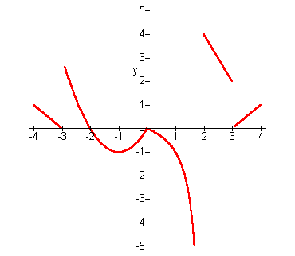

a) What are the critical numbers of f ? b) What is the absolute maximum of f on
$\left[−4,4\right]$ ?

c) What is the absolute minimum of f on $\left[−4,4\right]$? d) Where does f have local maxima?

e) Where does f have local minima? f) Where does f appear to be concave-up?

g) Where does f appear to be concave- down? h) Where does f have inflection points?

i) Identify the intervals where f is increasing. j) Identify the intervals where f is
decreasing.

k) Find the maximum of f on $\left[2,3\right]$. l) Find the maximum of f on $\left[0,2\right]$.

m) Find the minimum of f on $\left(−3,0\right)$. n) Find the maximum of f on$\left(−4,−\frac{5}{2}\right)$.
2. Given the graph of the function f on the interval $\left[−4,4\right]$, which consists of linear, quadratic and cubic pieces, answer the following questions.
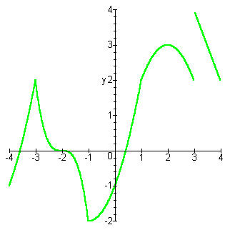

a) Identify the intervals where f is increasing. b) Identify the intervals where f is decreasing.

c) Identify the intervals where f is concave-up. d) Identify the intervals where f is concave-
down.

e) Identify critical numbers. f) Find local max. g) Find local min.

h) Find the inflection points. i) What is the absolute maximum of the function?

j) What is the absolute minimum of the function? k) Find the maximum of f on $\left[2,4\right]$.

3. Using the graphs of the functions f and g, determine the following limits:
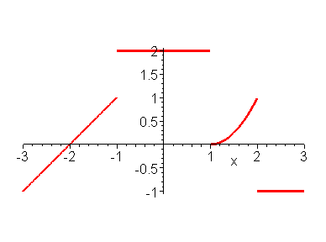
Graph of f
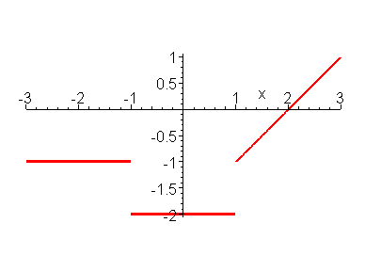
Graph of g

a)$\underset{x→0}{\text{lim}}\left(f\left(x\right)+g\left(x\right)\right)$ b) $\underset{x→−1}{\text{lim}}\left(f\left(x\right)+g\left(x\right)\right)$ c) $\underset{x→2}{\text{lim}}\left(f\left(x\right)g\left(x\right)\right)$ d) $\underset{x→2^{−}}{\text{lim}}\frac{f\left(x\right)}{g\left(x\right)}$

e) $\underset{x→2^{+}}{\text{lim}}\frac{f\left(x\right)}{g\left(x\right)}$ f) $\underset{x→2}{\text{lim}}\frac{f\left(x\right)}{g\left(x\right)}$ g) $\underset{x→−1}{\text{lim}}\frac{f\left(x\right)}{g\left(x\right)}$

h) $\underset{x→1^{+}}{\text{lim}}f\left(g\left(x\right)\right)$ i) $\underset{x→1^{−}}{\text{lim}}f\left(g\left(x\right)\right)$ j) $\underset{x→3^{−}}{\text{lim}}f\left(g\left(x\right)\right)$

4. What are the largest and smallest values of the function $f\left(x\right)=e^{{\text{cos}}^{2}x}$?

5. What are the largest and smallest values of the function $g\left(x\right)={\text{sin}}^{2}x−4\text{sin}x+5$?

6. What are the largest and smallest values of the function $h\left(x\right)={\text{cos}}^{2}x−\text{cos}x+1$?

7. What are the largest and smallest values of the function $k\left(x\right)={\text{log}}_{3}\left(2+\text{cos}x\right)$?

8. If $−1<f\left(x\right)<−\frac{1}{2}$ for $0<x<1$, and this is all we know about f.
a) Could f be continuous at $x=1$ if $f\left(1\right)=0$?

b) Could f be continuous at $x=0$ if $f\left(0\right)=0$?

c) Could f be continuous at $x=1$ if $f\left(1\right)=−1$?

d) Could f be continuous at $x=0$ if $f\left(0\right)=−\frac{3}{4}$?

e) Could f be continuous at $x=\frac{1}{2}$ if $f\left(\frac{1}{2}\right)=−2$?

f) Could f be continuous at $x=\frac{1}{2}$ if $f\left(\frac{1}{2}\right)=−\frac{3}{4}$?

II. Derivatives
1. Determine what is happening at the critical number 0 for the function
$f\left(x\right)=−\frac{x^{4}}{\text{24}}+\frac{x^{2}}{2}−1+\text{cos}x$.

2. Given the graph of the derivative of f, answer the following questions.
a) Where is f increasing? b) Where is f decreasing? c) Where does f have local maxima?

d) Where does f have local minima?
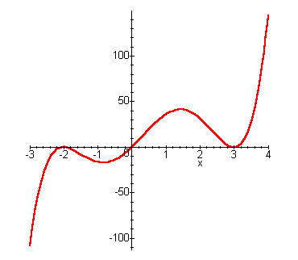

e) Which is larger $f\left(2\right)$ or $f\left(3\right)$?

f) Which is larger $f\left(−1\right)$ or $f\left(−3\right)$?

g) Is there an inflection point at $x=3$?

h) Is there an inflection point at $x=0$?

i) Is there an inflection point at $x=−2$?

3. Given the graph of the derivative of f, answer the following questions.
a) Where is f increasing? b) Where is f decreasing? c) Where does f have local maxima?

d) Where does f have local minima? e) Which is larger $f\left(0\right)$ or $f\left(1\right)$?
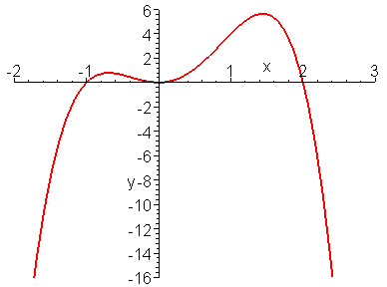

f) Which is larger $f\left(−2\right)$ or $f\left(0\right)$?

g) Is there an inflection point at $x=2$?

h) Is there an inflection point at $x=0$?

i) Is there an inflection point at $x=−1$?
4.
a) Find $\frac{d^{4}}{{\text{dx}}^{4}}\left(2\text{cos}x\right)$.

b) Find $\frac{d^{\text{913}}}{{\text{dx}}^{\text{913}}}\left(2\text{cos}x\right)$. (Yes, the 913th derivative of $2\text{cos}x$.)

c) Find $\frac{d^{\text{903}}}{{\text{dx}}^{\text{903}}}\left(x\text{sin}x\right)$. (Yes, the 903rd derivative of $x\text{sin}x$.)

d) Find the 21st derivative of $x{\left(x^{2}+1\right)}^{\text{10}}$.

5. a) Use the Intermediate Value Theorem to show that the function $f\left(x\right)=x^{3}−4x^{2}+5x−2$ has at least one zero in the interval $\left[0,3\right]$.

b) According to Rolle’s Theorem, what is the maximum number of zeros it can have in $\left[0,3\right]$?

c) How many zeroes does this function have in $\left[0,3\right]$?

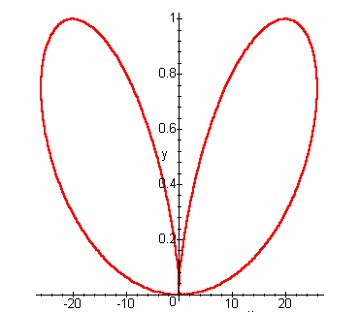
6. Given the graph of the equation relating x and y, answer the following questions.

a) At the point $\left(\text{10},\text{.}8\right)$, if $\frac{\text{dx}}{\text{dt}}=3$, what will be the sign of $\frac{\text{dy}}{\text{dt}}$?
b) At the point$\left(−\text{10},\text{.}8\right)$, if $\frac{\text{dx}}{\text{dt}}=−3$, what will be the sign of $\frac{\text{dy}}{\text{dt}}$?

7. Find the smallest slope of a tangent line for the function $f\left(x\right)=\frac{1}{5}x^{5}−\frac{1}{3}x^{3}+x$.

8. The relative derivative $f^{}\left(x\right)=\frac{f^{'}\left(x\right)}{f\left(x\right)}$ measures the relative rate of change of the function $f$. Find $f^{}\left(x\right)$ for the following functions:

a) $f\left(x\right)=x^{n}$

b) $f\left(x\right)=2^{x}$

c) Express $f^{}\left(x\right)$ for the function $f\left(x\right)=\frac{u\left(x\right)}{v\left(x\right)}$ in terms of $u^{}\left(x\right)$ and $v^{}\left(x\right)$.

d) Express $f^{}\left(x\right)$ for the function $f\left(x\right)=u\left(x\right)+v\left(x\right)$ in terms of $u^{}\left(x\right)$ and $v^{}\left(x\right)$.

9. Suppose that the power series $\sum_{n=0}^{∞}{a_{n}{\left(x+2\right)}^{n}}$converges if $x=−7$ and diverges if $x=7$. Determine if the following statements must be true, may be true, or cannot be true.
a) The power series converges if $x=−8$.

b) The power series converges if $x=1$.

c) The power series converges if $x=3$.

d) The power series diverges if $x=−\text{11}$.

e) The power series diverges if $x=−\text{10}$.

f) The power series diverges if $x=5$.

g) The power series diverges if $x=−5$.

10. Find the first three non-zero terms of the Maclaurin series for the following:
a) $e^{−x}−1+x$ b) $e^{−x}\text{sin}x$ c) $\int_{0}^{x}{\frac{\text{sin}t}{t}\text{dt} }$
11. Determine the intervals of concave-up and concave-down and the inflection points for the function $g\left(x\right)=x^{4}−\text{24}x^{2}+\text{10}x−5$. Also, use the Intermediate Value Theorem on the intervals $\left[−4,−3\right]$, $\left[0,1\right]$, and $\left[3,4\right]$ to estimate the critical numbers, and determine the local extrema using the 2nd Derivative Test.

12. Suppose that f is continuous in the interval $\left[a,b\right]$ and $f^{''}\left(x\right)$ exists for all x in $\left(a,b\right)$. If there are three values of x in $\left[a,b\right]$ for which $f\left(x\right)=0$, then what is the fewest number of values of x in $\left(a,b\right)$ where $f^{''}\left(x\right)=0$?

13. Find $\underset{x→0}{\text{lim}}\frac{x^{2}\text{sin}\left(\frac{1}{x}\right)}{\text{tan}x}$

14. Find $\underset{x→0}{\text{lim}}\frac{1−\text{cos}\left(x^{2}\right)}{x^{3}\text{sin}x}$

15. $\underset{x→∞}{\text{lim}}x^{2}\left(e^{−\frac{1}{x^{2}}}−1\right)$

16. Find values of a and b so that $\underset{x→0}{\text{lim}}\left(\frac{\text{sin}2x}{x^{3}}+a+\frac{b}{x^{2}}\right)=0$.

17. $\underset{x→0}{\text{lim}}\frac{\text{sin}x−x+\frac{x^{3}}{6}}{x^{5}}$

18. If $f\left(2\right)=0$, and $f^{'}\left(2\right)=7$ , then evaluate $\underset{x→0}{\text{lim}}\frac{f\left(2+3x\right)+f\left(2−5x\right)}{x}$.

19. Find numbers a, b, and c so that $\underset{x→1}{\text{lim}}\frac{{\text{ax}}^{4}+{\text{bx}}^{3}+1}{\left(x−1\right)\text{sin}\left(πx\right)}=c$.

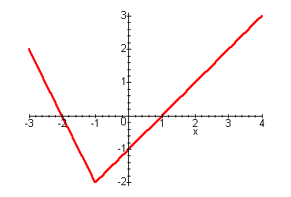
20. Given the graph of $f\left(x\right)$ on the interval $\left[−3,4\right]$, which consists of line segments, find the following limits.
a) $\underset{x→1}{\text{lim}}\frac{f\left(x\right)}{x^{2}−1}$

b) $\underset{x→2^{+}}{\text{lim}}\frac{f\left(x\right)}{x^{2}−4}$ c) $\underset{x→1}{\text{lim}}\frac{f\left(x\right)}{f\left(−2x\right)}$

21. Let $f\left(x\right)={\text{xe}}^{2x}$. What is the coefficient of $x^{\text{101}}$in the Maclaurin series of f?

22. Let f be a function such that $f\left(0\right)=0$ and $\frac{1}{2}≤f^{'}\left(x\right)≤1$ for all x.
a) Can $f\left(2\right)=3$?

b) How large can $f\left(2\right)$ be?

c) How small can $f\left(−1\right)$ be?

23. A 24-by-36 sheet of cardboard is folded in half to form a 24-by-18 rectangle. Then four equal squares of side length $x$ are cut from the corners of the folded rectangle. The sheet is unfolded, and the six tabs are folded up to form a box(suitcase). Determine the value of x that maximizes the volume. (See diagrams and attached model.)

36
24

24
18
x
x

36
24
x
x
x
x
x

24. Given the graph of the differentiable function f,

a) Let $h\left(x\right)=x^{2}f\left(x\right)$. Evaluate $h^{'}\left(2\right)$. Is h increasing or decreasing at $x=2$?
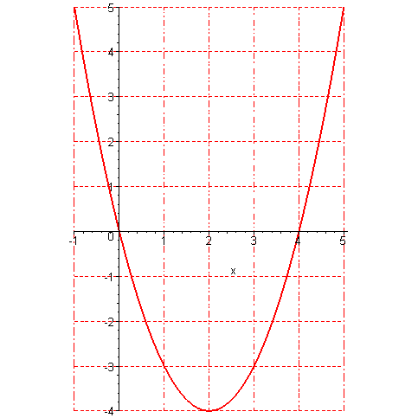
b) Let $m\left(x\right)=\frac{f\left(x\right)}{x^{2}+1}$. Is m increasing or decreasing at $x=0$?

c) Let $g\left(x\right)=f\left(x^{2}\right)$. For which values of x is $g^{'}\left(x\right)=0$?

d) Is g increasing or decreasing at $x=−1$?

e) Is $g^{'}$ positive or negative over the interval $\left(\sqrt{2},\sqrt{5}\right)$?

f) Is $g^{'}$ positive or negative over the interval $\left(−\sqrt{5},−\sqrt{2}\right)$?

25. Find the tangent lines to the graph of $y=x^{3}−9x$ that pass through the point $\left(1,−9\right)$.
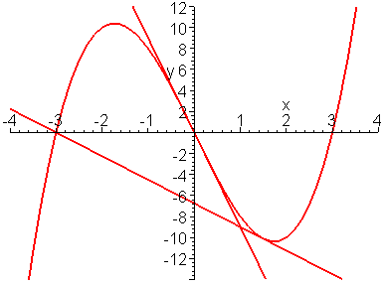

III. Integrals
1. If f is continuous, find $f\left(4\right)$ if
a) $\int_{0}^{x}{f\left(t\right)\text{dt}=x\text{cos}\left(πx\right)}$ b) $\int_{0}^{f\left(x\right)}{t^{4}\text{dt}=x\text{cos}\left(πx\right)}$

2. Suppose that $f$ is continuous and $4x^{3}−\text{256}=\int_{c}^{x}{f\left(t\right) \text{dt}}$.
a) Find a formula for$f\left(x\right)$? b) Find the value of c.

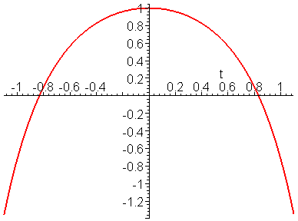
3. If $F\left(u,v\right)=\int_{u}^{v}{f\left(t\right)\text{dt}}$, with f continuous and u and v differentiable functions of x, then using the chain rule and the Fundamental Theorem of Calculus, we get that $\frac{\text{dF}}{\text{dx}}=f\left(v\left(x\right)\right)\frac{\text{dv}}{\text{dx}}−f\left(u\left(x\right)\right)\frac{\text{du}}{\text{dx}}$. Use this result to find the value of x that maximizes the integral $\int_{x}^{x+1}{\left(2−e^{t^{2}}\right) \text{dt}}$. The integral corresponds to a portion of the signed area between the graph of $f\left(t\right)=2−e^{t^{2}}$ and the t-axis.

4. Suppose that g has a continuous derivative on the interval $\left[0,2\right]$, and $−5≤g^{'}\left(x\right)≤3$ on $\left[0,2\right]$. By considering the formula for the length of the graph of g on the interval $\left[0,2\right]$, $\int_{0}^{2}{\sqrt{1+{\left[g^{'}\left(x\right)\right]}^{2}}}\text{dx}$,
a) Determine the maximum possible length of the graph of g on the interval $\left[0,2\right]$.

b) Determine the minimum possible length of the graph of g on the interval $\left[0,2\right]$.

5. Find the area of the region outside $r=\text{cos}θ$ and inside $r=1$.
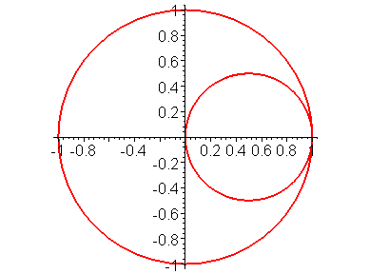

6. Suppose that f is a continuous function with the property that, for every a > 0, the volume swept out by revolving the region enclosed by the x-axis and the graph of f from x = 0 to x = a is ${πa}^{3}+{πa}^{2}$. Find f(x).
Volume of revolution = $π\int_{0}^{a}{{\left[f\left(x\right)\right]}^{2}}\text{dx}$ = ${πa}^{3}+{πa}^{2}$.

7. Determine the values of C for which the following improper integrals converge:
a) $\int_{0}^{∞}{\left(\frac{2x}{x^{2}+1}−\frac{C}{2x+1}\right)\text{dx}}$

b) $\int_{0}^{∞}{\left(\frac{1}{\sqrt{x^{2}+4}}−\frac{C}{x+2}\right)}\text{dx}$

c) $\int_{0}^{∞}{\left(\frac{x}{x^{2}+1}−\frac{C}{3x+1}\right)\text{dx}}$

8. Find a function $f\left(x\right)$ such that $\int{f\left(x\right)\text{sin}\text{xdx}=−f\left(x\right)\text{cos}x+\int{x^{3}\text{cos}\text{xdx}}}$.

9. If f is a differentiable function such that $\int_{0}^{x}{f\left(t\right)\text{dt}}={\left[f\left(x\right)\right]}^{2}$ for all x, then find f.
10. Suppose that f is continuous, has an inverse, $f\left(0\right)=0$, $f\left(1\right)=1$, and $\int_{0}^{1}{f\left(x\right)\text{dx}=\frac{1}{3}}$. Find the value of $\int_{0}^{1}{f^{−1}\left(y\right)\text{dy}}$.

11. Let f be the function graphed below on the interval [0,13]. Note: The graph of f consists of two line segments and two quarter-circles of radius 3.
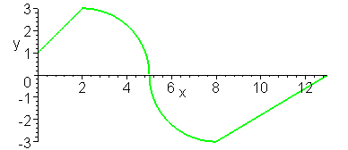

a) Evaluate $\int_{0}^{2}{f\left(x\right)\text{dx}}$ b) Evaluate $\int_{0}^{5}{f\left(x\right)\text{dx}}$ c) Evaluate $\int_{2}^{8}{f\left(x\right)\text{dx}}$

d) Evaluate $\int_{2}^{8}{\left|f\left(x\right)\right|\text{dx}}$ e) Evaluate $\int_{8}^{\text{13}}{f\left(x\right)\text{dx}}$ f)Evaluate $\int_{0}^{\text{13}}{f\left(x\right)\text{dx}}$

g) If $F\left(x\right)=\int_{0}^{x}{f\left(t\right)\text{dt}}$, then construct the sign chart for the derivative of F on the interval $\left[0,\text{13}\right]$.

h) Find the local extrema and absolute extrema for F on the interval $\left[0,\text{13}\right]$.

i) If $H\left(x\right)=\int_{0}^{x}{F\left(t\right)\text{dt}}$, then construct the sign chart for the derivative of H on the interval $\left[0,\text{13}\right]$.
12. Find the value of c, $0≤c≤1$, that minimizes the volume of the solid generated by revolving the region between the graphs of $y=4x\left(1−x\right)$ and $y=c$ from $x=0$ to $x=1$ about the line $y=c$.
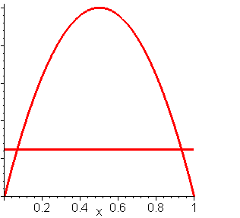

13. Assume that the function f is a decreasing function on the interval $\left[0,1\right]$ and that the following is a table showing some function values.
x | 0 | .25 | .5 | .75 | 1
f(x) | 2 | 1 | .8 | .4 | 0
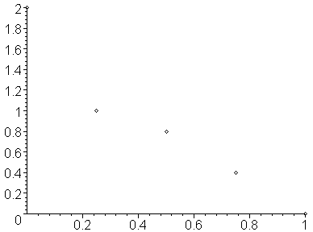
a) Estimate $\int_{0}^{1}{f\left(x\right)\text{dx}}$using a Riemann sum with four subintervals and evaluating the function at the left endpoints. Sketch the rectangles.

b) Is the Riemann sum estimate of the definite integral too big or too small?

c) Find an upper bound on the error of the estimate.

14. The integral $\int{\frac{x^{5}+x^{2}}{{\left(x^{6}+2x^{3}\right)}^{7}} \text{dx}}$ would require the solution of 40 equations in 40 unknowns if the method of partial fractions were used to evaluate it. Use the substitution $u=x^{6}+2x^{3}$ to evaluate it much more simply.

15. Find the second degree polynomial, $p\left(x\right)=\text{ax}+\text{bx}+c$, so that $p\left(0\right)=1$, $p^{'}\left(0\right)=0$, and $\int{\frac{p\left(x\right)}{x^{3}{\left(x−1\right)}^{2}} \text{dx}}$ is a rational function.

