Presentation Problems
I. Functions, Graphs, and Limits
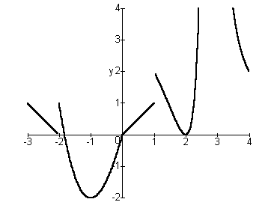
1. Here’s the graph of the function f on the interval $\left[−3,4\right]$. It has a vertical asymptote at $x=3$, $\underset{x→3}{\text{lim}}f\left(x\right)=∞$.

a) What are the critical numbers of f ? b) What is the absolute maximum of f on
$\left[−3,4\right]$ ?
$−2,−1,0,1,2,3$ DNE

c) What is the absolute minimum of f on $\left[−3,4\right]$? d) Where does f have local maxima?

$−2$ $x=−2$

e) Where does f have local minima? f) Find the maximum of f on $\left[−2,0\right]$.

$x=−1,2,3$ 1

g) Find the minimum of f on $\left(1,3\right)$. h) Find the maximum of f on $\left[0,2\right]$.

0 DNE

i) Find the minimum of f on $\left[2,4\right]$. j) Find the minimum of f on $\left[−3,−2\right]$.

0 DNE

k) Where is the function increasing? l) Where is the function decreasing?
$\left[−1,1\right],[2,3)$ $[−3,−2),\left[−2,−1\right],(1,2],(3,4]$
2. Using the graphs of the functions f and g, evaluate the following limits:
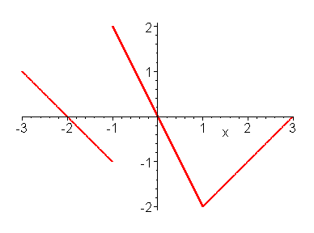
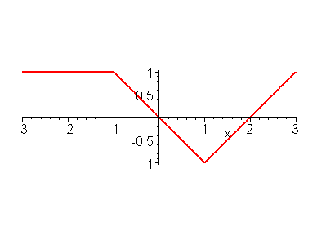
Graph of f
Graph of g

a) $\underset{x→−2}{\text{lim}}\frac{f\left(x\right)}{g\left(x\right)}$ b) $\underset{x→0}{\text{lim}}\frac{f\left(x\right)}{g\left(x\right)}$ c) $\underset{x→2^{−}}{\text{lim}}\frac{f\left(x\right)}{g\left(x\right)}$

$0$ $2$ $∞$

d) $\underset{x→2^{+}}{\text{lim}}\frac{f\left(x\right)}{g\left(x\right)}$ e) $\underset{x→1}{\text{lim}}\frac{f\left(x\right)}{g\left(x\right)}$ f) $\underset{x→1^{−}}{\text{lim}}f\left(g\left(x\right)\right)$

$−∞$ $2$ $2$

g) $\underset{x→−1^{−}}{\text{lim}}\left[f\left(x\right)+g\left(x\right)\right]$ h) $\underset{x→−1^{+}}{\text{lim}}\left[f\left(x\right)+g\left(x\right)\right]$ i)$\underset{x→2}{\text{lim}}\frac{g\left(x−2\right)}{f\left(−x\right)}$

$0$ $3$ $−1$

j) $\underset{x→0}{\text{lim}}\frac{f\left(2x\right)}{g\left(3x\right)}$

$\frac{4}{3}$

3. a) $\underset{x→0^{−}}{\text{lim}}\frac{3−x}{\text{400}x^{3}−x}$ b) $\underset{x→0^{+}}{\text{lim}}\frac{3−x}{\text{400}x^{3}−x}$ c) $\underset{x→0}{\text{lim}}\frac{3−x}{\text{400}x^{3}−x}$

$∞$ $−∞$ DNE

4. If $1<f\left(x\right)<2$ for $0<x<1$, and f is continuous at $x=0$, what can you say about $f\left(0\right)$? Be precise.
$$1≤f\left(0\right)≤2$$

5. What are the maximum and minimum values of $f\left(x\right)=\left|{\text{sin}}^{3}x−\frac{1}{2}\right|$ on $\left[0,2π\right]$.

$$\frac{3}{2},0$$

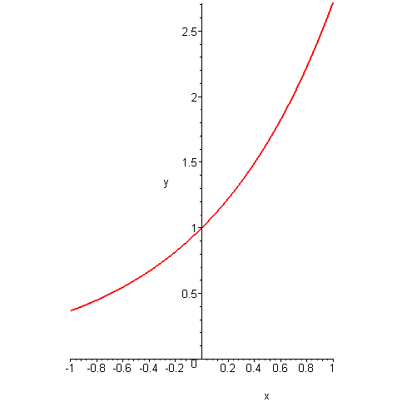
6. What are the largest and smallest values of the function $f\left(x\right)=e^{\text{sin}x}$?

$$e,\frac{1}{e}$$

7. What are the largest and smallest values of the function $g\left(x\right)={\text{sin}}^{2}x+4\text{sin}x+5$?
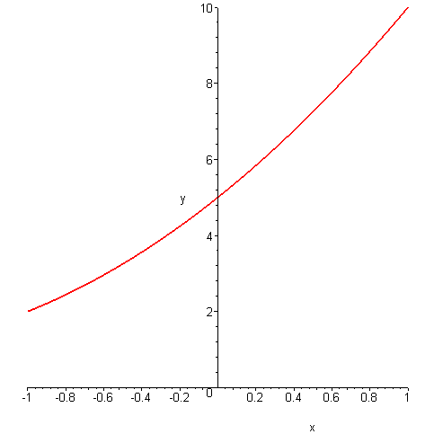

$$\text{10},2$$

8. What are the largest and smallest values of the function $h\left(x\right)={\text{sin}}^{2}x−\text{sin}x−1$?
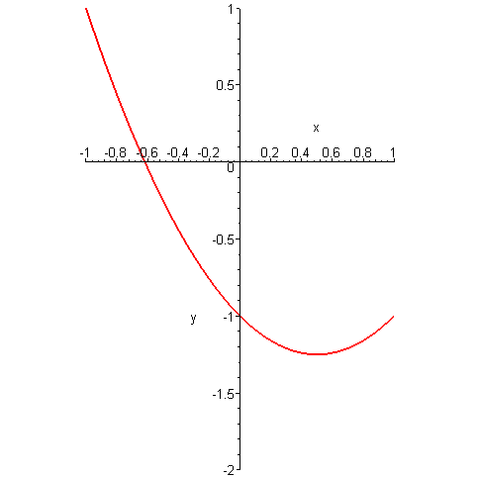

$$1,−\frac{5}{4}$$

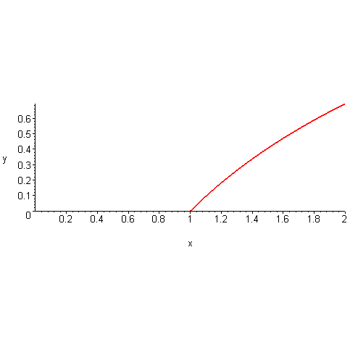
9. What are the largest and smallest values of the function $k\left(x\right)=\text{ln}\left(1+{\text{sin}}^{2}x\right)$?

$$\text{ln}2,0$$

II. Derivatives
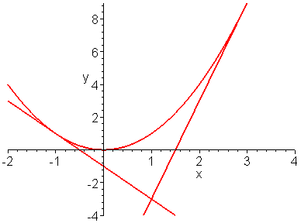
1. Find the equations of the two tangent lines to the graph of $f\left(x\right)=x^{2}$ that pass through the point $\left(1,−3\right)$.

$$\begin{aligned}y+3=−2\left(x−1\right) \\ y+3=6\left(x−1\right)\end{aligned}$$

2. Determine what is happening at the critical number 0 for the function
$f\left(x\right)=\frac{x^{3}}{6}+\frac{x^{2}}{2}−1+\text{cos}x$.

Neither a maximum or a minimum; it’s an inflection point.

3. A piece of cardboard measures 10 inches by 15 inches. Two equal squares are removed from the corners of a 10 inch side as shown. Two equal rectangles are removed from the other corners so that the tabs can be folded to form a rectangular box with a lid. What value of x gives the maximum volume of the box?

x
x
x
x
155
105

$$\text{Volume}\left(x\right)=x\left(\frac{\text{15}−2x}{2}\right)\left(\text{10}−2x\right);0<x<5$$
Maximum at $x=\frac{\text{25}−5\sqrt{7}}{6}$
4. Given the graph of the derivative of f, answer the following questions.
a) Where is f increasing? b) Where is f decreasing? c) Where does f have local maxima?

$\left[−∞,−2\right],\left[0,∞\right]$ $\left[−2,0\right]$ $x=−2$

d) Where does f have local minima? e) Which is larger $f\left(0\right)$ or $f\left(1\right)$?

$x=0$ $f\left(1\right)$
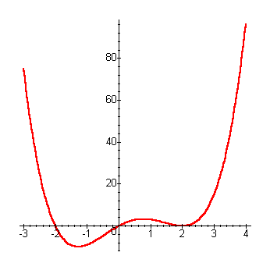
f) Which is larger $f\left(−1\right)$ or $f\left(0\right)$?
$f\left(−1\right)$

g) Is there an inflection point at $x=2$?
yes

h) Is there an inflection point at $x=0$?
no

i) Is there an inflection point at $x=−2$?
no

5. a) Find $\frac{d^{3}}{{\text{dx}}^{3}}\left(x^{3}\right)$. $3!$

b) Find $\frac{d^{4}}{{\text{dx}}^{4}}\left(x^{3}\right)$. $0$

c) Find $\frac{d^{8}}{{\text{dx}}^{8}}\left(x^{8}+\text{21}x^{7}−\text{53}x^{6}+\text{411}x^{5}−\text{213}x^{4}+5x^{3}−2x^{2}−\text{123}\right)$. $8!$

d) Find $\frac{d^{4}}{{\text{dx}}^{4}}\left(\text{sin}x\right)$. (Yes, the 4th derivative of $\text{sin}x$.) $\text{sin}x$

e) Find $\frac{d^{\text{903}}}{{\text{dx}}^{\text{903}}}\left(\text{sin}x\right)$. (Yes, the 903rd derivative of $\text{sin}x$.) $−\text{cos}x$

f) Find $\frac{d^{9}}{{\text{dx}}^{9}}\left[\left(\text{sec}x−\text{tan}x\right)\left(\text{tan}x+\text{sec}x\right)\right]$ $0$

6. The graphs of the differentiable functions f and g are given below.
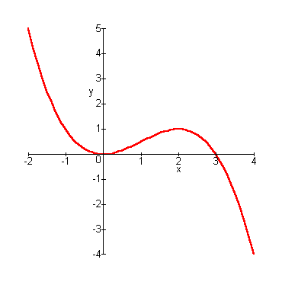
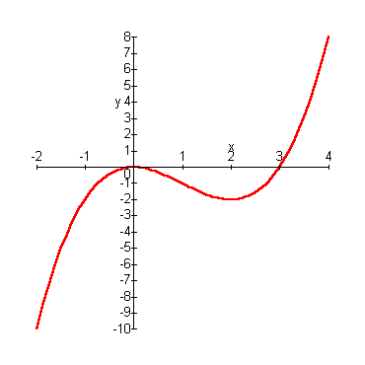
Graph of f
Graph of g
a) Evaluate $\left(f∘g\right)\left(−1\right)$ b) Evaluate $\left(g∘f\right)\left(2\right)$ c) Is ${\left(f∘g\right)}^{′}\left(−1\right)$ positive,
negative, or zero?
$5$ $−1$ negative

d) Is${\left(g∘f\right)}^{′}\left(2\right)$ positive, negative, or zero? e) Is${\left(\text{gf}\right)}^{′}\left(2\right)$ positive, negative, or zero?

Zero zero

7. a) Use the Intermediate Value Theorem to show that the function $f\left(x\right)=x−\text{cos}x$ has at least one zero on the interval $\left[0,\frac{π}{2}\right]$.

$$f\left(0\right)=−1,f\left(\frac{π}{2}\right)=\frac{π}{2}$$
b) Use Rolle’s Theorem to show that it has at most one zero on the interval $\left[0,\frac{π}{2}\right]$.
$f^{'}\left(x\right)=1+\text{sin}x>0$ for $0≤x≤\frac{π}{2}$

c) How many zeroes does the function have on the interval $\left[0,\frac{π}{2}\right]$?
1
8. If f is differentiable on the interval $\left[0,2\right]$, $f\left(0\right)=1$, and $f^{'}\left(x\right)≤3$on $\left[0,2\right]$, then what is the largest value possible for $f\left(2\right)$?

7

9. Given the graph of the equation relating x and y, answer the following questions.
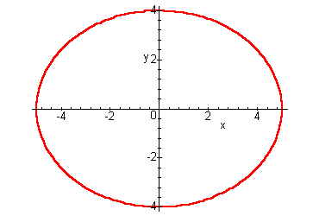

a) At the point $\left(−4,\frac{\text{12}}{5}\right)$, if $\frac{\text{dx}}{\text{dt}}=3$, what will be the sign of $\frac{\text{dy}}{\text{dt}}$?

Positive

b) At the point$\left(3,\frac{\text{16}}{5}\right)$, if $\frac{\text{dx}}{\text{dt}}=3$, what will be the sign of $\frac{\text{dy}}{\text{dt}}$?

Negative

10. What is the smallest slope of a tangent line to the graph of the function $f\left(x\right)=x^{5}+2x$?

2

11. The following figure shows the velocity of a particle moving on a coordinate line.
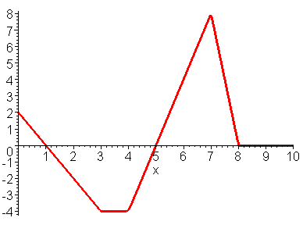

a) When is its velocity positive? b) When is its velocity negative?
$[0,1),\left(5,8\right)$ $\left(1,5\right)$

c) When is its velocity zero? d) When does the particle move at its
$1,5,(8,\text{10}]$ greatest speed?
$7$

e) When is its acceleration positive? Negative? Zero?

$\left(4,7\right)$ $[0,3),\left(7,8\right)$ $\left(3,4\right),(8,\text{10}]$

f) If the particle began at position 0, what’s its position after 3 seconds?

$$−3$$

g) What is the total distance traveled during the ten seconds?

$$\text{23}$$

12. Suppose $f\left(1\right)=1$ and $f^{'}\left(1\right)=2$. Evaluate $\underset{x→1}{\text{lim}}\frac{{\left(f\left(x\right)\right)}^{2}−1}{x^{2}−1}$.

$$2$$

13. Suppose that $f$ is differentiable, $f\left(0\right)=0$, and that $\underset{x→0}{\text{lim}}\frac{f\left(x\right)}{\text{sin}\left(2x\right)}=5$. Find the value of $f^{'}\left(0\right)$.

$$\text{10}$$

14. $\underset{x→{\left(\frac{π}{2}\right)}^{−}}{\text{lim}}\frac{\text{sec}x}{\text{tan}x}$

$$1$$

15. Determine whether the series $\sum_{k=2}^{∞}{a_{k}}$ converges or not. If it converges, find the sum.
$$a_{k}=\sum_{n=2}^{∞}{{\left(\frac{1}{k}\right)}^{n}}$$
converges to 1

16. The relative derivative $f^{}\left(x\right)=\frac{f^{'}\left(x\right)}{f\left(x\right)}$ measures the relative rate of change of the function $f$. Find $f^{}\left(x\right)$ for the following functions:

a) $f\left(x\right)=x^{2}$

$$\frac{2}{x}$$

b) Express $f^{}\left(x\right)$ for the function $f\left(x\right)=u\left(x\right)v\left(x\right)$ in terms of $u^{}\left(x\right)$ and $v^{}\left(x\right)$.

$$u^{}\left(x\right)+v^{}\left(x\right)$$

17. Suppose that $f\left(0\right)=0$ and that $f^{'}\left(0\right)=−2$. Calculate the derivative of $f\left(f\left(f\left(x\right)\right)\right)$ at $x=0$.

$$−8$$

18. Find the first three non-zero terms of the Maclaurin series for the following:
a) $\frac{1}{1−x^{3}}$ b) $x\text{sec}x$

$1+x^{3}+x^{6}$ $x+\frac{x^{3}}{2}+\frac{5x^{5}}{\text{24}}$

19. Suppose that the power series $\sum_{n=0}^{∞}{a_{n}x^{n}}$converges if $x=−3$ and diverges if $x=7$. Determine if the following statements must be true, may be true, or cannot be true.
a) The power series converges if $x=−\text{10}$.

Cannot be true

b) The power series diverges if $x=3$.

May be true

c) The power series converges if $x=6$.

May be true

d) The power series diverges if $x=2$.

Cannot be true

e) The power series diverges if $x=−7$.

May be true

f) The power series converges if $x=−4$.

May be true

20. Suppose that f is differentiable for all values of x, $f\left(−1\right)=1,f\left(1\right)=−1$, and $\left|f^{'}\left(x\right)\right|≤1$ for all x. What must $f\left(0\right)$ equal?
$$0$$

21. Find values of r and s so that $\underset{x→0}{\text{lim}}\left(\frac{\text{sin}3x}{x^{3}}+\frac{r}{x^{2}}+s\right)=0$.
$$r=−3,s=\frac{9}{2}$$

22. If $f\left(x\right)=\text{sin}\left(x^{3}\right)$, then find $f^{\left(\text{15}\right)}\left(0\right)$.
$$\frac{\text{15}!}{5!}$$

III. Integrals
1. Let $f\left(x\right)=x^{2}+x$. Consider the region bounded by the graph of f, the x-axis, and the line $x=2$. Divide the interval $\left[0,2\right]$ into 8 equal subintervals.
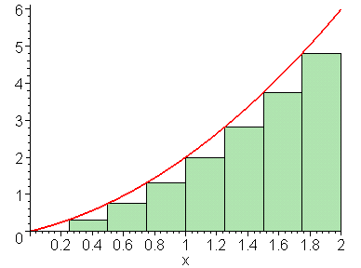
a) Obtain a lower estimate for the area of the region by using the left endpoint of each subinterval.

$$3\frac{\text{15}}{\text{16}}$$

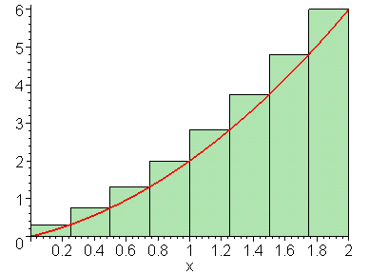
b) Obtain an upper estimate for the area of the region by using the right endpoint of each subinterval.

$$5\frac{7}{\text{16}}$$

c) Find an approximation for the area of the region that you think is better than either of the answers obtained in parts a) and b).
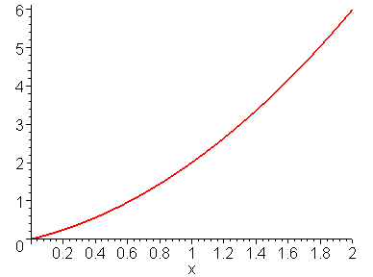
Average the previous two, and get the trapezoid approximation.

$$4\frac{\text{11}}{\text{16}}$$

Midpoint, and take advantage of the error cancellation.

$$4\frac{\text{21}}{\text{32}}$$

d) Determine if the answer in part c) is larger or smaller than the true area, and tell why.

Picture and concavity for both methods

2. Suppose that f is a continuous function. Find $f\left(2\right)$, if $\int_{0}^{x}{f\left(t\right)\text{dt}=x\text{sin}\left(πx\right)}$.

$$2π$$

3. Suppose that f is a continuous function. Find $f\left(\frac{1}{2}\right)$, if $\int_{0}^{f\left(x\right)}{t^{2}\text{dt}=x\text{sin}\left(πx\right)}$.
$$\sqrt[3]{\frac{3}{2}}$$

4. If $x\text{sin}πx=\int_{0}^{x^{2}}{f\left(t\right)\text{dt}}$, where f is a continuous function, find $f\left(4\right)$.

$$\frac{π}{2}$$

5. For what value of x does the function $f\left(x\right)=\int_{0}^{x^{2}}{\frac{t−1}{t+1}\text{dt}}$, $0≤x≤2$ take on its minimum value?

$$1$$

6. Find the interval on which $f\left(x\right)=\int_{0}^{x}{\frac{1+t}{1+t^{2}} \text{dt}}$ is concave-up.

$$\left[−1−\sqrt{2},−1+\sqrt{2}\right]$$
7. Suppose $f$ is a continuous function and $5x^{3}+\text{40}=\int_{c}^{x}{f\left(t\right) \text{dt}}$.
a) What is $f\left(x\right)$? b) Find the value of c.

$\text{15}x^{2}$ $−2$

8. Find the absolute minimum value of $F\left(x\right)=\int_{0}^{x^{2}}{\frac{1}{1+t^{2}} \text{dt}}$.

$$0$$

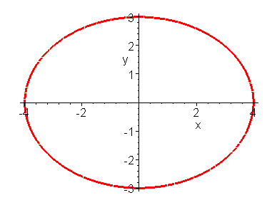
9. A gasoline tank is an ellipsoid of revolution formed by revolving the region bounded by the graph of $\frac{x^{2}}{\text{16}}+\frac{y^{2}}{9}=1$ about the y-axis. Find the depth of the gasoline in the tank when it is filled to ¼ its capacity.

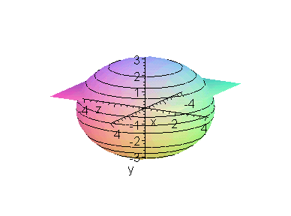

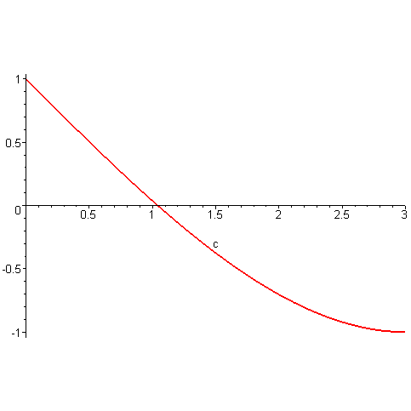

Solve $\frac{c^{3}}{\text{27}}−c+1=0$ with bisection, iteration, Newton, and subtract from 3.

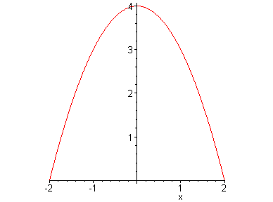
10. Determine the value of c so that the region between the graph of $y=4−x^{2}$ and the x-axis from $x=−2$ to $x=2$ is divided in half by the line$y=c$.

$$4−\sqrt[3]{\text{16}}$$

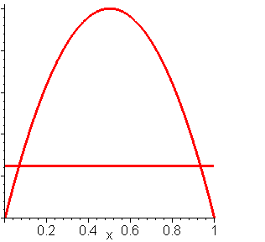
11. Find the value of c, $0≤c≤1$, that minimizes the area of the region between the graphs of $y=4x\left(1−x\right)$ and $y=c$ from $x=0$ to $x=1$.

$$\frac{3}{4}$$

12. $\frac{1}{n}\left({\left(\frac{1}{n}\right)}^{\text{19}}+{\left(\frac{2}{n}\right)}^{\text{19}}+⋯+{\left(\frac{n}{n}\right)}^{\text{19}}\right)$ is a Riemann sum for some function on the interval $\left[0,1\right]$. Identify this function, and evaluate its definite integral on $\left[0,1\right]$ to find the value of $\underset{n→∞}{\text{lim}}\frac{1}{n}\left({\left(\frac{1}{n}\right)}^{\text{19}}+{\left(\frac{2}{n}\right)}^{\text{19}}+⋯+{\left(\frac{n}{n}\right)}^{\text{19}}\right)$.

$$\int_{0}^{1}{x^{\text{19}}\text{dx}=\frac{1}{\text{20}}}$$

13. Let f be a continuous function on the closed interval $\left[0,2\right]$. If $2≤f\left(x\right)≤4$, then what is the largest possible value of $\int_{0}^{2}{f\left(x\right)\text{dx}}$? The smallest possible value?
$$8,4$$

14. Let $f$ be the function graphed below on the interval $\left[−5,5\right]$. Let $F\left(x\right)=\int_{0}^{x}{f\left(t\right) \text{dt}}$. Note: The graph of f consists of line segments.
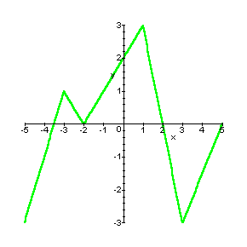

a) Find $F\left(2\right)$ b) Find $F\left(0\right)$
4 0

c) Find $F\left(−2\right)$
$−2$

d) Construct the sign chart for $F^{'}$ on $\left[−5,5\right]$, and use it to find the x-coordinates of the local extrema of F on $\left[−5,5\right]$ .

- 5
- 2
2
5
0
0
0

e) Construct the sign chart for $F^{''}$ on $\left[−5,5\right]$, and use it to find the x-coordinates of the inflection points of F.
- 5
- 2
3
5
u
u
u
- 3
1
u

f) What is the average value of f on$\left[2,5\right]$?

$$−\frac{3}{2}$$

15. Suppose that f is continuous on $\left[a,b\right]$. What value of c minimizes the value of $\int_{a}^{b}{{\left[f\left(x\right)−c\right]}^{2} \text{dx}}$?

$$\frac{1}{b−a}\int_{a}^{b}{f\left(x\right)\text{dx}}$$

16. Calculate the value of $\int_{−1}^{1}{\left[1+\text{tan}x+\frac{\sqrt[3]{x}}{{\left(1+x^{2}\right)}^{7}}−x^{\text{17}}\text{cos}x\right]\text{dx}}$

2

17. Given $\int_{0}^{2}{f\left(x\right)\text{dx}=2}$, $\int_{1}^{2}{f\left(x\right)\text{dx}=−1}$, and $\int_{2}^{4}{f\left(x\right)\text{dx}=7}$, find the values of
a) $\int_{1}^{4}{f\left(x\right)\text{dx}}$ b) $\int_{0}^{4}{3f\left(x\right)\text{dx}}$ c) $\int_{0}^{1}{f\left(x\right)\text{dx}}$

6 27 3

d) $\int_{0}^{1}{\left(f\left(x\right)+1\right)\text{dx}}$ e) $\int_{0}^{1}{f\left(x+1\right)\text{dx}}$ f) $\int_{2}^{4}{f\left(x−2\right)\text{dx}}$

4 $−1$ 2

g) $\int_{0}^{1}{f\left(2−x\right)\text{dx}}$ 1
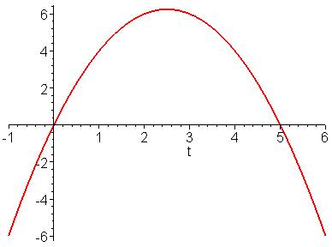
18. If $F\left(u,v\right)=\int_{u}^{v}{f\left(t\right)\text{dt}}$, with f continuous and u and v differentiable functions of x, then using the chain rule and the Fundamental Theorem of Calculus, we get that $\frac{\text{dF}}{\text{dx}}=f\left(v\left(x\right)\right)\frac{\text{dv}}{\text{dx}}−f\left(u\left(x\right)\right)\frac{\text{du}}{\text{dx}}$. Use this result to find the value of x that maximizes the integral $\int_{x}^{x+3}{t\left(5−t\right) \text{dt}}$. The integral corresponds to a portion of the signed area between the graph of $f\left(t\right)=t\left(5−t\right)$ and the t-axis.

1

19. Suppose that g has a continuous derivative on the interval $\left[0,2\right]$, and $1≤g^{'}\left(x\right)≤5$ on $\left[0,2\right]$. By considering the formula for the length of the graph of g on the interval $\left[0,2\right]$, $\int_{0}^{2}{\sqrt{1+{\left[g^{'}\left(x\right)\right]}^{2}}}\text{dx}$,

a) Determine the maximum possible length of the graph of g on the interval $\left[0,2\right]$.
$$2\sqrt{\text{26}}$$

b) Determine the minimum possible length of the graph of g on the interval $\left[0,2\right]$.
$$2\sqrt{2}$$

20. Suppose that $f\left(x\right)$ has the property that $f^{'}\left(0\right)=f^{'}\left(1\right)=0$ and that $f$ has two continuous derivatives. Use integration by parts to find the largest possible value of $\int_{0}^{1}{f^{''}\left(x\right)f\left(x\right) \text{dx}}$. {Hint: let $u=f\left(x\right)$ and $\text{dv}=f^{''}\left(x\right) \text{dx}$.} What functions give it the largest value?
$$\int_{0}^{1}{f^{''}\left(x\right)}f\left(x\right)\text{dx}=f^{'}\left(x\right)f\left(x\right)|_{0}^{1}−\int_{0}^{1}{\left[f^{'}{\left(x\right)}^{2}\right] }\text{dx}$$
21. Find the value of the limit, $\underset{x→∞}{\text{lim}}\frac{\int_{1}^{x}{\sqrt{1+e^{−t}} \text{dt}}}{x}$.

1

22. The integral $\int{\frac{x+2x^{3}}{{\left(x^{4}+x^{2}\right)}^{3}} \text{dx}}$ would require the solution of 11 equations in 11 unknowns if the method of partial fractions were used to evaluate it. Use the substitution $u=x^{4}+x^{2}$ to evaluate it much more simply.

$$\frac{x+2x^{3}}{{\left(x^{4}+x^{2}\right)}^{3}}=\frac{1+2x^{2}}{x^{5}{\left(x^{2}+1\right)}^{3}}=\frac{A}{x}+\frac{B}{x^{2}}+\frac{C}{x^{3}}+\frac{D}{x^{4}}+\frac{E}{x^{5}}+\frac{\text{Fx}+G}{x^{2}+1}+\frac{\text{Hx}+J}{{\left(x^{2}+1\right)}^{2}}+\frac{\text{Kx}+L}{{\left(x^{2}+1\right)}^{3}}$$

$$\frac{−1}{4{\left(x^{4}+x^{2}\right)}^{2}}+C$$

23. Suppose that $f\left(x\right)$ has the property that $f^{'}$ is continuous, $f\left(0\right)=2$, and $\int_{0}^{π}{f\left(x\right)\text{sin}x \text{dx}−\int_{0}^{π}{f^{'}\left(x\right)\text{cos}x \text{dx}=6}}$. Use integration by parts to find $f\left(π\right)$. {Hint: let $u=\text{cos}x$ and $\text{dv}=f^{'}\left(x\right) \text{dx}$.}

$$\int_{0}^{π}{f\left(x\right)\text{sin}\text{xdx}−\left[f\left(x\right)\text{cos}x|_{0}^{π}+\int_{0}^{π}{f\left(x\right)\text{sin}\text{xdx}}\right]=6}$$

4

24. Use L’Hopital’s Rule to evaluate $\underset{x→0}{\text{lim}}\frac{\int_{0}^{x}{{\text{sin}}^{7}t \text{dt}}}{x^{8}}$.

$$\frac{1}{8}$$

25. Suppose that f is a continuous function with the property that, for every a > 0, the volume swept out by revolving the region enclosed by the x-axis and the graph of f from x = 0 to
x = a is ${πa}^{3}$. Find f(x).

Volume of revolution = $π\int_{0}^{a}{{\left[f\left(x\right)\right]}^{2}}\text{dx}$ = ${πa}^{3}$.

$f\left(x\right)=\sqrt{3}a$ or $f\left(x\right)=−\sqrt{3}a$

26. Determine the values of C for which the following improper integrals converge:
a) $\int_{0}^{∞}{\left(\frac{2x}{x^{2}+1}−\frac{C}{2x+1}\right)\text{dx}}$

$$C=4$$

b) $\int_{1}^{∞}{\left(\frac{{\text{Cx}}^{2}}{x^{3}+1}−\frac{1}{3x+1}\right)\text{dx}}$

$$C=1$$

