Fooling Newton’s Method
You might think that if the Newton sequence of a function converges to a number, that the number must be a zero of the function. Let’s look at the Newton iteration and see what might go wrong:

Most textbooks give examples where the Newton sequence gets stuck(oscillates), hits a horizontal tangent and fails, or simply converges to a different zero than the one intended, but I don’t see textbooks give examples of Newton sequences converging to nonzeros.

Normally the Newton sequence converges to a number L and the function and its derivative are continuous, so we can let in the Newton formula to conclude that
.
Assuming that, we conclude that the Newton sequence converges to a zero of f.

If we can get a Newton sequence to converge to a number L with the property that diverges to , then L might not be a zero of f.
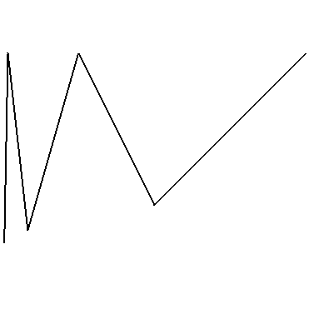
1

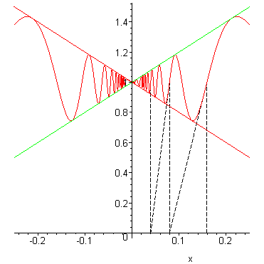
Consider the function , and let’s start the sequence with .

a) Find a formula for the Newton sequence, and verify that it converges to a nonzero of f.

b) Find a formula for and determine its behavior as .

A Stirling-like Inequality

Stirling’s asymptotic approximation comes from the inequality
.

Let’s use some elementary calculus to derive a weaker inequality:

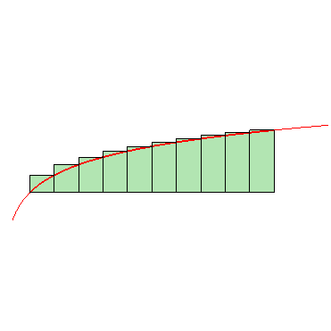
I.
1
2
n

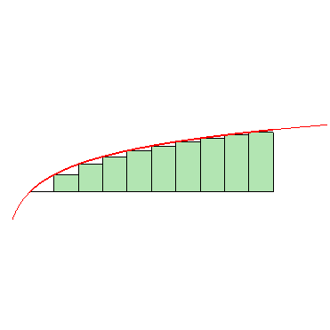
3
2
n
n + 1

From the two graphs, you can deduce the following double inequality:

.

Integrate the left and right sides,
exponentiate, and complete the inequality:

.

II. Find the interval of convergence of the power series . Use part I. for the endpoints. (Most textbooks just ask for the radius of convergence!)

III. a) If k is a positive integer, find the radius of convergence of the power series .

b) If check the endpoints.

c) If , use the result of I. to check the endpoints.

Evaluating Proper/Improper Integrals with little or no Integration.

I. For the improper integral , let’s look at the two cases: and . For , , so it’s convergent by comparison.

For , , but is convergent. So is absolutely convergent by comparison.

Use the substitution to find its value.

II. Evaluate using the substitution . {Hint: .}

For ,

For ,
III. If you use the substitution in the integral , you arrive at . Is it okay to conclude that ? Explain.

IV. a) Use the substitution along with the identities and to evaluate the definite integral .

b) Evaluate the definite integral for n a positive integer.

V. Evaluate using the substitution and the identities and .
.

VI. Show that if f is continuous then by showing that using the substitution , , and symmetry.

Limit Problems
I. What happens if you try L’Hopital’s Rule on ?

Find by considering the inequality which is valid for .

II. .{See problem I.}

III. Find the value of c so that .

IV. Find a simple formula for , for .

V. Find $\underset{x→0}{\text{lim}}\frac{x^{2}\text{sin}\left(\frac{1}{x}\right)}{\text{tan}x}$. L’Hopital’s Rule won’t work, so try something else.

VI. Find the following limits:
a) b)

VII. Find by observing the following:

The last expression is a Riemann sum of some definite integral.

VIII. The alternating series converges by the Alternating Series Test, but what does it converge to?

Let’s look at the even partial sums:

Solving the previous equation for , we get

So .
Find , and you’ll know the sum of the series.
Method 1: Calculate by rewriting it as
and identifying it as a definite integral.

Method 2:
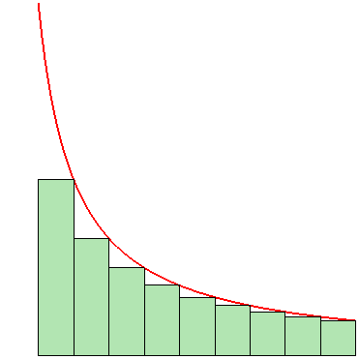
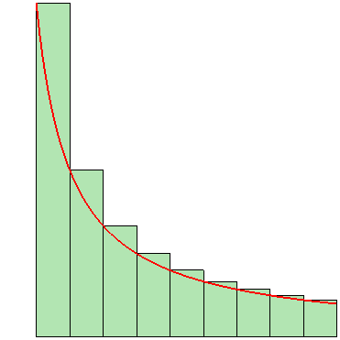

From the pictures you get
IX. Telescopers
a)

b) {Hint:.}

c) {Hint: , choose x and y carefully.}

Assorted Series
I. {Hint: For , .}

II. {Try something like I.}

III. a) Show that .

b) Show that if is a sequence of positive numbers, then if is decreasing, then is decreasing. In other words, show that if , then .

c) For , show that . {Hint: , and .}

d) Show that is a decreasing sequence by showing that has a negative derivative. {Hint:Use part c).}

e) Determine whether the alternating series is absolutely convergent, conditionally convergent, or divergent using the previous results.

IV. a) Starting with , you get that . Now integrate from to and get . Evaluate the integrals on both sides of the equation and find the sum of a series.

b) You can verity the sum you found in part a) by noticing that . So find the sum of this telescopic series and verify the previous result.

The Goat/Cow Grazing in the Grass/Seaweed Problem
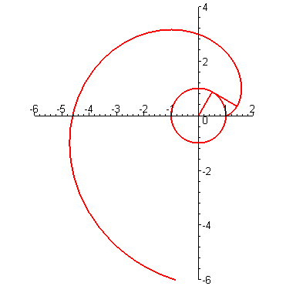
I. Suppose that after a string is wound clockwise around a circle of radius a, its free end is at the point . Now the string is unwound, always stretched tight so the unwound portion is tangent to the circle at . The set of points traced out by the free end of the string is called the involute of the circle.

Find the parametric equations of the involute of the circle.

II. Suppose the circle in the previous problem represents the cross-section of a cylindrical water tank of radius a, and the string is a rope of length . The rope is anchored at the point B opposite point A. If the other end of the rope is tied to a cow, let’s examine the region that can be grazed by the cow. Here is a diagram showing the rope in various positions:
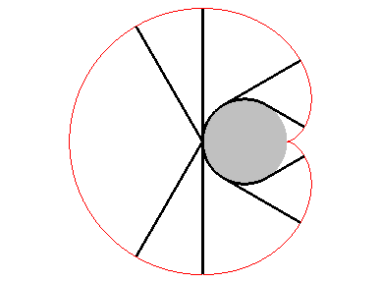

The boundary of the grazing region can be broken down into three pieces: is a portion of the involute of the circle, is a semicircle, and is the reflection across the x-axis of a portion of the involute.

Find the length of the boundary of the grazing region.

III. Find the area of the grazing region.
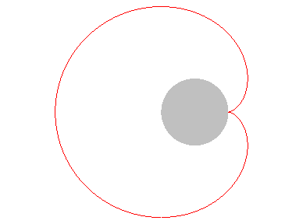

IV. Now suppose that a sea cow(manatee) is tied to a point on the surface of a sphere of radius a by a rope of length . Try to find the surface area and the volume of the grazing region of the sea cow.
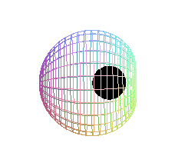

V. Now suppose that the rope in the previous problem has length and is anchored at the point A before being wound completely around the tank.
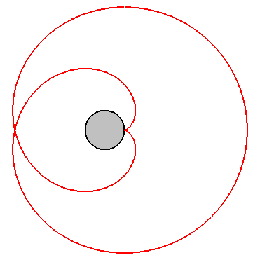
A
P
Q
R
S

APQ is a portion of the involute, QR is a semicircle, and RSA is a reflection of a portion of the involute.

Attempt all the previous calculations: Length, area, surface area, and volume.

Iteration and More Grazing
I. Analyze the following recursively defined sequences using a cobweb diagram:
a) b)
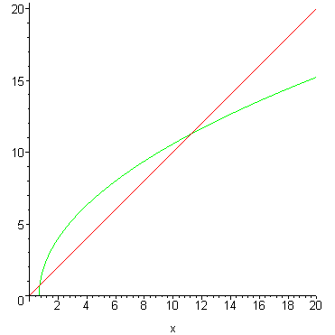

c) d)
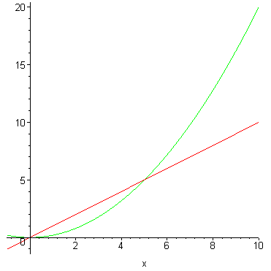
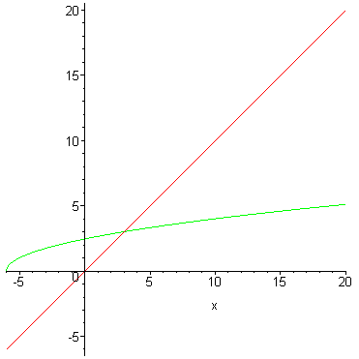

e) f)
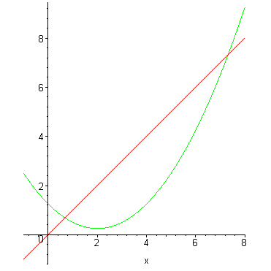

g) Determine the convergence or divergence of the series whose terms are defined recursively by the following:
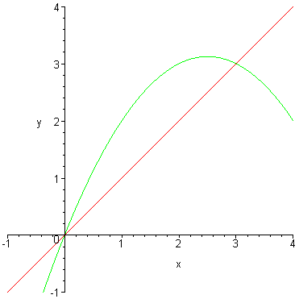
{Hint: Determine by cob-web analysis.}

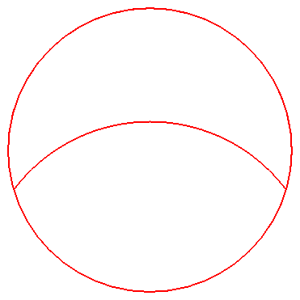
II. A farmer has a fenced circular pasture of radius a and wants to tie a cow to the fence with a rope of length b so as to allow the cow to graze half the pasture. How long should the rope be to accomplish this?

The length of the rope, b, must be longer than a and shorter than , i.e. . To find the area of the grazing region, we can use polar coordinates:

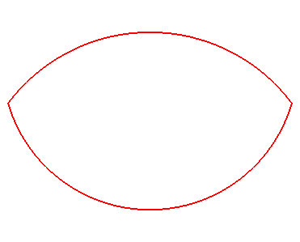

The grazing area .
We want this to equal half the pasture area which is , so we get the equation . If we multiply both sides by and perform the integrations, we arrive at the equation .

a) Verify the previous equation.

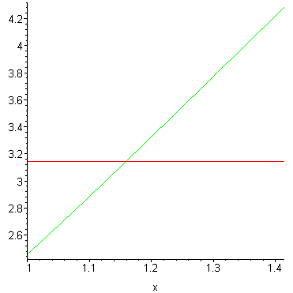
If we let , we get the simplified equation , and we’re looking for the solution x, with . Here’s a plot of the leftside and rightside of the equation:
solution

If we rearrange the equation, we can produce a sequence that will converge to the solution:

.

Let , and .

b) Complete the cobweb diagram for the recursive sequence.
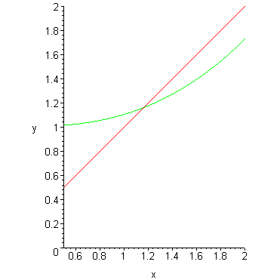

Here are the first 14 terms of the sequence generated by Excel:
1
1.10363
1.13795
1.15068
1.15558
1.15749
1.15824
1.15854
1.15865
1.15870
1.15872
1.15872
1.15873
1.15873

So the rope length, b, should be approximately .

