The Goat/Cow Grazing in the Grass/Seaweed Problem
I. Find the parametric equations of the involute of the circle.

II. Find the length of the boundary of the grazing region.

III. Find the area of the grazing region.

IV. Try to find the surface area and the volume of the grazing region of the sea cow.

Surface Area:

Volume:

V. Attempt all the previous calculations: Length, area, surface area, and volume.

Enjoy!!!

Iteration and More Grazing
I. Analyze the following recursively defined sequences using a cobweb diagram:
a) b)
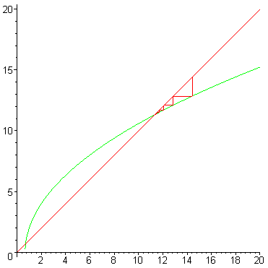
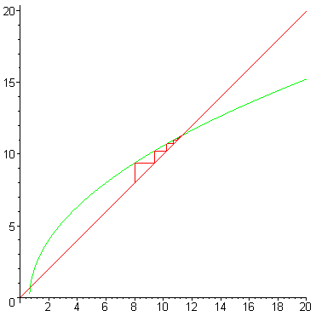

c) d)

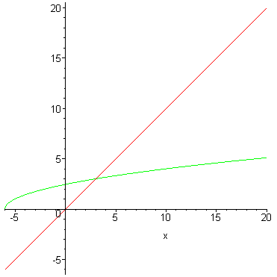
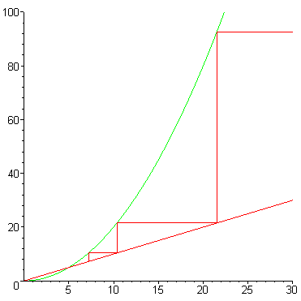
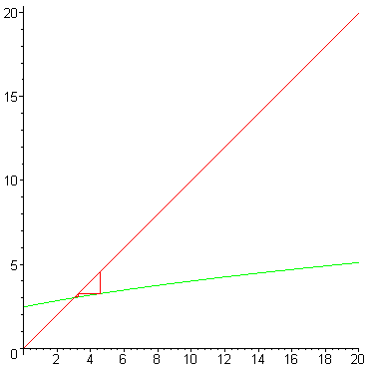

e) f)
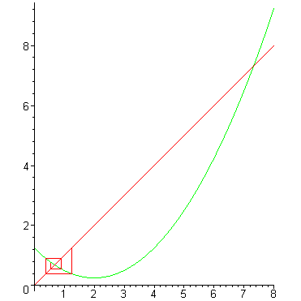

g) Determine the convergence or divergence of the series whose terms are defined recursively by the following:

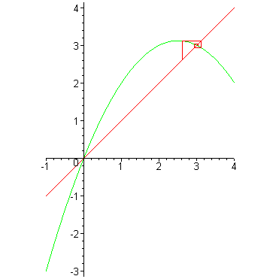

, so the series diverges by n^{th} term test.

