Right and Left-Hand Sums

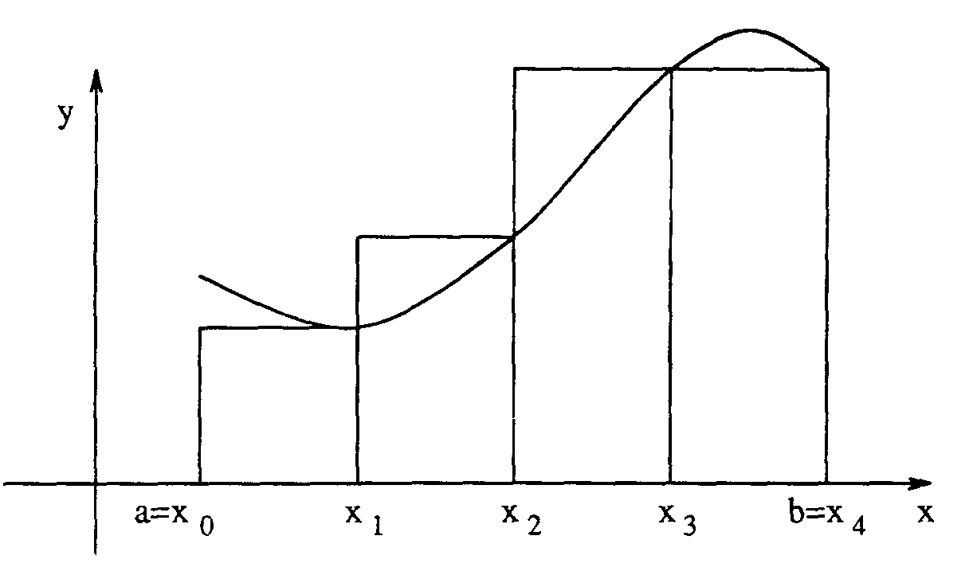

1. The figure above shows the graph of a function f (x) = -.1x³ + 1.25x² - 4.03x + 5.86 on the interval [1,7]. We want to write an expression for the sum of the areas of the four rectangles.

  - The four subintervals that form the bases of the rectangle along the x-axis all have the same length. This is called ∆x. What is the length? ______
  - If a = 1, what are the values of x₁, x₂, x₃, and x₄? Label each in the figure above.
  - What are the heights of the four rectangles? ______________________
  - Write an expression for the sum of the areas of the four rectangles and call the sum R(4). R(4) = ____________________________________________
  - Factor out the ∆x value.
R(4) = ____________________________________________
  - Evaluate this expression. __________

- In this section, we want to generalize the work in part 1 to obtain an expression for R(n), the sum of rectangular areas when the interval [a,b] is partitioned into n subintervals of equal length and the endpoint of each subinterval is used to determine the height of the rectangle above it.

  - If n is the number of subintervals, write an expression for ∆x in terms of a, b, and n. ∆x = _________
  - Write expression for x_{1,} x₂, x₃, and x₄ in terms of a, b, and n.
x₁ = a + ∆x = __________
x₂ = a + 2∆x = __________
x₃ = a + 3∆x = __________
x₄ = a + 4∆x = __________
  - The height of the rectangle on the left can be written in function notation as f (x₁) or$f\left(a+\frac{b−a}{n}\right)$. Write expressions for the following using f, a, b and n.
f (x₂) = ___________________
f (x₃) = ___________________
f (x₄) = ___________________
The general form for the height is f (x_{i}) = ___________________
  - Write the sum of the heights using summation notation.
$\sum_{i=1}^{n}{}$____________________________
  - The TI-89 calculator notation for summation operation:
∑(expression, variable, low, high) Example: ∑(1/x,x,1,5) for $\sum_{x=1}^{5}{\frac{1}{x}}$
Use calculator notation to express the sum in part d.
∑ ( ____________________________________________ )
If function f is put in the calculator in y₁, re-write the sum in terms of y₁.
∑ ( ____________________________________________ )
  - Using what you learned in part 1, write a calculator expression for R(n) using summation notation. R(n) = _________________________________________

3. We want to generalize a formula for the left-hand sum. Let L(n) denote the sum of rectangular areas when left-hand endpoints rather than right-hand endpoints are used to determine the heights of the rectangles.
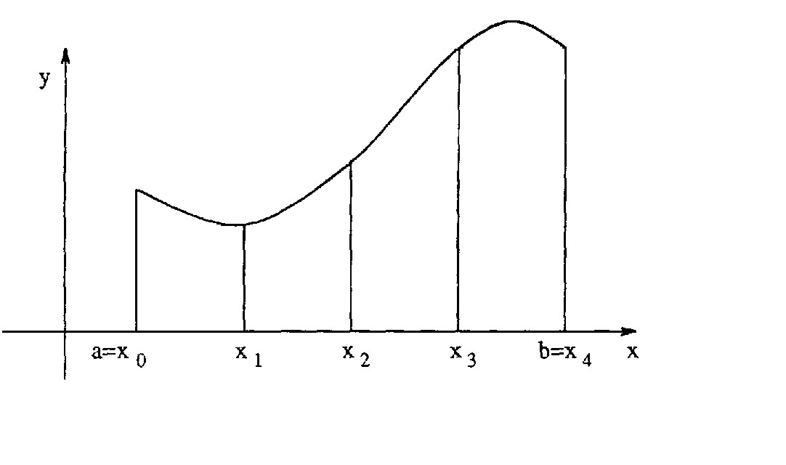
a. Add some details to the figure to illustrate the areas being summoned for L(4).
b. What modification in the expression for R(n) do you need to make to get the formula for L(n)? L(n) = ____________________________________________

4. In this section we will create a RHS and LHS function in your TI-89 calculator.

a. First put your function in y_{1.}
b. Functions like y₅(x) have one input variable x. x is called the argument. However, you can define a function to have more than one input (argument) as in
g(a,b,c) = a + 2b + c. The right-hand sum function (called ‘rhs’) that we will define has three arguments a (left endpoint), b (right endpoint), and n (number of subintervals). To define this function on your calculator:
- type ‘(b-a)/n*∑(y1(a+i*(b-a)/n),i,1,n)STO►rhs(a,b,n)’ then press ENTER
To define the left-hand sum function (called ‘lhs’) on your calculator:
- type ‘(b-a)/n*∑(y1(a+i*(b-a)/n),i,0,n-1) STO►lhs(a,b,n)’ then press ENTER
To edit a function:
- press APPS, Program Editor, Open, type (choose ‘function’), variable (choose ‘lhs’), ENTER, edit function, 2nd Quit

5. The functions rhs and lhs evaluate the expression on the right side of the equal sign using the supplied values a,b, and n.

a. To find the right-hand sum in part 1 using your calculator, type ‘rhs(1,7,4)’. Did you get the same value you obtained in part 1?
b. To find the left-hand sum, type ‘lhs(1,7,4)’.

6. What formula would you use for the midpoint-sum?

