A program for finding Riemann Sums

$y=\text{.}3(x+1)^{2}$ on [1,3] is graphed at right
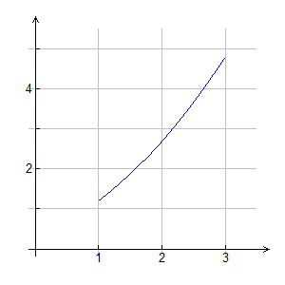
Shade the region between the curve and the
x-axis.

Approximate the area by using the
Riemann Sum Program

To Run the Program
Type function into $y_{1}$
Type rsum( ) into the entry line on the home screen

You will see
left | Left end point 1
right | Right end point 3
(0,1)  This is your $x_{i}$ choice | 0 is L Riemann Sum  1 is R Riemann Sum  0.5 is MidPt R. Sum  Any decimal in (0,1)  can be chosen
number | Number of partitions
sum | Answer is given

$$y=\text{.}3(x+1)^{2}$$

N | Left Sum | Right Sum | Mid Pt Sum | your $x_{i}$
10
50
100
250

N | Left Sum | Right Sum | Mid Pt Sum | your choice
10
50
100
250

Example: f(x) = __________________ [a,b] = [ ]
Example: f(x) = __________________ [a,b] = [ ]

N | Left Sum | Right Sum | Mid Pt sum | Your  Choice

Example: f(x) = _______________ [a,b] = [ ]
N | Left Sum | Right Sum | Mid Pt Sum | your  choice
N | Left Sum | Right Sum | Mid Pt sum | your  choice

Example: f(x) = ______________[a,b] = [ ]
]

