Powers  Fractions  Integers | Powers | Quadratic Equations  Parent Function:  General Form:  Standard Form:  Intercept Form:  Vertex:  Axis of Symmetry:  Quadratic Formula:  Graph  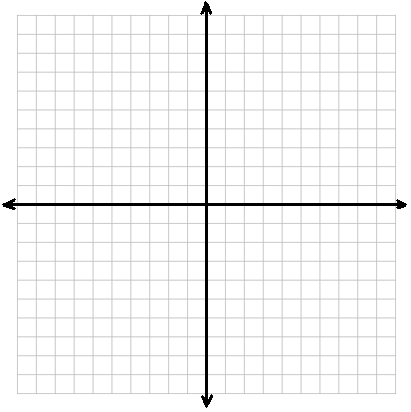 label 3 points  Inequality Meanings  Three ways to solve a system of equations  1.  2.  3.
 | Factorials
Linear Equations

Parent Function:

Standard Form:

Slope-Intercept Form:

Point-Slope Form:

Slope:

Graph
label 3 points
Order of Operations  1.  2.  3.  4.  Absolute Value  Function Definitions  Domain:  Range:  Function:  Direct Variation:  Indirect Variation:  Roots:  Distance Formula (physics)  Pythagorean Theorem | Properties (use a, b, c)  Commutative  Addition:  Multiplication:  Associative  Addition:  Multiplication:  Distributive:  Measures of Central Tendency  Mean:  Median:  Mode:  Range: | Distance Formula (between two points)  Midpoint Formula  Parallel and Perpendicular Lines  If  Parallel line slope:  Perpendicular line slope:  Dimensional Analysis  ()  Convert  Solve The System  x =  y =  Discriminant  Formula:  Nature of roots:  > 0  < 0  = 0
Piecewise Graph

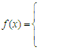
label 3 points

