Pythagorean Theorem:  Trigonometry:  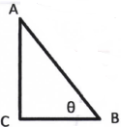  Parts of a Triangle:  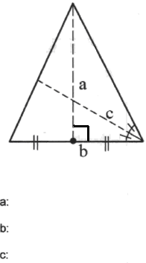  Similarity  Ratio of sides a:b  Ratio of perimeters  Ratio of areas  Ratio of volumes | Triangle Congruence:  1.  2.  3.  4.  5.  Transformations:  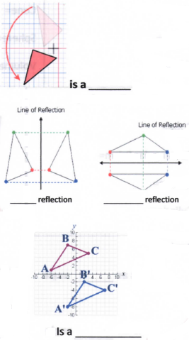  Logic  Conditional Statement:  Converse:  Inverse:  Contrapositive: | Perimeter Formulas:  Square:  Rectangle:  Circumference of a Circle:  Special Right Triangles:  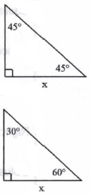  Parallel Lines:  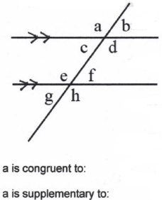
Area Formulas:  Square:  Rectangle:  Parallelogram:  Trapezoid:  Circle:  Right Triangle:  Any Triangle (Heron’s Formula):  Equilateral Triangle:  Regular Polygon:  Surface Area Formulas:  Cube:  Sphere:  Cylinder:  Angles:  is an _______ angle  is an ________ angle  Complementary angles add up to ____  Supplementary angles add up to ____ | Volume Formulas:  Cube:  Prism:  Cylinder:  Pyramid:  Cone:  Sphere:  Volume is measured in ____ units  Parts of a Circle:  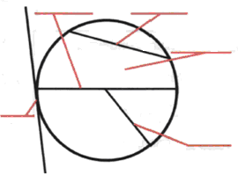  Polygon Interior Angle Sums:  Triangle:  Quadrilateral:  Regular Polygon:  Arc and Sector  Arc Length:  Sector Area:  Roots to Know: | Polygon Names:  Sides: Name:  3  4  5  6  7  8  9  10  Polygon Parts:  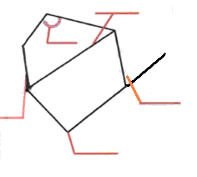  Lines:  