Even – Odd Functions  If is even, then  If is odd, then  Composite Functions  Triangles  Law of Cosines:  Law of Sines:  Values of Trigonometric  Functions for Common Angles  Know both the inverse trig and the trig values. E.g. tan⁻¹(1) | Trig Graph  Parametric Equations  Graph  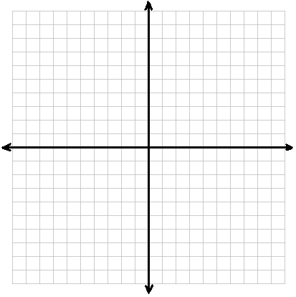  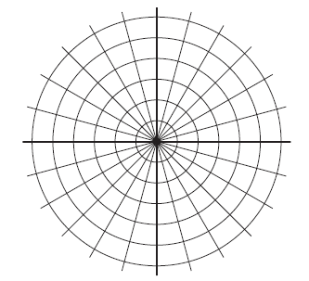  Polar Equations  Standard Formulas  Graph
  θ | sin θ | cos θ | tan θ
  0°
  π
Trig Identities  Double Angle  Power Reduction  Pythagorean  Reciprocal  Even/Odd | Trig Unit Circle  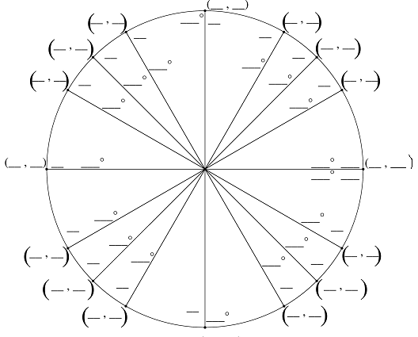  Vectors  Graph

Sequences and Series | Matrices
 |  | Synthetic Division
Perfect Squares

Perfect Cubes

Binomial Theorem

 | Decomposition of Fractions
 |  | Projectile Motion
Rational Functions

