Using Areas to find the centroid of a region.
1. Let R be the region bounded by the x-axis, the graph of , and the line x = 4.
(a) Find the area of the region R.

(b) Find the value of h such that the vertical line x = h divides the region R into two regions of equal area.

(c) Find the value of k such that the horizontal line y = k divides the region R into two regions of equal area.

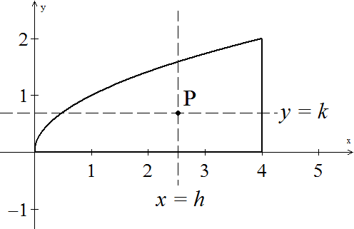
(d) The point P is called the centroid of the region and it should be the
perfect balancing point of the region. Write the coordinates of P.
displaying 5 decimal places.

Use the method on the front page to determine a centroid of one of the following regions and test your result.

- The region bounded by y = x² and y = x + 2

- The region bounded by the x-axis, x = 6 and y = ln(x)

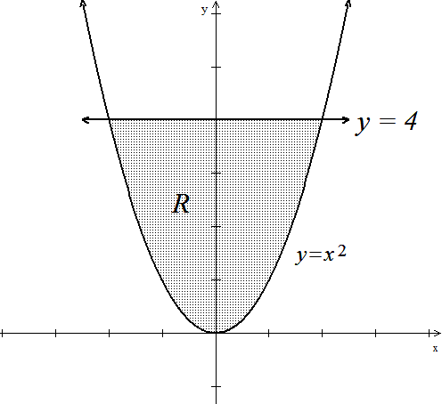

- The region R given in the diagram to the left.

- The region in the first quadrant below y = 1/x between x = 0.5 and x = 3.

- The region bounded by , y = 1 and x = 2.

