Matching the containers with side views and circular cross-sections. The height of the liquid in any container is an increasing function of the volume of the liquid. The graphs of these nine functions are given. Match each container with its graph.

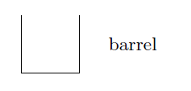 | 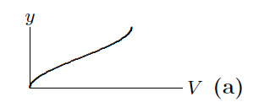 | I  As the volume increases, the height of the liquid increases at a constant rate followed by a slower constant rate.
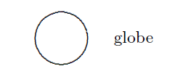 | 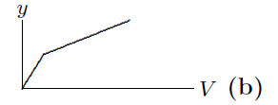 | II  As the volume increases, the height of the liquid increases at a constant rate followed by a decreasing rate.
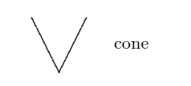 | 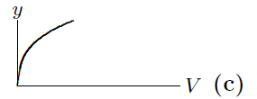 | III  As the volume increases, the height of the liquid increases at an increasing rate followed by a decreasing rate.
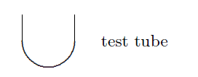 | 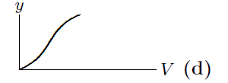 | IV  As the volume increases, the height of the liquid increases at an increasing rate followed by a constant rate.
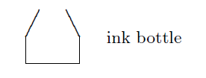 | 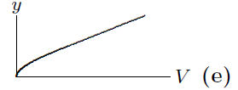 | V  As the volume increases, the height of the liquid increases at a constant rate followed by an increasing rate.
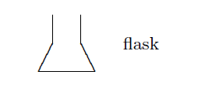 | 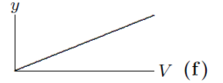 | VI  As the volume increases, the height of the liquid increases at a decreasing rate followed by a constant rate.
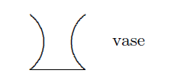 | 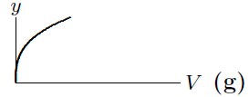 | VII  As the volume increases, the height of the liquid increases at a decreasing rate.
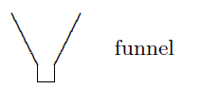 | 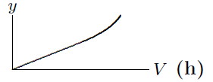 | VIII  As the volume increases, the height of the liquid increases at a decreasing rate followed by an increasing rate.
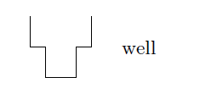 | 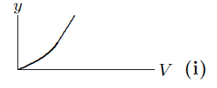 | IX  As the volume increases, the height of the liquid increases at a constant rate.

Table # ________
Names:
___________________________________
___________________________________
___________________________________
Name | Graph letter (a) thru (i) | Verbal roman numerals I thru IX
Barrel
Cone
Flask
Funnel
Globe
Ink Bottle
Test Tube
Vase
Well

Table # ________
Names:
___________________________________
___________________________________
___________________________________
Name | Graph letter (a) thru (i) | Verbal roman numerals I thru IX
Barrel
Cone
Flask
Funnel
Globe
Ink Bottle
Test Tube
Vase
Well

