Adjusting to the New AP Calculus
Curriculum Framework

L’Hopital’s Rule is coming! Should we panic? Keep calm and BC on!

#4 BC 2016 Operational Free Response

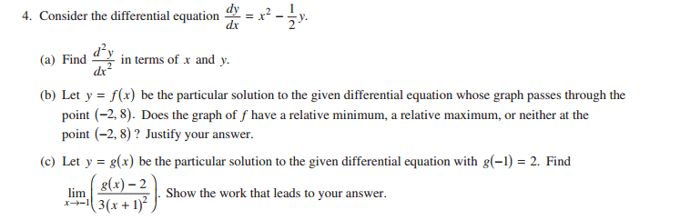

#5 BC 2013 Operational Free Response

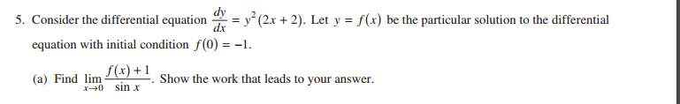

Inspired by #1 BC 2016 International Multiple Choice

$$\lim_{x→2}{\frac{x^{2}-4}{\sin\left(\frac{πx}{2}\right)}}$$

Inspired by #3 AB 2016 International Multiple Choice

$$\lim_{x→∞}{\frac{3x-4}{\sqrt{16x^{2}+1}}}$$

$$\lim_{x→-∞}{\frac{\sqrt{9x^{6}+2}}{x^{3}-1}}$$

Inspired by #3 AB 2008 International Multiple Choice

Identify all asymptotes for $y= \frac{5+ e^{x}}{1- e^{x}}$

Inspired by #88 BC 2016 International Multiple Choice (only 9% of BC students answered correctly!)

Find each of the following limits using the graph at left.

i) $\lim_{x→0}{f(2+ x^{2}})$

ii) $\lim_{x→0}{f(2- x^{2}})$

iii) $\lim_{x→0}{f(2+ x})$
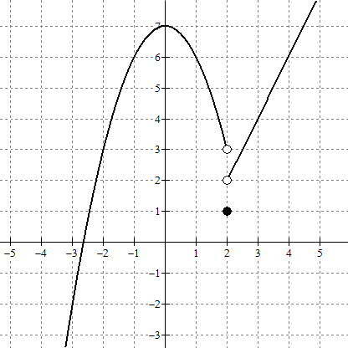
LO 3.2A Interpret the definite integral as the limit of a Riemann sum. Express the limit of a Riemann sum in integral notation.

Instructions: Match the integral expression in the left column with the appropriate limit of a Riemann sum in the right column.

1. ${\int_{1}^{3}{(4x}}^{2}+2) dx$ _____ a. $\lim_{n→∞}{\sum_{j=1}^{n}{ }}\left[4\left(5-\frac{3j}{n}\right)-2 \right]\left(\frac{-3}{n}\right)$

2. ${\int_{2}^{5}{(x}}^{3}+1) dx$ _____ b. $\lim_{n→∞}{\sum_{j=1}^{n}{ }}\left[4{\left(2+\frac{3j}{n}\right)}^{2}+2 \right]\left(\frac{3}{n}\right)$

3. $\int_{7}^{5}{(3x+1) dx}$ _____ c. $\lim_{n→∞}{\sum_{j=1}^{n}{ }}\left[{\left(2+\frac{3j}{n}\right)}^{3}+1 \right]\left(\frac{3}{n}\right)$

4. ${\int_{2}^{4}{(4x}}^{2}+2) dx$ _____ d. $\lim_{n→∞}{\sum_{j=1}^{n}{ }}\left[4{\left(1+\frac{2j}{n}\right)}^{2}+2 \right]\left(\frac{2}{n}\right)$

5. $\int_{5}^{2}{(4x-2) dx}$ _____ e. $\lim_{n→∞}{\sum_{j=1}^{n}{ }}\left[3\left(7-\frac{2j}{n}\right)+1 \right]\left(\frac{-2}{n}\right)$

6. ${\int_{2}^{5}{(4x}}^{2}+2) dx$ _____ f. $\lim_{n→∞}{\sum_{j=1}^{n}{ }}\left[4{\left(3-\frac{2j}{n}\right)}^{2}+2 \right]\left(\frac{–2}{n}\right)$

7. $\int_{5}^{7}{(4x-2) dx}$ _____ g. $\lim_{n→∞}{\sum_{j=1}^{n}{ }}\left[3\left(2+\frac{3j}{n}\right)+1 \right]\left(\frac{3}{n}\right)$

8. ${\int_{3}^{1}{(4x}}^{2}+2) dx$ _____ h. $\lim_{n→∞}{\sum_{j=1}^{n}{ }}\left[4\left(5+\frac{2j}{n}\right)-2 \right]\left(\frac{2}{n}\right)$

9. ${\int_{5}^{7}{(x}}^{3}+1) dx$ _____ i. $\lim_{n→∞}{\sum_{j=1}^{n}{ }}\left[{\left(5+\frac{2j}{n}\right)}^{3}+1 \right]\left(\frac{2}{n}\right)$

10. $\int_{2}^{5}{(3x+1) dx}$ _____ j. $\lim_{n→∞}{\sum_{j=1}^{n}{ }}\left[4{\left(2+\frac{2j}{n}\right)}^{2}+2 \right]\left(\frac{2}{n}\right)$

LO 3.2A Interpret the definite integral as the limit of a Riemann sum. Express the limit of a Riemann sum in integral notation.

Instructions: Fill in the missing integral expression in the left column or the appropriate limit of a Riemann sum in the right column.

1. ${\int_{1}^{3}{(4x}}^{2}+2) dx$ ________________________________

2. __________________ $\lim_{n→∞}{\sum_{j=1}^{n}{ }}\left[4{\left(2+\frac{3j}{n}\right)}^{2}+2 \right]\left(\frac{3}{n}\right)$

3. $\int_{7}^{5}{(3x+1) dx}$ ________________________________

4. __________________ $\lim_{n→∞}{\sum_{j=1}^{n}{ }}\left[4{\left(2+\frac{2j}{n}\right)}^{2}+2 \right]\left(\frac{2}{n}\right)$

5. $\int_{5}^{2}{(4x-2) dx}$ ________________________________

6. __________________ $\lim_{n→∞}{\sum_{j=1}^{n}{ }}\left[4{\left(3-\frac{2j}{n}\right)}^{2}+2 \right]\left(\frac{–2}{n}\right)$

7. $\int_{5}^{7}{(4x-2) dx}$ ________________________________

8. __________________ $\lim_{n→∞}{\sum_{j=1}^{n}{ }}\left[3\left(2+\frac{3j}{n}\right)+1 \right]\left(\frac{3}{n}\right)$

9. ${\int_{5}^{7}{(x}}^{3}+1) dx$ ________________________________

10. __________________ $\lim_{n→∞}{\sum_{j=1}^{n}{ }}\left[{\left(2+\frac{3j}{n}\right)}^{3}+1 \right]\left(\frac{3}{n}\right)$

Integration Techniques

In each of the pairs of similar problems below, one of the problems can be solved using a u-substitution and the other can be solved using an algebraic manipulation to re-write the integrand. Determine the necessary technique and find each integral.

1. A. $\int{x^{2}}{\left(x^{3}+1\right)}^{2}dx$ B. $\int{x{\left(x^{3}+1\right)}^{2}}dx$

2. A. $\int{\frac{x}{x^{2}+5 }}dx$ B. $\int{\frac{1}{x^{2}+ 4x+ 5 }}dx$

3. A. $\int{\frac{x^{2}+ 4x+ 5}{x+2 }}dx$ B. $\int{\frac{x+2}{x^{2}+ 4x+ 5 }}dx$

4. A. $\int{\frac{1}{\sqrt{4x- x^{2}-3}}}dx$ B. $\int{\frac{2-x }{\sqrt{4x- x^{2}-3}}}dx$

5. A. $\int{x {\left(3x-1\right)}^{2}}dx$ B. $\int{x {\left(3x^{2}-1\right)}^{8}}dx$

6. A. $\int{\frac{x^{2}}{x^{3}+1 }}dx$ B. $\int{\frac{x^{3}+1}{x^{2} }}dx$

