What Can Be Learned From A Close Examination
of the Samples Posted at AP Central?

http://apcentral.collegeboard.com/apc/public/repository/ap-calculus-course-description.pdf

- Yes! That is tested! But, maybe not in the way you taught it.

BC Sample
BC Sample
- Students should be able to apply derivative rules in a broad range of situations and to “generic” functions.

BC Sample

The two worksheets that follow were originally written in response to a free response question #3 on the 2007 exam.
Demonstrating knowledge of derivative rules: first semester

Let f(x), g(x), and h(x) be twice differentiable functions of x with the values as given in the table below.
x | g(x) | g’(x) | h(x) | h’(x)
-3 | 1 | 3 | 5 | 4
4 | -3 | 2 | 6 | -5
6 | 4 | 7 | -1 | 10

- Find f’(4) for each of the following:

  - f(x) = [ h(x) ]³

  - f(x) = g(x) + h(x)

  - f(x) = g(x) h(x)

  - f(x) = g(x) / h(x)

  - f(x) = g(x) - h(x)

  - f(x) = g(h(x))

  - f(x) = [g(x)]²

  - f(x) = h(g(x))

2. Find d/dx [g⁻¹(x)] at x = -3.

- Let f(x) = x²g(x). Write the equation of a line tangent to f(x) at x = 4.

4. Let f(x) = h(g(x)) + 6x. Write the equation of a line tangent to f(x) at x = 6.

ANSWERS:

- Find f’(4) for each of the following:

  - f(x) = [ h(x) ]³ -540

  - f(x) = g(x) + h(x) -3

  - f(x) = g(x) h(x) 27

  - f(x) = g(x) / h(x) -1/12

  - f(x) = g(x) - h(x) 7

  - f(x) = g(h(x)) -35

  - f(x) = [g(x)]² -12

  - f(x) = h(g(x)) 8

2. Find d/dx [g⁻¹(x)] at x = -3. ½

- Let f(x) = x²g(x). Write the equation of a line tangent to f(x) at x = 4.

y + 48 = 8(x – 4)

4. Let f(x) = h(g(x)) + 6x. Write the equation of a line tangent to f(x) at x = 6.

y – 42 = -29(x – 6)

Demonstrating knowledge of derivative rules: second semester

Let g(x), h(x), and f(x) be twice-differentiable functions of x with values as given in the table below.
x | g(x) | g’(x) | h(x) | h’(x)
-2 | 4 | 3 | 2 | 8
3 | 5 | -4 | -2 | 7
5 | 1 | -1 | 3 | 6

- Find f’(3) for each of the following:
  - f(x) = g(x) / h(x)

  - f(x) = h(x) – g(x)

  - f(x) = h(g(x))

  - f(x) = [h(x)]⁴

  - f(x) = g(x) h(x)

  - f(x) = h(x) / g(x)

  - f(x) = g(h(x))

  - f(x) = [g(x)]³

2. Find d/dx [g⁻¹(x)] at x = 5.

- Let f(x) = g(h(x))
  - Is there a point c, 3 < c < 5, such that f(c) = 9/2? Explain.

  - Is there a point c, 3 < c < 5, such that f ’(c) = ½? Explain.

c. Is there a point c, 3 < c < 5, such that f ”(c) = -45/2. Explain.
ANSWERS:

- Find f’(3) for each of the following:
  - f(x) = g(x) / h(x) -27/4

  - f(x) = h(x) – g(x) 11

  - f(x) = h(g(x)) -24

  - f(x) = [h(x)]⁴ -224

  - f(x) = g(x) h(x) 43

  - f(x) = h(x) / g(x) 27/25

  - f(x) = g(h(x)) 21

  - f(x) = [g(x)]³ -300

2. Find d/dx [g⁻¹(x)] at x = 5. -1/4

- Let f(x) = g(h(x))
  - Is there a point c, 3 < c < 5, such that f(c) = 9/2? Explain.
Yes, f(3) = 4 and f(5) = 5. Since f(x) is differentiable, it is also continuous and the Intermediate Value Theorem applies which guarantees that the function will pass through all y-values between 4 and 5.

  - Is there a point c, 3 < c < 5, such that f ’(c) = ½? Explain.
Yes, since f(x) is continuous and differentiable, the Mean Value Theorem guarantees the existence of a point c, such that
f ’(c) = (f(5) – f(3))/ (5-3) = ½

c. Is there a point c, 3 < c < 5, such that f ”(c) = -45/2. Explain.
Yes, since f(x) is twice differentiable, then the Mean Value Theorem
guarantees a point c, such that (f’(5) – f’(3))/(5-3) = f”(c).

- The relationships between $f$, $f^{'}$and $f^{''}$tell us something about relative sizes of tangent line approximations.

This was also tested on 2008 released exam.
90 | The function f is continuous on the closed interval [2, 4] and twice differentiable on the open interval  (2, 4). If f ‘(3) = 2 and f ‘’ (x) < 0 on the open interval (2, 4), which of the following could be a table of values for f?
  AAAAAAAAAA | BBBBBBBBBBB | CCCCCCCCCCC | DDDDDDDDDD | EEEEEEEEEEEE
    x | f(x)
    2 | 2.5
    3 | 5
    4 | 6.5
    x | f(x)
    2 | 2.5
    3 | 5
    4 | 7
    x | f(x)
    2 | 3
    3 | 5
    4 | 6.5
    x | f(x)
    2 | 3
    3 | 5
    4 | 7
    x | f(x)
    2 | 3.5
    3 | 5
    4 | 7.5

- Even an old dog like motion can learn some new tricks!

The form B exam also tries to get our attention:
- That idea of overlapping intervals is something that should have already been on our radar IF we are studying the BC exams.

The question below is from the 2008 BC exam.

- Speaking of old dogs, how about a good optimization problem or two? (Both of these are BC samples over AB material.)
- Now, that we are thinking about applications of integration, let’s talk about average value problems.

f(x) = x^{1/2} [0,4]

For what value of k will the function given above have an average value of 1 on the closed interval [0,k]?

f(x) = e^{x} [-1,2]

For what value of k will the function given above have an average of 4 on the closed interval [-1,k]?
8. There is not a person in this room who emphasizes Riemann sums sufficiently or in this particular way.

1. Area of the region between the graphs of $y=x^{2}$ and $y=2x$ | 6. Area of the region enclosed by the x-axis, $y=\frac{1}{2}x$, and $x=4$
2. Volume of the solid formed by revolving the region enclosed by $y=x^{2}$ and $y=2x$ about the x-axis | - Volume of the solid formed by revolving the region enclosed by the x-axis, $y=\frac{1}{2}x$, and $x=4$about the x-axis
- Volume formed by the solid with base enclosed by the graphs of $y=x^{2}$ and $y=2x$ with square cross-sections perpendicular to the x-axis | 8. Volume formed by the solid with base enclosed by the x-axis, $y=\frac{1}{2}x$, and $x=4$ with semi-circular cross sections perpendicular to the y-axis
- Volume of the solid formed by revolving the region enclosed by $y=x^{2}$ and $y=2x$ about the y-axis | - Volume formed by revolving the region enclosed by the x-axis, $y=\frac{1}{2}x$, and $x=4$about the y-axis
- Volume formed by the solid with base enclosed by the graphs of $y=x^{2}$ and $y=2x$ with semi-circular cross-sections perpendicular to the x-axis | - Volume formed by revolving the region enclosed by the x-axis, $y=\frac{1}{2}x$, and $x=4$about the line $x=4$

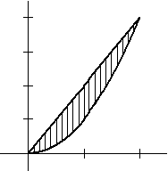  G  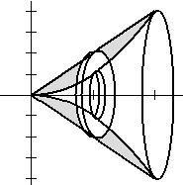 | 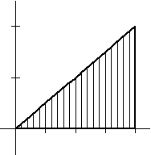  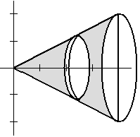C
J  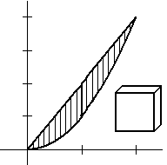 | I
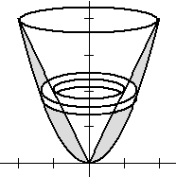  A | 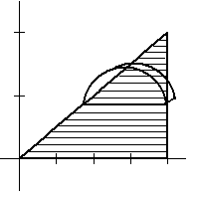  H
D  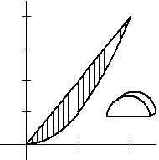 | 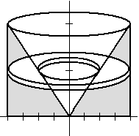  B
F | 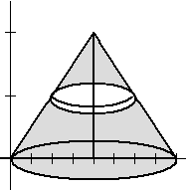  E

d) $\sum_{i=1}^{n}{\frac{2}{n}}\left(\frac{4i}{n}−{\left(\frac{2i}{n}\right)}^{2}\right)$ | h) $\sum_{i=1}^{n}{\frac{4}{n}\left[\frac{2i}{n}\right]}$
g) $π\sum_{i=1}^{n}{\frac{2}{n}\left[4{\left(\frac{2i}{n}\right)}^{2}−{\left(\frac{2i}{n}\right)}^{4}\right]}$ | a) $π\sum_{i=1}^{n}{\frac{4}{n}\left[\frac{4i^{2}}{n^{2}}\right]}$
b) $\sum_{i=1}^{n}{{\frac{2}{n}\left[\frac{4i}{n}−\frac{4i^{2}}{n^{2}}\right]}^{2}}$ | j) $\frac{π}{8}\sum_{i=1}^{n}{\frac{2}{n}}{\left(4−\frac{4i}{n}\right)}^{2}$
e) $π\sum_{i=1}^{n}{\frac{4}{n}\left[\frac{4i}{n}−\frac{4i^{2}}{n^{2}}\right]}$ | i) $π\sum_{i=1}^{n}{\frac{2}{n}\left[\text{16}−\frac{\text{16}i^{2}}{n^{2}}\right]}$
f) $\frac{π}{8}\sum_{i=1}^{n}{\frac{2}{n}}{\left(\frac{4i}{n}−\frac{4i^{2}}{n^{2}}\right)}^{2}$ | c) $π\sum_{i=1}^{n}{{\frac{2}{n}\left[4−\frac{4i}{n}\right]}^{2}}$

iii) $\int_{0}^{2}{2x−x^{2}\text{dx}}$ | ix) $\int_{0}^{4}{\frac{1}{2}\text{xdx}}$
v) $π\int_{0}^{2}{4x^{2}−x^{4}\text{dx}}$ | i) $π\int_{0}^{4}{\frac{1}{4}x^{2}\text{dx}}$
x) $\int_{0}^{2}{{\left[2x−x^{2}\right]}^{2}\text{dx}}$ | vii) $\frac{π}{8}\int_{0}^{2}{{\left(4−2y\right)}^{2}\text{dy}}$
viii) $π\int_{0}^{4}{y−\frac{y^{2}}{4}\text{dy}}$ | ii) $π\int_{0}^{2}{4^{2}−4y^{2}\text{dy}}$
vi) $\frac{π}{8}\int_{0}^{2}{{\left(2x−x^{2}\right)}^{2}\text{dx}}$ | iv) $π\int_{0}^{2}{{\left(4−2y\right)}^{2}\text{dy}}$

Answer Sheet for Matching

Description | Graph/Sketch | Reimann Sum | Definite Integral
1

2

3

4

5

6

7

8

9

10

Answer Key for Matching

Description | Graph/Sketch | Reimann Sum | Definite Integral
1 | G | d | iii
2 | J | g | v
3 | A | b | x
4 | D | e | vii
5 | F | f | vi
6 | C | h | ix
7 | I | a | i
8 | H | j | vii
9 | B | i | ii
10 | E | C | iv

9. There a ton of interesting applications that we should include.
Population Density Problems

A city located beside a river has a rectangular boundary as shown in the figure at right. The population density of the city at any point along a strip x miles from the river’s edge is f (x) persons per square mile. Which of the following expressions gives the population of the city?  (A) (B) (C)  (D) (E)  2008 AB released exam #92 | 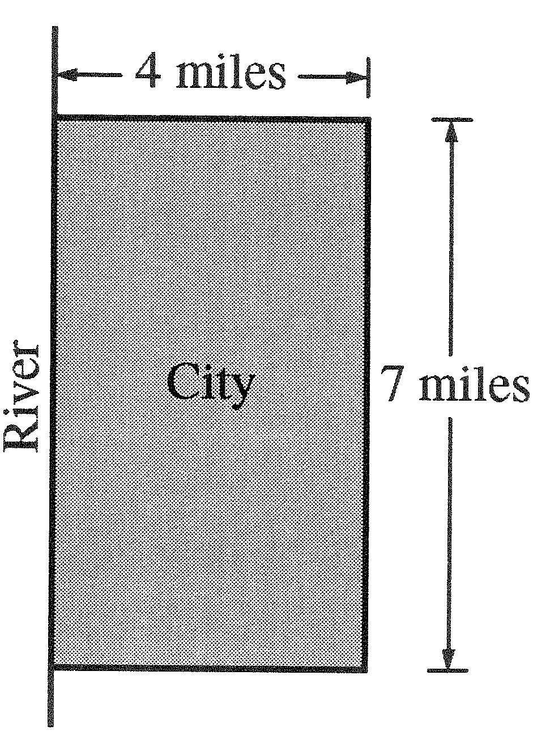

- (FDWK) Population density measures the number of people per square mile inhabiting a given living area. The population density of a certain city decreases as you move away from the center of the city. The density at a distance r miles from the city center can be approximated by the function 10000(2 – r).
  - If the population density tails off to zero at the edges of the city, what is the city radius?
  - A thin ring of area around the center of the city has thickness ∆r and radius r. If the ring is straightened out, it becomes a rectangular strip. What is the area of this region?
  - Explain why the population of the ring in part b is given by
10000(2-r)(2πr) ∆r.
  - Find the total population of the city by setting up and evaluating a definite integral.

- (Hughes-Hallett) The density of cars (in cars per mile) down a 20-mile stretch of the Pennsylvania Turnpike can be approximated by
$ρ(x)=\text{300}(2+\text{sin}(4\sqrt{x+0\text{.}\text{15})})$,
where x is the distance in miles from the Breezewood toll plaza.
- Sketch a graph of this function for 0 < x < 20.
- Write a sum that approximates the total number of cars on this 20-mile stretch.
- Find the total number of cars on the 20-mile stretch.

- (Hughes-Hallett) The density of oil in a circular oil slick on the surface of the ocean at a distance r meters from the center of the slick is given by $ρ(r)=\frac{\text{50}}{1+r}$ kg/m².
  - If the slick extends from r = 0 to r = 10,000 m, find a Riemann sum approximating the total mass of oil in the slick.
  - Find the exact value of the mass of oil in the slick by turning your sum into an integral and evaluating it.
  - Within what distance r is half the oil of the slick contained?

- (Hughes-Hallett) Suppose you want to find the total mass of a 3 x 5 rectangular sheet, whose density per unit area at a distance x from one of the sides of length 5 is $\begin{aligned}\frac{1}{1+x^{4}}\text{.} \\ \end{aligned}$
  - Find a Riemann sum which approximates the total mass.
  - Find the mass to one decimal place.

- The soot produced by a garbage incinerator spreads out in a circular pattern. The depth H(r), in millimeters, of the soot deposited each month at a distance r kilometers from the incinerator is given by H(r)=0.115e^{-2r}.
  - Write a definite integral giving the total volume of soot deposited within 5 kilometers of the incinerator each month.
  - Evaluate the integral you found in part a, giving your answer in cubic meters.

- A sample of mold growing in a laboratory spreads out in a circular pattern. The density of mold spores is approximated by 1000(20-t), where t is the distance from the center of the mold sample, measured in millimeters.
  - What is the radius of the mold sample?
  - Write a definite integral that approximates the total number of mold spores in the mold sample.
  - Evaluate the integral from part b.
10. All AP Calculus teachers are familiar with the Fundamental Theorem of Calculus,
$\int{F^{'}(x)\text{dx}=F(b)−F(a)}$

But how many of us emphasize this as the Total Change Theorem ala Stewart?

Say this with me, “ “

Now, let’s look at some problems.

2003 AB released exam #84. A pizza, heated to a temperature of 350 degrees Fahrenheit, is taken out of an oven and placed in a 75○ F room at t = 0 minutes. The temperature of the pizza is changing at a rate of -110e^{-0.4t} degrees Fahrenheit per minute. To the nearest degree, what is the temperature of the pizza at time t = 5 minutes?
A) 112○ F B) 119○ F C) 147○ F D) 238○ F E) 335○ F

2003 AB released exam #91 A particle moves along the x-axis so that at any time t>0, its acceleration is given by a(t) = ln (1 + 2^{t}). If the velocity of the particle is 2 at time t = 1, then the velocity of the particle at time t = 2 is
A) 0.462 B) 1.609 C) 2.555 D) 2.886 E) 3.346

Wouldn’t it make sense to teach a variation on FTC,
$F(a)+\int{F^{'}(x)\text{dx}=F(b)}$
And have students interpret this as “initial value plus change in value equals new value?”

- There is no way I will get to this last page, but if a miracle occurs, I want to draw attention to the 2nd FTC.

