Before the Lesson - Taylor Polynomials

1. Write a series for each sequence using sigma notation.
a) 2, 7, 12, 17,…
b) 5, 15, 45, 135,…
c) 3, 1.2, 0.48, 0.192, …
Find the sum when possible.
What is the significant idea in being able to find the sums above?

2. Write f and g as functions of x that represent the values in the table.
x | 1 | 2 | 3 | 4
f | 2 | 7 | 12 | 17
g | 2 | 7 | 13 | 20

3. Consider the initial value problem $y^{'}=3−y, y(0)=1\text{.}$
a) Use Euler’s method with 4 steps to estimate $y(1)\text{.}$
b) Sketch the slope field for this differential equation in the first quadrant, and use it to decide if your estimate in an over or underestimate.
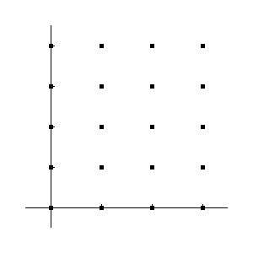
5. Write a tangent line approximation for each.
a) g(x) = 3x² + 2x + 1 at x = 0
b) f (x) = cos x at x = 0

Write the formula for finding a tangent line approximation for function h at x = 0.

