Match the slope fields with their differential equations.
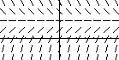
(A) (B)
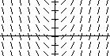

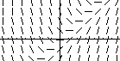
(C) (D)
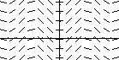

7. 8. 9. 10.
____________________________________________________________________________
Match the slope fields with their differential equations.
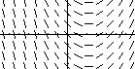
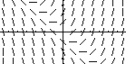
(A) (B)

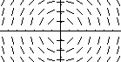
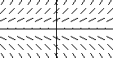
(C) (D)

11. 12. 13. 14.
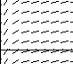
_____________________________________________________________________________
15. (From the AP Calculus Course Description)

The slope field from a certain differential equation is shown above. Which of the following
could be a specific solution to that differential equation?
(A) (B) (C) (D) (E)

16.
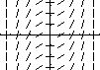
The slope field for a certain differential equation is shown above. Which of the following could be a specific solution to that differential equation?
(A) (B) (C) (D) (E)
______________________________________________________________________________
17. Consider the differential equation given by .
(a) On the axes provided, sketch a slope field for the given differential equation.
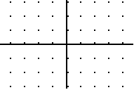
(b) Let f be the function that satisfies the given differential equation. Write an equation for the
tangent line to the curve through the point (1, 1). Then use your tangent line
equation to estimate the value of
(c) Find the particular solution to the differential equation with the initial
condition . Use your solution to find .
(d) Compare your estimate of found in part (b) to the actual value of found in
part (c). Was your estimate from part (b) an underestimate or an overestimate? Use your
slope field to explain why.
______________________________________________________________________________
18. Consider the differential equation given by .
(a) On the axes provided, sketch a slope field for the given differential equation.

(b) Sketch a solution curve that passes through the point (0, 1) on your slope field.
(c) Find the particular solution to the differential equation with the initial
condition .
(d) Sketch a solution curve that passes through the point on your slope field.
(e) Find the particular solution to the differential equation with the initial
condition .
19. Consider the differential equation given by .

(a) On the axes provided, sketch a slope field for the given differential equation.
(b) Sketch a solution curve that passes through the point (0, 1) on your slope field.
(c) Find . For what values of x is the graph of the solution concave
up? Concave down?
____________________________________________________________________________
20. Consider the logistic differential equation ;
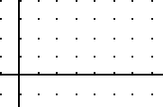
(a) On the axes provided, sketch a slope field for the given differential equation.

(b) Sketch a solution curve that passes through the point (4, 1) on your slope field.
(c) Show that satisfies the given differential equation.
(d) Find by using the solution curve given in part (c).
(e) Find . For what values of y, 0< y < 2, does the graph of have an
inflection point?
_____________________________________________________________________________
21. (a) On the slope field for , sketch three
solution curves showing different types of behavior
for the population P.
(b) Is there a stable value of the population? If so, what is it?
(c) Describe the meaning of the shape of the solution curves
for the population: Where is P increasing? Decreasing?
What happens in the long run? Are there any inflection
points? Where? What do they mean for the population?
(d) Sketch a graph of against P. Where is positive?
Negative? Zero? Maximum? How do your observations
about explain the shapes of your solution curves?
(Problem 21 is from Calculus (Third Edition) by Hughes-Hallett, Gleason, et al)

