LOCAL LINEARITY: SEEING MAY BE BELIEVING

A function f is said to be linear over an interval if the difference quotient
is constant over that interval. Although few functions (other than linear functions) are linear over an interval, all functions that are differentiable at some point where x =c are well-modeled by a unique tangent line in a neighborhood of c and are thus considered locally linear. Local linearity is an extremely powerful and fertile concept.

Most students feel comfortable finding or identifying the slope of a linear function. Most students understand that a linear function has a constant slope. Our goal should be to build on this knowledge and to help students understand that most of the functions they will encounter are "nearly linear" over very small intervals; that is most functions are locally linear. Thus, when we "zoom in" on a point on the graph of a function, we are very likely to "see" what appears to be a straight line. Even more important, we want them to understand the powerful implications of this fact!

The Derivative

If shown the following graph and asked to write the rule, most students will write f(x) = x. This shows some good understanding, but not enough skepticism.

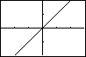

If the viewing window [-.29,.29] x [-.19,.19] were known, some students might actually question whether enough is known to conjecture about the function presented.

In the viewing window [-4,4] x [-2,2], a very different graph is observed:

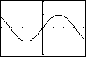
As teachers, we understand that the first window gets at the idea of local linearity (in the neighborhood of x = 0) of the differentiable function we see in the second window. In fact, the two windows are also supportive of an important limit result: $\underset{x→0}{\text{lim}}\frac{\text{sin}x}{x}=1$! Our ultimate goal, however, is to have students come upon at least an intuitive understanding of the formal definition of the derivative of a function f for themselves. They should be able to say "of course" rather than question "What IS that?" when presented with that formal definition. It is technology that makes this approach possible, and that helps students understand the concept of derivative rather than merely memorizing some obscure (to them) notation.

Technology to the Rescue:
Discovering local linearity of common functions

Start with a simple non-linear function, say . Select an integer x-value and have students “zoom-in” on that point on the graph until they “see” a line in their viewing window. Ask them to use some method to estimate the slope of the “line” and be ready to describe their process. Most will pick two nearby points and use the slope formula. If they have done as instructed, they should all be finding a slope value very nearly the same. If not, ask them to work in small groups until everyone has agreed on some common reasonable estimate. This will allow them to check their method and become comfortable with the technology.

Next, assign pairs of students their own, personal x-coordinate. In fact, if the class is small, you might assign two or more x-coordinates to each pair. Be sure the assign both positive and negative x-coordinates within an interval, say [-4,4]. Most of the assigned values will be given in tenths. Make a table of results (either on the board or using the statistics capabilities of your overhead calculator). The class should discover on their own that there appears to be a predictable relationship between the x-coordinate and the resulting slope. In fact, they are likely to make a conjecture about the general derivative function without even realizing what they are doing.

This conjecture can be confirmed using the difference quotient and an intuitive idea of limit as follows: If a student group was assigned the x-value of , then they would have predicted the slope of a line containing the point . When they zoomed in, a nearby coordinate might have been (x, x²). Thus, their predicted slope would have been which can be easily simplified to . If x is “very close” to in value, then the predicted slope should have almost !

Linear Approximation

In the Pre-technological Age, linear approximation was a useful evaluation tool. To students today, it may seem like a historic lodestone around their neck. They can just imagine a teacher thinking, "I had to do this, so you will too!" This topic should be presented as a first (and perhaps primitive step) toward what we know as Taylor Polynomials. In fact, many of us may decide to acquaint our AB as well as BC students with the idea of quadratic or cubic approximations as well. Whether we do so or not, the notion of using lines to model the behavior of a function in a small neighborhood of some domain value at which the function is differentiable, should be clear to those students who have developed the concept of local linearity. Within the following actual free response questions, we find many applications of local linearity that should “be obvious” to students who truly understand the derivative of a function at a particular point.

1998 AB4

Let be a function with such that for all points on the graph of the slope is given by .
- Find the slope of the graph of at the point where .
- Write an equation for the line tangent to the graph of at and use it to approximate .
- Find by solving the separable differential equation with the initial condition .
- Use your solution from part (c) to find .

Instantaneous Rate of Change

The new course description includes "instantaneous rate of change as the limit of average rate of change.” Many students find it helpful to understand instantaneous rate as what a policeman's radar gun approximates. The radar gun actually reads two positions of the vehicle over an extremely small interval of time and generates the average rate of change on that tiny interval of time. Thus local linearity once again comes to the rescue and allows us to model the situation in such a way as to help us (and the policeman) see a constant rate where there may be none. The definition of instantaneous rate of change becomes obvious.

1998 - AB 3
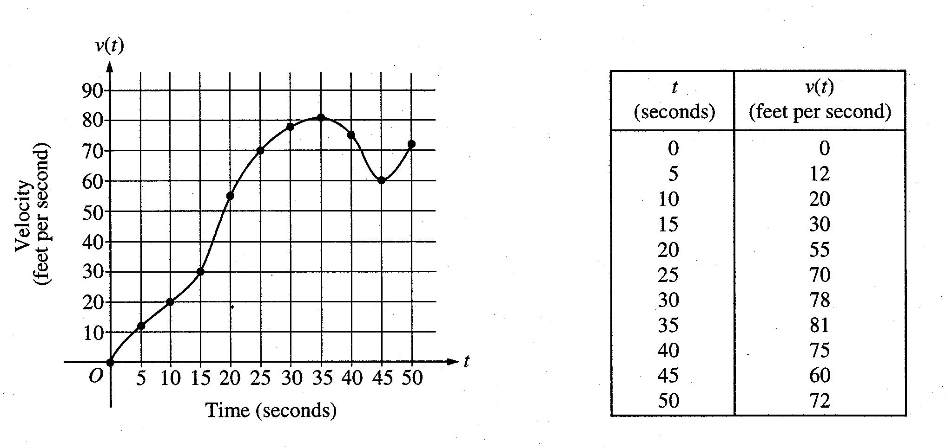

The graph of the velocity , in , of a car traveling on a straight road, for , is shown above. A table of values for , at 5 second intervals of time t, is shown to the right of the graph.

(a) During what intervals of time is the acceleration of the car positive? Give a reason for your answer.

(b) Find the average acceleration of the car, in , over the interval .

(c) Find one approximation for the acceleration of the car, in , at . Show the computations you used to arrive at your answer.

- Approximate with a Riemann sum, using the midpoints of five subintervals of equal length. Using correct units, explain the meaning of this integral.

Differential Equations and Slope Fields

The AB and BC syllabi now include finding solutions of variable separable differential equations, and we will come back to this topic later. Effective with the 2004 Examinations, the topic of slope fields (now only in the BC syllabus) will become a part of the AB syllabus. We can begin to set the stage for a more thorough look at slope fields and differential equations early in the year.

A Slope field (sometimes called a directional field) is used to give us insight into the graphical behavior of a function by looking at its rate of change (derivative) function. For example, consider the differential equation given by . That is, for some function , y is changing (with respect to x) at a rate that is directly proportional to x itself, and the constant of proportionality is 2. Suppose we know that . We could use the fact that for , to find that the slope of at x = 1 is 2. We could then write the equation for the line tangent to the graph of at x = 1 as .
In fact, we could graph a small piece of the line tangent to at (1,4) and “see” the behavior of near this point.

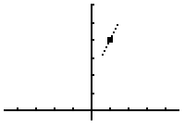

Of course, we know that is not linear because its rate of change function is not constant, but we get a glimpse of based on local linearity. Given ONLY the differential equation , we do not know particular values of , but we can “see” the behavior of the graph by creating an entire slope field .

First, complete the table below for this differential equation.

x
-3
-2
-1
0
1
2
3

Next, transfer the information above to the grid below showing little portions of the tangent line at each of the indicated points. After doing so, can you begin the get a sense of the family of functions whose derivative is ?

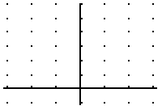

We will return to the exploration of slope fields later, but for now, notice that here is just one more powerful application of local linearity!

Definitive? Definitions

Definition: Let a function be defined on some interval I. We say that f is increasing on I provided that for all , if , then .

Properties contributed by Theorems of Calculus:

- If for all , then is increasing on I.
Note: This theorem of calculus does not say that is a requirement for to be increasing on I. The theorem only speaks to what happens if . Another way to look at this is that the inverse of a conditional statement is not necessarily true.

- If at each point and if is continuous on and differentiable on , then is increasing on .

Clarifying Examples:

- Given ; increases on even though .
- Given ; increases on and on . Note: Many textbooks/mathematicians say that this function “is an increasing function” (meaning that increases on its discrete domain intervals). However, the domain for this function is , and is not increasing on its domain.

- Given the following function

increase on even though does not exist.

- Given ; decreases on and increases on .
Note: is decreasing at each point of and increasing at each point of . The function is neither increasing nor decreasing at because there is no open interval contain for which for all x in that interval. This points out the difference between intervals over which a function increases and points at which a function is increasing.

Definition: Let be a function that is differentiable on an open interval . We say that the graph of is concave up on if is increasing on .

Properties contributed by Theorems of Calculus:

- If for all , then the graph of is concave up on .

- If and if , then there is a local minimum at . Note: This is often referred to as the Second derivative Test for Local Extrema.

Note: Based upon the definition above, it is correct to say that “ is concave up on any open interval over which for all x belonging to that interval”, but it is not correct to say that that “ is concave up only on an open interval over which for all x belonging to that interval”.

Clarifying Examples Based Upon the Definition Above:

- Given ; is concave up on even though . This is true because and thus is increasing on .

- Given ; is concave up on and concave down on . The endpoints at are not included because the definition addresses concavity only on an open interval.

- Given ; is concave up on and concave up on . It is not concave up on because is not differentiable at .

Definition One: A point of inflection is a point at which the graph of is continuous and at which changes sign.

Definition Two: A point of inflection is a point at which the graph of has a tangent line and at which changes sign.

Note: Mathematicians choose to disagree as to whether a tangent line is required or not.

Clarifying Examples:

- Given ; the graph of f has a point of inflection at (0,0) by either definition. Although is not defined at , there is a best linear model (a.k.a. tangent line) at this point – the vertical line .

- Given ; the graph of f has a point of inflection at (2,3) by Definition One because the graph of f is continuous and changes concavity there. However, the graph of f does not have a point of inflection at (2,3) by Definition Two because the graph of f has a cusp at (2,3) and thus does not have a tangent line at that point.

- Given ; the graph of f does not have a point of inflection at (0,0) by either definition. Although , does not have a change of sign around the origin.

What Does a Respected Mathematics Dictionary Say?

Mathematical Dictionary, 5th Edition by James and James provides the following as definitions.

Increasing Function: If a function f is differentiable on an open interval I, then the function is increasing on I if the derivative is non-negative throughout I and not identically zero in any interval of I.

Note: This is sufficient, but not necessary (see example 3 in the increasing function discussion.)

Concave Up: A curve is concave toward a line if every segment of the arc cut off by a chord lies in the chord or on the opposite side of the chord from the line. If the line is horizontal such that the curve lies below it and is concave toward it, the curve is said to be concave up.

Note: If you think this is tough to understand (much less, apply), you’re not alone. It might be paraphrased to say that the graph of a function is concave up on an interval if the graph always lies below a segment joining any two points of the graph on that interval. This would still be a horrendous definition to apply.

What Do Some Textbooks Use as Definitions?

Calculus: Graphical Numerical, Algebraic by Finney, Demana, Waits, Kennedy 1999 says
Increasing Function: Let f be a function defined on an interval I. Then f increases on I if, for any two points and in I, .
Concave Up: The graph of a differentiable function is concave up on an interval I if is increasing on I.
Point of Inflection: A point where the graph of a function has a tangent line and where the concavity changes is a point of inflection.

Calculus, Single Variable , 2nd ed. by Hughes Hallett, Gleason, et al. 1992 says
Increasing Function: A function f is increasing if the values of increase as x increases.
Concave Up: If >0 on an interval, then is increasing, so the graph of is concave up there.
Inflection Point: A point at which the function changes concavity is called a point of inflection.

Calculus 5th ed.by Larson, Hostetler, Evans says
Increasing Function: A function f is increasing on an interval if for any two numbers and in the interval, implies .
Concave Up: Let f be differentiable on an open interval, I. The graph of f is concave upward on I if is increasing on the interval.
Point of Inflection: If the concavity of f changes at a point for which a tangent line to the graph exists, then the point is a point of inflection.

Calculus 4th ed. by Stewart 1999 says
Increasing Function: A function is called increasing on an interval I if whenever in I.
Concave Up: If the graph of f lies above all of its tangents on an interval I, then it is called concave upward on I.
Point of Inflection: A point P on a curve is called an inflection point if the curve changes concavity at P.

Calculus 5th ed by Anton 1995 says
Increasing Function: Let f be defined on an interval, and let x₁ and x₂ denote points in that interval. The function f is increasing on the interval if whenever .
Concave Up: Let f be differentiable on an interval. The function f is called concave up on the interval if is increasing on the interval
Point of Inflection: If f is continuous on an open interval containing x_{o}, and if f changes direction of its concavity at x_{o}, then the point on the graph is called an inflection point of f.

RULES TO DIFFERENTIATE BY

In the Age of Computer programs such as Maple and Derive , Hewlett Packard’s and TI-89’s, and other high power technology, should we require our students to know and to be able to apply the rules of differentiation? Most of us would really like to answer “yes” but is there just cause to do so (not just the old “we had to learn the rules therefore so do you” response?)

Ties that Bind (Local Linearity Revisited)

A function that is differentiable at possesses a unique best linear model (known as the tangent line) at that point. This property prompts an understanding of the “logic” behind many of our rules of differentiation.

I . Consider two functions, and , that are differentiable at . Let . What does local linearity at contribute to our understanding about why it is that ?

II. Consider a function that is differentiable at . Let where is a non-zero constant. What does local linearity at contribute to our understanding about why it is that ?

III. Consider two functions, and , that are differentiable at . Let . What does local linearity at contribute to our understanding about why it is that ? Is there anything that local linearity or previous mathematics contributes to our understanding about why it is that ?

The Chain Rule

Once students have learned how to differentiate some basic functions, there are fun and interesting ways for them to “discover” the Chain Rule. The following are several good functions with which to start the exploration:

A step toward confirming conjectures that arise from
exploration of the Chain Rule

Consider two functions, and , that are differentiable at . Let . What does local linearity at contribute to our understanding about why it is that ?

Assessing Student Ability to Apply the Rules of Differentiation

1977 AB4, BC2

Let f and g and their inverses f⁻¹ and g⁻¹ be differentiable functions and let the values of f, g, and the derivatives f' and g' at x=1 and x=2 be given by the table below.

x | f(x) | g(x) | f '(x) | g '(x)
1 | 3 | 2 | 5 | 4
2 | 2 | $$p$$ | 6 | 7

Determine the value of each of the following

(a) The derivative of f+g at x=2
(b) The derivative of fg at x=2
(c) The derivative of f/g at x=2
(d) h'(1) where h(x) = f(g(x))
(e) The derivative of g⁻¹ at x=2

A Variation on the Theme

Given that f and g are both differentiable functions on the interval (-10,10) and specific values of the functions and their derivatives are provided in the table below.

x | f(x) | f ' (x) | g(x) | g ' (x)
-1 | 4 | 7 | -5 | 2
3 | -2 | 3 | -1 | $$p$$

(a) Find p '(3) if P(x) = f(x) g(x)
(b) Find s ' (-1) if s(x) = f(x) + p(x)
(c) Find q ' (x) if q(x) = f(x) / g(x)
(d) Find c ' (3) if c(x) = f(g(x))
(e) Find the slope of g⁻¹ (x) at x = -1 if g⁻¹ represents the inverse function of g
(f) Find h ' ($\sqrt{3}$) if h(x) = f(x²)

Questions from other sources:

From Calculus 3rd Edition by Stewart

- If where is differentiable at , find ,

- Suppose is a differentiable function such that . If , evaluate .

From Calculus, 5th Edition by Anton

- Given the following table of values, find the requested derivatives.

x
2 | 1 | 7
8 | 5 | - 3

- where
- where

- Given that and , find if
- Find if .

From Calculus 3rd Edition by Gillett

- Suppose that .
- Confirm that
- Why is it incorrect to say that ?
- Over what intervals is
- Explain why the range of is

- Let and .
- Use the definition of the derivative to show that and that .
- If and we attempt to evaluate , what goes wrong? Does ?
(This problem illustrates how one-sided derivatives can complicate the theory. Rather than stating hypotheses that exclude such cases, we assume that algebraic combinations of functions are legitimate only when the domains overlap in nontrivial ways.)

from Calculus Problems for a New Century, MAA Notes Number 28

- Let where the graphs of and are given below.

- Evaluate .
- Estimate

- Let where the graphs of and are given below.

(a) Is positive, negative, or zero. Explain how you know.
(b) Is positive, negative, or zero. Explain how you know.
(c) *** Estimate the value of

IMPLICIT DIFFERENTIATION and RELATED RATES

Many functions that our students and we encounter can be described by explicitly expressing one variable in terms of another. After exploring the Chain Rule, however, it is possible to work with functions that are defined implicitly by a relation between x and y.

The classic introductory example of implicitly defined functions in most textbooks is . This example illustrates a situation where two functions are defined by the given relationship – one is the upper branch of a circle and the other is the lower branch of that same circle. Let’s consider those two functions, namely and .
Given that , it is simple to show that both and satisfy the given relationship. For example, because .

The problem, which for the most part is beyond the scope of a first year Calculus course, is that not all relations define a function. In other words, there might not be a function that satisfies a given relation. A simple example of such a relation would be , a relation that is temptingly like the introductory relation of most texts. If one is too hasty, one will apply the procedure used to find the derivative of implicitly defined function, and arrive at an “answer”. However, by more careful inspection, one will note that the relation defined by leads to the equivalent statement requiring . Oops!

There is, in fact, an Implicit Function Theorem which tells us when a relation in and does define a differentiable function of . The statement and proof can be found in multivariable calculus textbooks, and depends upon an understanding of partial derivatives. Neither the statement nor the proof is within the grasp of most first year calculus students. Thus, the heart of the matter is that, as one honest author named Philip Gillett wrote to students,
“We ask you to wait for a multivariable calculus; meanwhile you will have to trust us not to present any foolish problems.”

Even though they are more than willing to trust teachers and textbook authors, many students find the concept of implicit differentiation perplexing. In this presentation, we will discuss ways to help students achieve greater understanding of the concepts that underlie implicit differentiation and attain greater confidence in their ability to correctly apply the procedure.

If students understand the Chain Rule and implicit differentiation, then they will also better understand Related Rates problems.

After some introductory discussion and work that will be detailed in the presentation, the following concept reinforcing-and-extending problems could be addressed.

- Assuming that the equation defines one or more differentiable functions of the form , write an expression for .

- (1992 AB4, BC1) Consider the curve defined by the equation for .
- Find in terms of .
- Write an equation for each vertical tangent to the graph.
- Find in terms of .

- (1980 AB6, BC4) Let be the continuous function that satisfies the equation and whose graph contains the points (2,1) and (-2,-2). Let be the line tangent to the graph of at .
- Find an expression for .
- Write an equation for line .
- Give the coordinates of a point that is on the graph of but is not on line .
- Give the coordinates of a point that is on line but is not on the graph of .
- An icicle is in the shape of a right circular cone. At a particular moment in time the height is 15 cm and is increasing at the rate of 1 cm/hr, while the radius of the base is 2 cm and is decreasing at the rate of 0.1 cm/hr. Is the volume of ice increasing or decreasing at that instant? at what rate?

- 1995 AB5/BC3

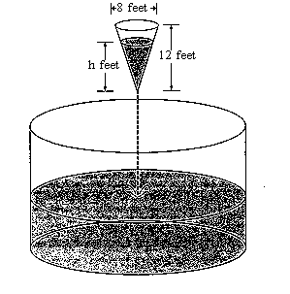
As shown in the figure above, water is draining from a conical tank with height 12 feet and diameter 8 feet into a cylindrical tank that has a base with area $\text{400}p$ square feet. The depth h, in feet, of the water in the conical tank is changing at the rate of $\left(h−\text{12}\right)$ feet per minute. (The volume V of a cone with radius r and height h is $V=\frac{1}{3}{pr}^{2}h$.)
(a) Write an expression for the volume of water in the conical tank as a function of h.
(b) At what rate is the volume of water in the conical tank changing when $h=3$? Indicate units of measure.
(c) Let y be the depth, in feet, of the water in the cylindrical tank. At what rate is y changing when $h=3$? Indicate units of measure.

6. 1991 AB6

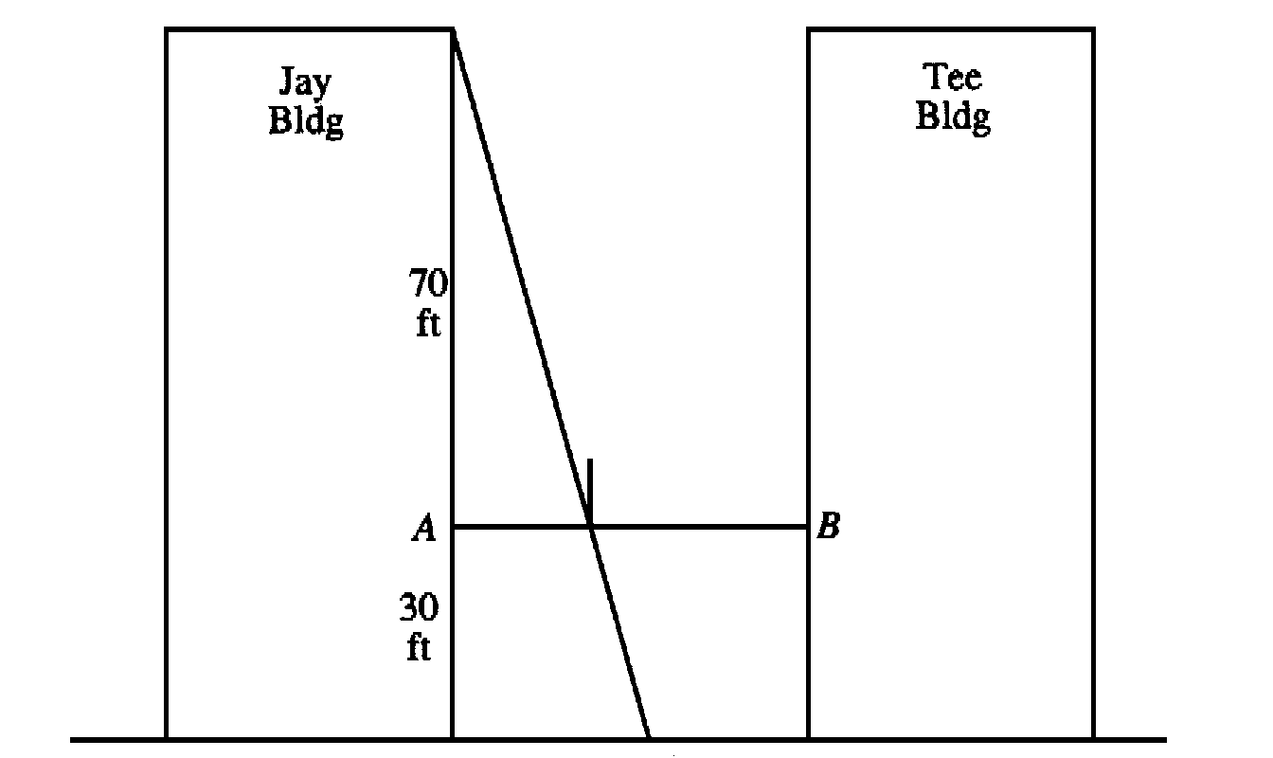

A tightrope is stretched 30 feet above the ground between the Jay and the Tee buildings, which are 50 feet apart. A tightrope walker, walking at a constant rate of 2 feet per second from point A to point B, is illuminated by a spotlight 70 feet above point A, as shown in the diagram.

(a) How fast is the shadow of the tightrope walker's feet moving along the ground when she is midway between the buildings? (Indicate units of measure.)

(b) How far from point A is the tightrope walker when the shadow of her feet reaches the base of the Tee Building? (Indicate units of measure.)

(c) How fast is the shadow of the tightrope walker's feet moving up the wall of the Tee building when she is 10 feet from point B ? (Indicate units of measure.)

RELATING THE GRAPHS OF

In the past, our emphasis with students has been on the process of “finding” derivatives. We drilled our students on the various derivative rules; the rules became the focus until we turned to application problems.

In the Age of Reform, however, we realize that we want our students to understand the concept of derivative better. We will hopefully spend less time in the future drilling students on rules, and more time on helping students develop an understanding of the concept of derivative.

Gaining Information about the Slope of a Function
from the Graph of that Function.

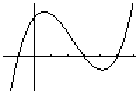

Example 1: Function F is defined and continuous on the closed interval [a,g]. The graph of F is shown above. Use this graph to answer the following questions.

- Over what intervals is F increasing ?
- Over what intervals is > 0 ?
- At what x-values is = 0 ?

Example 2:

The graph of , the derivative function for F, is sketched above. is continuous on the interval (a,g). Use this graph to answer the following questions.

(a) Over what interval(s) is > 0 ?

- Over what interval(s) is increasing ?

- Over what interval(s) is F increasing ?

- Over what interval(s) is (x) > 0 ?

- Over what interval(s) is the graph of F concave up ?

- If it is known that the graph of F contains the point (a,0), sketch a possible graph of F on the axes below.

Example 3:

The graph of is sketched on the axes above. is continuous on the interval (a,g). Use this graph to answer the following questions.

- Over what interval(s) is (x) 0 ?

- Over what interval(s) is increasing?

- At what x-values does the graph of F have inflection points ?

- If (a) = 2, is (c) positive or negative ? Write an argument that supports your conclusion.

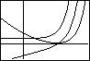
Example 4:

The graphs of H, H ’, and H ’’ are sketched on the axes above and G, G’, and G” are sketched below. Determine which is which, and clearly explain your reasoning.

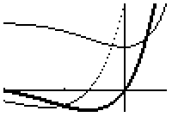

1989 AB5

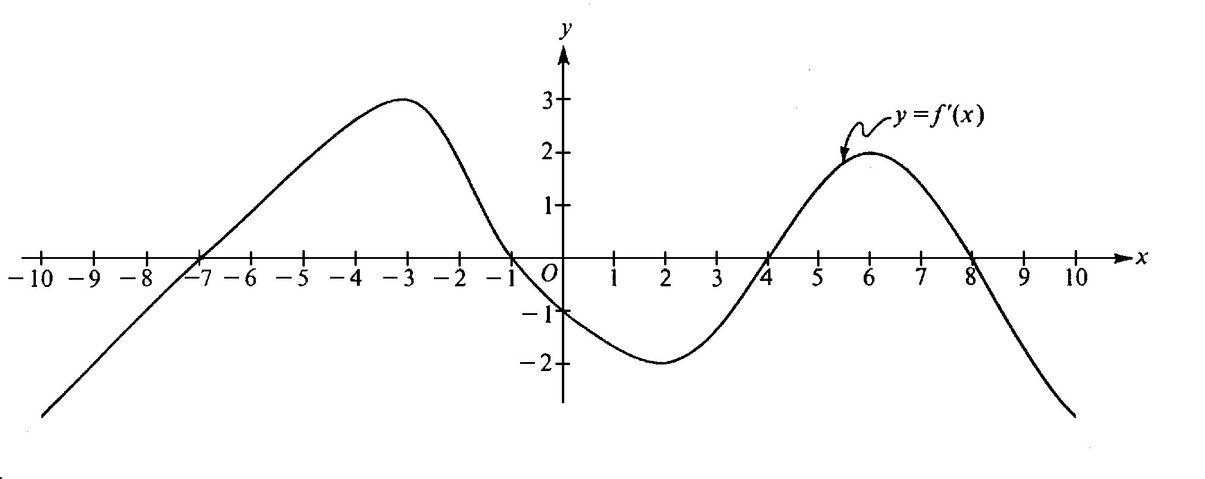

Note: This is the graph of the derivative of f, not the graph of f

The figure above shows the graph of $f^{'}$, the derivative of a function $f$. The domain of $f$ is the set of all real numbers x such that -10 x 10.

- For what values of x does the graph of $f$ have a horizontal tangent?
- For what values of x in the interval (-10,10) does $f$ have a relative maximum? Justify your answer.
- For what values of x is the graph of $f$ concave downward?

1985 AB6

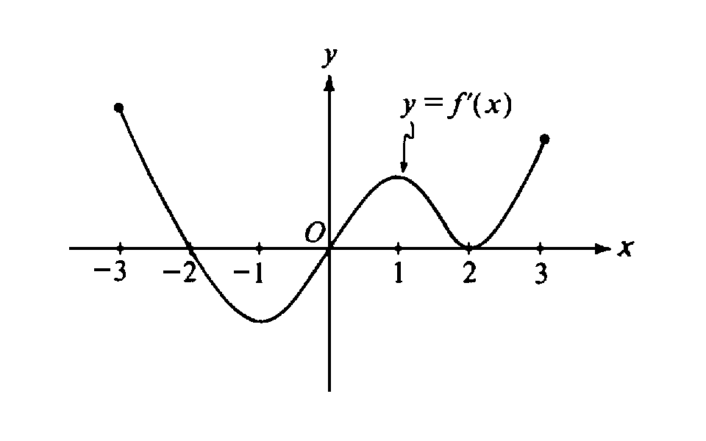
Note: This is the graph of the derivative of f, not the graph of f

The figure above shows the graph of $f^{'}$, the derivative of a function $f$. The domain of the function $f$ is the set of all x such that - 3 x 3.

- For what values of x, -3 < x < 3, does $f$ have a relative maximum? A relative minimum? Justify your answer.
- For what values of x is the graph of $f$ concave up ? Justify your answer.
- Use the information found in parts (a) and (b) and the fact that $f$( -3)=0 to sketch a possible graph of $f$.

The Fundamental Theorem of Integral Calculus

What is so fundamental about the Fundamental Theorem? To a mathematician, the "fundamental theorems" are those that are the foundations for the subject being addressed. This is certainly true for the Fundamental Theorem of Arithmetic (which states that every positive integer greater than 1 is either prime or can be written as a product of primes in essentially one way) and the Fundamental Theorem of Algebra (which states that every polynomial equation of degree n$³1$ with complex coefficients has at least one root, which is a complex number.) For many years before the Fundamental Theorem of Calculus was proved, mathematicians worked with derivatives, antiderivatives, and sums of products. After Isaac Barrow discovered and proved the Fundamental Theorem of Calculus, both his student, Isaac Newton, and Gottfried Leibnitz developed many of the concepts of calculus that we use and study today. The power of the Fundamental Theorem of Calculus is that it (i) connects the branches of differentiation and integration, and (ii) provides an efficient means of accumulating rates of change. Let’s discuss possible approaches to the development of this theorem in our classrooms that will enable our students to both understand and appreciate this most powerful and fundamental of theorems.

The Area Approach

This is probably the most frequently seen textbook and classroom development of the theory behind the Fundamental Theorem. Students relate easily to the concept of area, to the idea of getting better approximations to area by increasing the number of rectangles employed, and the instinctive (and visually appealing) sense that using limits will bring us to an "exact area". Unfortunately, this approach can also be misleading. Since area is of positive magnitude, this approach is built upon the given function being positive on the interval described, and thus neglects the implications of a function that may not (always) be positive on the given interval. Also, this approach does not help build the critical relationship between differentiation and integration except by happenstance.

The Distance Approach

Just as the Area Approach is based upon the accumulation of small pieces of area, the Distance Approach is based upon the accumulation of small distances.
The disadvantage of this approach is that it is not as familiar nor as visual for students. The advantage is that is so beautifully shows the integration process as one of accumulating rates of change, and thus gives clear evidence of the relationship between differentiation and integration. It also has the advantage of allowing velocity (function) values to be either positive or negative or both. The student can literally "see" the contrast between total distance traveled and displacement, a concept which has no parallel in the area approach.

A Formal Proof Approach

A fairly formal proof of the Fundamental Theorem is given in many textbooks, and is presented in many classrooms. Since few students are neither comfortable with the notation used, nor able to appreciate the theoretical development without some concrete work first, to provide the proof as a sole means of having students grasp the Fundamental Theorem is futile. However, in the "Age of Reform" (drumroll, please) are we expected to present the proof as part of our development? Do we feel that it is productive, useful, or desirable to do so whether or not the Reform movement thinks so?

Let us summarize our goals:
- We want students to understand the Fundamental Theorem.
- We want students to appreciate its power.
- We want students to see that the Fundamental Theorem explains the relationship between the two major themes of calculus: integration and differentiation.
- We want students to see the Fundamental Theorem as providing a powerful tool for accumulating rates of change.

A QUESTION OF VELOCITY

Mark Saintly entered a Walk-a-Thon to help raise money for the local Community Center. He started the walk slowly, but gradually picked up some speed since there was a bonus $100 contribution made by a local business for any walker who completed the 5 mile walk in less than 100 minutes. The table below shows Mark’s speed at various times along the designated route.

Time, in minutes, since Mark began the Walk | 0 | 2 | 4 | 8
Mark’s speed in miles per minute | 0 | .03 | .04 | .06

Let’s assume that Mark never decreased his speed in these first 8 minutes.

- Use the information in this table to estimate the distance Mark had covered in the first 8 minutes. Provide not only an answer, but an rationale for why you feel this might be a reasonable estimate.

Suppose that we had more information about Mark’s speed than was provided in the first table. Below is a more complete table.

Time, in minutes, since Mark began the Walk | 0 | 1 | 2 | 4 | 6 | 8
Mark’s speed in miles per minute | 0 | .01 | .02 | .04 | .05 | .06

- With the additional information, revise your estimate of the distance Mark has covered in the first 8 minutes of the Walk-a-Thon.

- Based upon your estimate from question 2, what was Mark’s average rate for the first 8 minutes?

AN AREA PROBLEM WITH AN OOPS

A function, f, given by the rule f(x) = 96 - 32x is sketched on the axes below.

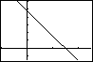

- Use the CRiemann program to estimate the area of the trapezoidal region enclosed by the graph of this function, the X-axis, the Y-axis, and the vertical line x = 1. Confirm using geometry.
- Use the CRiemann program to estimate the area of the triangular region enclosed by the graph of this function, the X-axis, and the Y-axis. Confirm using geometry.
- Find the total area trapped between this function, the X-axis, and the vertical lines x = 0 and x = 2. Explain the discrepancy with your result and the result when the Criemann program is applied to the same interval.

AP Examination Questions Relating to the Fundamental Theorem

1987 BC6

Let f be a continuous function with domain x > 0 and let F be the function given by $F(x)=\int_{1}^{x}{f(t)\text{dt}}$ for x > 0 . Suppose the F(ab) = F(a) + F(b) for all a>0 and b>0 and that F ' (1) = 3.

(a) Find f(1).
(b) Prove that ${\text{aF}}^{'}(\text{ax})=F^{'}(x)$ for every positive constant $a$.
(c) Use the results from parts (a) and (b) to find f(x). Justify your answer.

1991 BC4

Let $F(x)=\int_{1}^{2x}{\sqrt{t^{2}+1}}\text{dt}$.

(a) Find F ' (x).
(b) Find the domain of F.
(c) Find $\underset{x→1/2}{\text{lim}}F(x)$.
(d) Find the length of the curve y = F(x) for 1x2.

1993 AB Multiple Choice #41

$\frac{d}{\text{dx}}\int_{0}^{x}{\text{cos}(2pu)\text{du}}$ is

(a) 0 (b) $\frac{1}{2p}\text{sin}x$ (c) $\frac{1}{2p}\text{cos}(2px)$ (d) $\text{cos}(2px)$
(e) $2p\text{cos}(2px)$

FUNCTIONS DEFINED BY INTEGRALS

There are many functions defined by integrals. Perhaps the most “famous” function of this type from the realm of first year calculus is the natural logarithmic function. In the past, many of us have tended to race past the development of functions defined by integrals to get to functions themselves. In a sense, this is like racing to our destination without “stopping to smell (or even see) the roses” along the way.

In our haste to get to the skills of finding antiderivatives, to make our students competent with logarithmic and exponential functions, and to apply the students’ skills to applied problems such as volumes, we have missed some important theory and some wonderful explorations. This presentation hopes to revisit familiar topics with some sight-seeing and exploring along the way.

In the Teacher’s Guide: AP Calculus, the goals of AP Calculus have been listed and explained in greater detail. On page 9, the fourth goal is presented and explained:

- Students should understand the relationship between the derivative and the definite integral as expressed in both parts of the Fundamental Theorem of Calculus.

The fourth goal is for students to understand the Fundamental Theorem of Calculus, which they can really do only after the two previous goals have been met. They should understand “both parts” of the theorem. One part validates the use of antiderivatives to evaluate definite integrals, that is, $\int{f(x)\text{dx}=F(b)−F(a)}$, where $F$ is any antiderivative of $f$. The other part involves the differentiation of functions defined by definite integrals, that is, $\frac{d}{\text{dx}}\int{f(t)\text{dt}}=f(x)$. Students for whom integration is introduced from the outset as “the opposite of differentiation” are understandably less than impressed by the profundity of these results.

In order to get the most out of our travels, it will be important for students to have a good grip on the foundations: the meaning of the definite integral both as a limit of Riemann sums and as the net accumulation of a rate of change, and an understanding of the Fundamental Theorem of Calculus.

Let’s address the “part” of the Fundamental Theorem most critical to this topic: the part that states $\frac{d}{\text{dx}}\int{f(t)\text{dt}}=f(x)$.

One of the recent changes in the content of AB Calculus is that those students are expected to deal with topics at the same depth as their BC Calculus counterparts. Thus, they should be able to apply composition of functions to this concept by using the Chain Rule: that is,
$$\frac{d}{\text{dx}}\int{f(t)\text{dt}}=f(g(x))⋅g^{'}\left(x\right)$$

We will look at ways of helping our students understand this concept.

SAMPLE PROBLEMS:

Example 1:
Given function $\text{myst}$such that $\text{myst}(x)=\int_{1}^{x}{\frac{1}{t}}\text{dt}$. Describe the graph of $\text{myst}$ as completely as possible, giving explanations to support your conclusions. Be sure to include a discussion of the domain of this function, intervals over which it increases or decreases, and its concavity.

Example 2:

1995 AB6

The graph of a differentiable function $f$ on the closed interval [1,7] is shown.
Let $h(x)=\int{f}(t)\text{dt}\text{ for }1≤x≤7$.

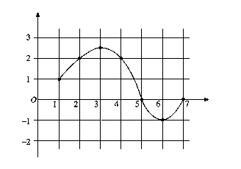

- Find $h\left(1\right)$
- Find $h^{'}\left(4\right)$
- On what interval or intervals is the graph of $h$ concave upward. Justify your answer.
- Find the value of x at which $h$ has its maximum on the closed interval [1,7]. Justify your answer.

Example 3:

1995 BC6

Let $f$ be a function whose domain is the closed interval [0,5]. The graph of $f$ is shown below.

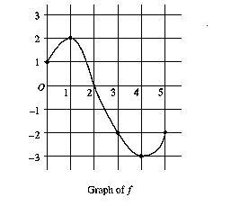

Let $h(x)=\int{f}(t)\text{dt}$

- Find the domain of $h$
- Find $h^{'}\left(2\right)$
- At what x is $h(x)$ a minimum? Show the analysis that leads to your conclusion.

Example 4:

- If $F(x)=\int_{1}^{x^{2}}{\frac{\text{dt}}{1+\sqrt{1−t}}}$ , then find $F^{'}\left(x\right)$.

- If $F(x)=\int_{\text{sin}(x)}^{0}{\frac{\text{dt}}{t+2}}$ , , then find $F^{'}\left(x\right)$.

- The variables x and y are related by $x=\int_{0}^{y}{\frac{1}{\sqrt{1+4t^{2}}}}\text{.}$ Show that $\frac{d^{2}y}{{\text{dx}}^{2}}$ is proportional to y and find the constant of proportionality.

Example 5: [Based on a problem from Calculus Problems for a New Century , pg.110]

Let $g(x)=\int_{0}^{x}{f(t)\text{dt}}$ where $f$ is graphed below.

- Does $g$ have any local maxima on (0,10)? If so, state at what x-values they occur and explain your reasoning for choosing these values.
- Must $g$ have an absolute maximum value on the interval [0,10]? Explain why or why not. If $g$ must have an absolute maximum value on [0,10], find the x-value at which it occurs and support your answer with an explanation of your reasoning.
- Determine any intervals within (0,10) on which $g$ will be concave up. Justify your answer.
- Sketch a possible graph of $g$.
- **Suppose that it is known that g is an even function with domain [-10,10]. Determine the intervals over which g must be concave up. Support your answer with work or an explanation that does not rely on the symmetry of the graph alone.

Example 6:

1997 AB5
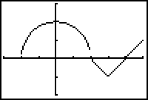

The graph of a function consists of a semicircle and two line segments as shown above. Let be the function given by .
- Find .
- Find all values of on the open interval (-2,5) at which has a relative maximum. Justify your answer.
- Write an equation for the line tangent to the graph of at x=3.
- Find the x-coordinate of each point of inflection of the graph of on the open interval (-2,5). Justify your answer.

VARIABLE SEPARABLE DIFFERENTIAL EQUATIONS

Differential equations are means of describing relationships between rates of change and other values.

$$\frac{\text{dy}}{\text{dx}}=x^{3}\text{ ; }\frac{\text{dy}}{\text{dx}}=y\text{ ; }\frac{\text{dy}}{\text{dx}}=\text{xy}$$

The above are examples of differential equations relating the rate of change $\frac{\text{dy}}{\text{dx}}$ to x, to y, or to both. They are each also of the type known as variable separable.

Differential equations are classified by type (ordinary or partial), by order (that of the highest order derivative that occurs in a differential equation) and by degree (the exponent of the highest power of the highest order derivative.) For example, is an ordinary differential equation of order three and degree two.

.
• To solve a differential equation means to find a family of functions that satisfies the particular differential equation. For example, show that any member of the family
$$y=A\text{cos}(x)+B\text{sin}(x)$$
solves the differential equation
$$y\text{ + y}=0\text{\} \{}$$

•To solve a differential equation of the form
$$\frac{\text{dy}}{\text{dx}}=f(x)$$
requires finding a function F that whose derivative is f . The most general solution of the given differential equation is thereby y = F(x) + C. For example, given
$\frac{\text{dy}}{\text{dx}}=\text{cos}(x)$,
the general solution is because cosine is the derivative function for sine.

• To find a particular family member of the general solution set of a differential equation requires having one or more initial conditions. For example, if we know that
$$\frac{\text{dy}}{\text{dx}}=\text{cos}(x)\text{ and that }y=3\text{ when }x=\frac{p}{2}$$
then we know (1) and also that (2) $3=\text{sin}(\frac{p}{2})+C$. Thus is the unique particular solution for the differential equation under the given initial conditions.

•Often, the method of substitution (used implicitly or explicitly) is a necessary integration technique enabling us to solve a differential equation using the Chain Rule. For example,
$$\frac{\text{dy}}{\text{dx}}={\text{cos}}^{3}(2x)⋅\text{sin}(2x)$$
is really of the form
$$\frac{\text{dy}}{\text{du}}\text{=-}\frac{1}{2}u^{3}\text{ where }u=\text{cos}(2x)$$
and so its general solution is $y\text{=-}\frac{1}{8}u^{4}+C$ or, better yet
$y\text{=-}\frac{1}{8}{\text{cos}}^{4}(2x)+C$.

Separation of Variables

Some differential equations take the form
$$\frac{\text{dy}}{\text{dx}}=G(x,y)$$
where the rate of change depends not only upon x but also upon y. If this differential equation can be written in the form
$$\frac{\text{dy}}{\text{dx}}=\frac{g(x)}{h(y)}$$
then it can be transformed to
$$h(y)\text{dy}=g(x)\text{dx}$$
and solved by antidifferentiating both the left-hand member and the right-hand member with respect to x. Looking at the general form of a variable separable differential equation, it appears that one is integrating the left-hand member with respect to y and the right-hand member with respect to x; not so, however.

Suppose we can write a differential equation in the form
$$\frac{\text{dy}}{\text{dx}}=\frac{g(x)}{f(y)}$$

then, we can transform this equation to one of the form
$f(y)\frac{\text{dy}}{\text{dx}}=g(x)$. (1)

This leads to
$f(y)\text{dy}=g(x)\text{dx}$,
which is the "classic" variable separable format.

If y is a function of x, say y(x), and if is an antiderivative of and F(y) is an antiderivative of f(y), we can use the Chain Rule to discover that
$\frac{d}{\text{dx}}(F(y(x)))=F^{'}(y(x))⋅y^{'}(x)=f(y)\frac{\text{dy}}{\text{dx}}$
If we rewrite equation (1) as
(2)
then it is clear ??? that the left member is the result of differentiating with respect to and that the right member is the result of differentiating with respect to . Thus we integrate (both sides of) equation (2) with respect to to get .

1. Growth and Decay Problems

Many quantities are found to increase or decrease (grow or decay) over time in direct proportion to the amount of the quantity present. The resulting differential equations is of the form
$$\frac{\text{dA}}{\text{dt}}=\text{kA}\text{ where }k\text{ is the constant of proportioanlity}\text{.}$$
A classic example of this type of problem is a "typical" population problem or a typical radioactive decay problem. For example,

1987 BC1

At any time t$³$0, in days, the rate of growth of a bacteria population is given by y' = ky where k is a constant a y is the number of bacteria present. The initial population is 1000 and the population triples during the first 5 days.

(a) Write an expression for y at any time t$³$0.
(b) By what factor will the population have increased in the first 10 days?
(c) At what time t, in days, will the population have increased by a factor of 6?

Newton's Law of Cooling(or Heating)

Another classic example is Newton's Law of Cooling (or Heating) which states that the rate at which an object cools (or warms) is proportional to the difference in temperature between the object and the temperature of the surrounding medium. Newton's Law of Cooling is an enlightening variation on the population problem.
(a) Derive an equation which expresses the temperature T of a cooling object at any time t if the temperature of the surrounding medium is T_{m}
(b) Use your results in part (a) to find a solution to the following problem:
You have just baked a fresh apple pie and removed it from the oven at a temperature of 450º F. You have left it to cool in a room whose temperature is maintained at a constant 70º F. The ideal temperature for serving hot apple pie is when the pie has cooled to 100º F. If after half an hour the pie has already cooled to 200º F, when is the ideal time to serve to pie?

1993 AB6

Let P(t) represent the number of wolves in a population at time t years, when t$³$0. The population P(t) is increasing at a rate directly proportional to 800 - P(t), where the constant of proportionality is k.

(a) If P(0) = 500, find P(t) in terms of t and k.
(b) If P(2) = 700, find k.
(c) Find $\underset{t→¥}{\text{lim}}P(t)$.

Coasting to a Stop

Consider an object in motion, such as a car, coasting to a stop. There are actually many forces at play in such a context, but if the situation is simplified, it might be assumed that the resisting force encountered is proportional to the velocity. [That is, the slower the object moves, the less resistance it encounters.]
From physics, it is known that Force = mass X acceleration . It has been determined that for a 50-kg ice skater, the constant of proportionality described above is about –2.5 kg/sec.
- How long will it take the skater to coast from 7 m/sec to 1 m/sec ?
- How far will the skater coast before coming to a complete stop?

The Salt Brine Problem

At time t = 0 minutes a tank contains 4 lbs. Of salt dissolved in 100 gallons of water. Brine containing 2 lbs. Of salt per gallon of water is allowed to enter the tank at the rate of 5 gal./min. The mixed solution is at the same time allowed to drain from the tank at the same rate. How much salt is in the tank after 10 minutes?

Logistic Equation Models from Differential Equations

A population growing in a confined environment often follows a logistic growth curve because the rate of growth of the population depends not only upon the existing population but also upon the maximum amount of population the confined environment can support. Such functions are interesting to investigate graphically. They come from the solution of a separable differential equation of the form $\frac{\text{dP}}{\text{dt}}=\text{kP}(1−\frac{P}{L})\text{ with k and L constant}\text{.}$

1991 BC6
A certain rumor spreads through the community at the rate $\frac{\text{dy}}{\text{dt}}=2y\left(1−y\right)$, where $y$is the proportion of the population that has heard the rumor at time $t$.

(a) What proportion has heard the rumor when it is spreading fastest?
- If at time t = 0, ten percent of the people have heard the rumor, find $y$ as a function of time $t$.
(c) At what time $t$ is the rumor spreading the fastest?

Sample Multiple Choice Questions

1993 AB33

If $\frac{\text{dy}}{\text{dx}}=2y^{2}$ and if y = -1 when x = 1 , then when x = 2, y =
(a) -2/3 (b) -1/3 (c) 0 (d) 1/3 (e) 2/3

Note: 62% omitted this problem with only 14% making the correct choice of (b).

1993 BC13

If $\frac{\text{dy}}{\text{dx}}=x^{2}y$, then y could be

(a) 3ln(x/3) (b) $e^{\frac{x^{3}}{3}}+7$ (c) $2e^{\frac{x^{3}}{3}}$ (d) $3e^{2x}$ (e) $\frac{x^{3}}{3}+1$
Note: 17% omitted this question. 45% chose the incorrect answer of (b) and 34% chose the correct answer of (c).

THE SLIPPERY SLIDES OF SLOPE FIELDS

There are programs for graphing calculators and for computers that will draw slope fields for us. Unfortunately, the resulting “pictures” do not always give an accurate sense of the behavior of the function or relation being investigated. This is where the “slippery slide” can occur. The experience we can provide our students with a paper and pencil introduction to slope fields is undoubtedly the most critical component of the topic at this level. That is, our goals (I would suggest) should be

- to be certain our students understand the information a first-order differential equation provides.
- to enable our students to have a real “feel” for the family of solutions to differential equations.
- To help our students focus on the concepts rather than on the technique alone.

Pedagogy: Investigating slope fields

After reflecting on slope as a rate of change and the locally linear behavior of a function in neighborhoods of points at which the function is differentiable, ask students to discuss the thoughts that come to mind when presented with a particular differential equation. For example, what does the following equation “mean” to them:
$$\frac{\text{dy}}{\text{dx}}=x^{3}y$$

(Note: I would intentionally pick a first order differential equation that they are not likely to be able to solve at the point you are introducing this topic). Gathering thoughts and then using graph paper and pencil to explore slope values at particular points might be the next order of business.

After one or more examples, I would turn the class loose on trying to similarly investigate the following:

$$\begin{aligned}\frac{\text{dy}}{\text{dx}}=2 \\ \frac{\text{dy}}{\text{dx}}=x \\ \frac{\text{dy}}{\text{dx}}=y \\ \frac{\text{dy}}{\text{dx}}=\frac{−x}{y} \\ \frac{\text{dy}}{\text{dx}}=\frac{x}{y} \\ \frac{\text{dy}}{\text{dx}}=\frac{y}{x} \\ \frac{\text{dy}}{\text{dx}}=x+y\end{aligned}$$

From our graphical display, we might try to make conjectures about a particular family that would behave the way the slope field demands, and then check our conjecture by substituting appropriate derivatives into the differential equation. Hopefully such exploration would reinforce what it means to “solve” a differential equation and what a differential equation describes. Perhaps students will more clearly see differential equations not merely as end results of some random differentiation but also, and more importantly, as providers of descriptive information about the behavior of a family of functions.

Throughout the year, this topic can be revisited at appropriate moments. For example, once students know that $\int_{1}^{x}{\frac{1}{t}}\text{dt}=\text{ln}(x)$, the solution of many of the above differential equations can be revisited.

Assessment: Understanding slope fields

The following graphs show slope fields in the particular viewing window provided. For each:
- Propose a family of functions that would solve the differential equation reflected by the slope field. Explain as completely as you can why you have selected this family.
- Propose a differential equation whose graph would be the slope field shown. Explain as completely as you can what characteristics of the slope field caused you to select this differential equation.

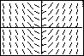
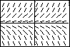
(a) [-4.7,4.7] x [-3.1,3.1] (b) [-4.7,4.7] x [-3.1,3.1]

(c) [-4.7,4.7] x [-3.1,3.1] (d) [-4.7,4.7] x [-3.1,3.1]
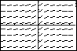
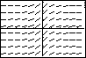

(e) [-4.7,4.7] x [-3.1,3.1] (f) [-4.7,4.7] x [-3.1,3.1]
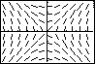
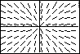

Content and Pedagogy: Euler’s Method

Slope fields are used to see trends in the behavior of solutions to differential equations. Euler’s method is used to find numerical approximations to solutions of these differential equations. That is, if we are given initial conditions that apply to the solution of a particular differential equation, we can begin at that point in the plane and head off in the direction indicated by the slope field. At some well-chosen point, we make a course correction by re-evaluating the direction we should be heading based upon the differential equation and some new location. Theoretically, if the intervals at which we make our course corrections are small enough, we should be able to piece together a rough, but reasonable, solution.

As a first example, a class might begin with the differential equation $\frac{\text{dy}}{\text{dx}}=x+y$ and the initial conditions y = 1 when x = 0. From the differential equation, the slope of a line tangent to the solution’s graph has slope 0 + 1 = 1. Thus, the tangent line $y−1=1(x−0)\text{ or }y=x+1$ models that solution. We follow along that line until we are ready to make a course correction. Using that model, y = 2 when x = 1. Therefore, at the point (1,2) we might make a change of direction, heading off along a line with slope of 1 + 2 = 3. Thus, the line$y−2=3(x−1)\text{ or y}=\text{3x-1}$ becomes our new model. If we move another unit in the x-direction before changing course, we would arrive at the point (2,5). Using the differential equation, the predicted slope would be 2 + 5 = 7. We then build a new model, $y−5=7(x−2)$ and continue along this new path.

What students would hopefully become suspicious about is the fact that we are making course corrects every horizontal unit of 1. This is not exactly a small increment! Someone might suggest a smaller horizontal increment be used to correct our course. The class could explore what happens when $Δx$ = 0.5 or even $Δx$= 0.1 Approximating the solution at x = 2 is markedly different for each choice of $Δx$. At this time, it might be helpful to have students verify that the general solution to this differential equation is $y={\text{Ce}}^{x}−x−1$ and that the initial conditions allow us to determine the specific family member $y=2e^{x}−x−1$. The class can then use this solution to compare approximations using Euler’s Method with several step sizes for $Δx$.

The three graphs below show the actual particular solution compared with models that start with the tangent at (01,) and progress through several course changes over the interval [0,2] based on $Δx$=1 and then $Δx$=0.5.
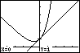
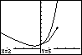
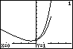

Solutions to Slope Field graphs:

$$\begin{aligned}1) \frac{\text{dy}}{\text{dx}}=x \\ 2) \frac{\text{dy}}{\text{dx}}=y \\ 3) \frac{\text{dy}}{\text{dx}}=\frac{1}{1+x^{2}} \\ 4) \frac{\text{dy}}{\text{dx}}=\frac{1}{3x^{2/3}} \\ 5) \frac{\text{dy}}{\text{dx}}=\frac{x}{y} \\ 6) \frac{\text{dy}}{\text{dx}}=\frac{y}{x}\end{aligned}$$

