FUNCTIONS DEFINED AS INTEGRALS
Bridging Differential and Integral Calculus
Through The Fundamental Theorems
Gladys Wood

Historically, the basic concepts of definite integrals were used by ancient Greeks, principally Archimedes (287-212 B.C.), which was many years before the differential calculus was discovered.
In the seventeenth century, almost simultaneously but working independently, Newton and Leibniz showed how the calculus could be used to find the area of a region bounded by a set of curves by evaluating a definite integral through anti differentiation. The procedure involves what are known as “The Fundamental Theorems of the Calculus”. These Fundamental Theorems provide a cornerstone – a bridge - that ties differentiation (slope land) to integration (accumulation world).

How do you sequence your course for the following topics?

Anti differentiation rules, Riemann Sums and Trapezoidal Rule (Area Approximation), Fundamental Theorems, Functions defined as integrals, Comparison of the two uses for the integral symbol.

For this discussion let us assume that students have a familiarity with anti derivatives and area approximation techniques.

DEFINITION: Let f be a function and “a”, any point in its domain.

Area Function:
A(x) = $\int_{a}^{x}{f(t)\text{dt}}$ = “signed” area defined by f from a to x.
“a” is the fixed edge of the boundary.  Questions: Why use both x and t ? | 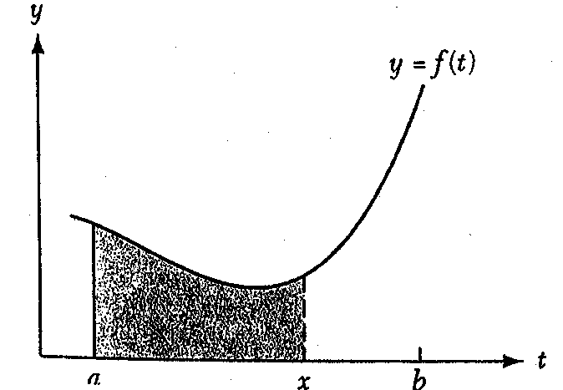
If f is continuous, how do the domains of A(x) and f(t) compare?

What if a > x ?
Wood page 1

Interesting Developments

1. What if f(t) is a constant function?

Choose f(t) = 5 and find A(x)=$\int_{0}^{x}{5\text{dt}}$ geometrically.

Notice anything?

2. What if f(t) is any linear function?

Choose f(t) = 6t and find A(x) = $\int_{0}^{x}{6\text{tdt}}$ geometrically
Let x > 0.

Let x < 0.

Notice anything?

Note: f(t) is increasing and A(x) is concave up.

Wood page 2
CALCULATOR:

Graph the following on window: x[-5,15] xscl 5 , y[-40,20] yscl 5, xres 5.
Copy graph onto space below.
TI-89 TI-83

y1(x) = 5-x y1=5-x
y2(x) = $\int{(5−t,t,0,x)}$ y2=fnint (y1,x,o,x)

Find coordinates of points A,B,C,D, and E as indicated and explain the meaning of each point.

Now turn off y2 and type:
TI-89 TI-83
y3(x) = d(y2(x),x) y3 = Nderiv (y2,x,x)

Go to Tblset and let tblstart -5 , Δtbl .1
Look at the table and compare y1(x) and y3(x) !!!!

What is this telling you?

Sketch y=A(x) and by hand sketch y=$A^{'}(x)$ to confirm.

Wood page 3

MORE INTERESTING DEVELOPMENTS

(3) What if f(t) is non-linear?

Let $f(t)=\frac{1}{t} \text{and} A(x)=\int_{1}^{x}{\frac{1}{t}\text{dt}}$.

Graph y=f(t).
Approximate y=A(x) using trapezoids and sketch.
What familiar curve does y=A(x) look like?
Note: f(t) is decreasing and A(x) is concave down.

Wood page 4
Let’s change the lower limit of our area function so that the antiderivative does not have a zero value there.

Let $A(x)=\int_{2}^{x}{6 t \text{dt}}\text{.}$ If x > 2, find the area.

Notice we have another antiderivative of f for our result.

From our examples it seems that we can state:
THE FUNDAMENTAL THEOREM OF CALCULUS, INFORMAL VERSION

For well – behaved functions f and any base point a, A(x) is an antiderivative of f.

FORMAL PRESENTATION OF THE FUNDAMENTAL THEOREM

If f is a continuous function on some interval [a,b] and
$A(x)=\int_{a}^{x}{f(t)\text{dt}}$, then $A^{'}(x)=f(x)$.

A geometric argument:

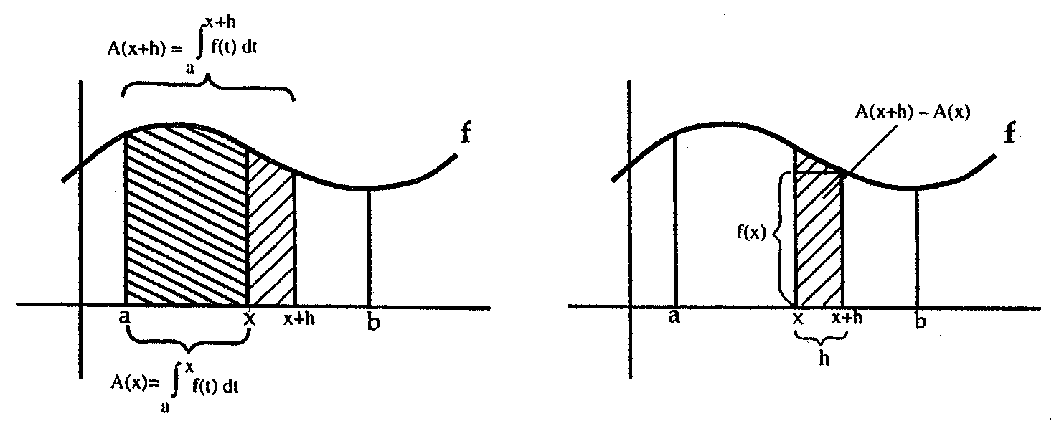

Note: Some text may use $F(x)=\int_{a}^{x}{f(t)\text{dt}}, \text{find} F^{'}(x) \text{or} \text{ask} \text{for} \frac{d}{\text{dx}}\int_{a}^{x}{f(t)\text{dt}}\text{.}$

Wood page 5

THE FUNDAMENTAL THEOREM, PART II

Let f be continuous on [a,b], and let F be any antiderivative of f.
Then
$$\int_{a}^{b}{f(x)\text{dx}}=F(b)−F(a)$$

Reason:

Since $F(x)=A(x)+c=\int_{a}^{x}{f(t)\text{dt}}+c,$

Then F(b)-F(a) = ( A(b)+c ) – ( A(a)+c ) =
= $\int_{a}^{b}{f(t)\text{dt}} − \int_{a}^{a}{f(t)\text{dt}}$
= $\int_{a}^{b}{f(t)\text{dt}}$

Concrete Example for students:

Suppose a car is traveling along a straight highway always in the same direction, and its position from an initial point can be measured at any time t. Let’s say car travels from t=0 to t=6 hours with velocity v(t) miles per hour and position at any time t hours is s(t) miles from an initial point.
As long as the car is traveling in the same direction, the total distance traveled is also the change in position of the car from t=0 to t=6 or s(6)-s(0).
Now look at the area under the velocity curve over [0,6], $\int_{0}^{6}{v(t)\text{dt}}$, and examine units.

Wood page 6

Conclusion: s(6)-s(0) is the same as $\int_{0}^{6}{v(t)\text{dt}}$. But $v(t)=s^{'}(t)$ so
$s(6)−s(0) = \int_{0}^{6}{s^{'}(t)\text{dt}}$.
Wow – look at the Fundamental Theorem at work!

CAUTION: If the car reverses direction traveled, $\int_{0}^{6}{v(t)\text{dt}}$ will give net displacement of car from initial position, not total distance traveled.
Total Distance Traveled = $\int_{0}^{6}{ \left|v(t)\right| \text{dt}}$

ACCUMULATION OF RATES
The Fundamental Theorem is often used with the accumulation of a rate of change over an interval and interpreted as the change in the quantity over the interval:
$$\int_{a}^{b}{f '(x)\text{dx}=f(b)−f(a)}$$

Example A: (Stewart Test Bank)

The velocity of a particle moving along a line is 2t meter per second. Find the distance traveled in meters during the time interval 1 < t < 3.
A) 9 B)5 C)2 D)8
E)4 F)3 G)6 H)7

Example B: (Hughes-Hallett text)

A cup of coffee at 90°C is put into a 20°C room when t=0. If the coffee’s temperature is changing at a rate given in °C by $r(t)=−7e^{−0\text{.}1t}$, t in minutes, estimate the coffee’s temperature when t=10.

Wood page 7

PROPERTIES OF A(X):
Let f and g be continuous functions on [a,b], k$ε$ Real Numbers, $A(x)=\int_{a}^{x}{f(t)\text{dt}}$
- A(0)=0
- Where f is positive, A(x) is increasing.
- Where f is negative, A(x) is decreasing.
- Where f is zero, A(x) has a critical (stationary) point.
- Where f is increasing, A(x) is concave up.
- Where f is decreasing, A(x) is concave down.
- $$\int_{a}^{b}{\text{kf}(t)\text{dt}}=k\int_{a}^{b}{f(t)\text{dt}}$$
- $$\int_{a}^{b}{(f(t)+g(t))\text{dt}}=\int_{a}^{b}{f(t)\text{dt}}+\int_{a}^{b}{g(t)\text{dt}}$$
- $$\int_{a}^{b}{f(t)\text{dt}}=\int_{a}^{c}{f(t)\text{dt}}+\int_{c}^{b}{f(t)\text{dt}}$$
- If f(t)g(t) on [a,b], then $\int_{a}^{b}{f(t)\text{dt}}≤\int_{a}^{b}{g(t)\text{dt}}\text{.}$

Example C:
Assume both f and g are continuous, a < b, and $\int_{a}^{b}{f(x)\text{dx}}>\int_{a}^{b}{g(x)\text{dx}}$
- Must $\left|\int_{a}^{b}{f(x)\text{dx}}\right|>\left|\int_{a}^{b}{g(x)\text{dx}}\right|$

- Must f(x) > g(x) for all x in the interval [ a , b ]?

- Does it follow that $\int_{a}^{b}{\left|f(x)\right|\text{dx}}>\int_{a}^{b}{\left|g(x)\right|\text{dx}}$?
Example D: Assume f is continuous, a < b, and $\int_{a}^{b}{f(x)\text{dx}}=0$
- Does it necessarily follow that f(x)=0 for all x [a,b]?
- Does is necessarily follow that f(x)=0 for at least some x in [a,b]?
- Does it necessarily follow that $\int_{a}^{b}{\left|f(x)\right|\text{dx}}=0$
- Does it necessarily follow that $\left|\int_{a}^{b}{f(x)\text{dx}}\right|=0$ Wood page 8
Example from Ostebee - Zorn:

(1) Suppose f is continuous and $\int_{0}^{x}{f(t)\text{dt}}=\text{sin}(x^{2})$.
Find an expression for $\int_{\sqrt{\frac{π}{2}}}^{x}{f(t)\text{dt}}$.

Example from Ostebee – Zorn:

(2) Let $A_{f}(x)=\int{f(t)\text{dt}}$ where f is the function graphed below.

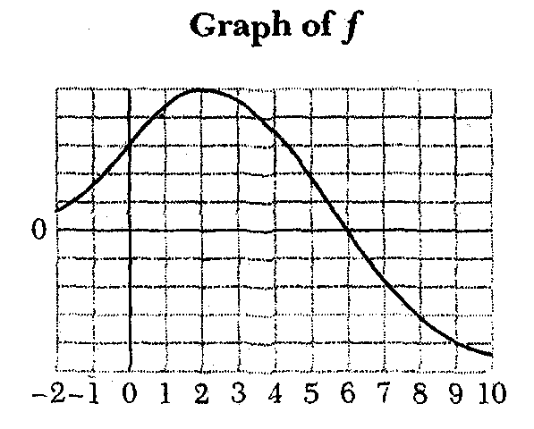

- Which is larger: $A_{f}(1)$ or $A_{f}(5)$? Justify your answer.
- Which is larger: $A_{f}(7)$ or $A_{f}(\text{10})$? Justify your answer.
- Which is larger: $A_{f}(−2)$ or $A_{f}(−1)$? Justify your answer.
- Where is $A_{f}$ increasing?
- Explain why $A_{f}$ has a stationary point at $x=6$. Is this a local maximum or a local minimum?
- Let $F(x)=\int{f(t)\text{dt}}$. Explain why $A_{f}=F(x)+C$ where C is a negative constant.

Example from Ellis and Gulick:

(3) $\int_{0}^{\frac{π}{2}}{(\frac{d}{\text{dx}}{\text{sin}}^{5}x)\text{dx}}=$
Wood Page 9
DEVELOP THE FUNDAMENTAL THEOREM BY OBSERVATION:

(4) Let $F(x)=\int_{2}^{x}{(3t^{2}+4)\text{dt}}$

- Find an equation for y = F(x).

- Find F′(x) using part (a). Do you notice anything?

- Would the answer in part (b) change if the “2” was changed to “-5” ?

- Draw a conclusion about $\frac{d}{\text{dx}}\int_{a}^{x}{f(t)\text{dt}=}$

(5) Let $F(x)=\int_{\frac{π}{3}}^{2x}{(\text{sin}t)\text{dt}}$

- Find an equation for y = F(x).

- Find F′(x).

- Does the conclusion in example 1 hold?

- Draw a new conclusion about $\frac{d}{\text{dx}}\int_{a}^{g(x)}{f(t)\text{dt}=}$

Wood Page 10

Examples:

- Find F′(x) given:

  - $F(x)=\int_{x}^{5}{3t \text{sin}t \text{dt}}$

  - $F(x)=\int_{0}^{3x}{\frac{1}{t^{4}+1} \text{dt}}$

  - $F(x)=\int_{2x}^{x^{2}}{\frac{1}{2+e^{t}} \text{dt}}$

(7) Let g be the function given by g(x) = .
Which of the following statements about g must be true?

- g is increasing on (1,2).
- g is increasing on (2,3).
- g (3) > 0

- I only
- II only
- III only
- II and III only
- I, II, and III

(8) Example from Ellis and Gulick:

Find the derivative of $F(x)=\frac{d}{\text{dx}}\int_{0}^{4x}{(1+t^{2})^{\frac{4}{5}}\text{dt}}$.

Wood Page 11
(9) Engineering Application from Johnston and Mathews:

The position of a valve in a circular pipe of radius 1 meter is a function
x = x(t) of time t. The valve opens to the right. The flow L through the valve, measured in cubic meters per minute, is directly proportional to the area of the shaded region. Given that x = x(t) = $2t^{2} , 0≤t≤1,$ determine the rate of change dL/dt in the flow when the valve is half open.

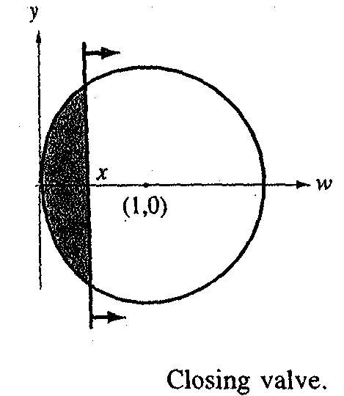

10. From Stewart Calculus:

If $f(x)=\int_{0}^{g(x)}{\frac{1}{\sqrt{2+t^{3}}} \text{dt}}$, where $g(x)=\int_{0}^{\text{cos}x}{[1+\text{sin}(t^{2})]\text{dt}}$, find $f^{'} \left(\frac{π}{2}\right)\text{.}$

11. Example:

Find the equation of the tangent line to the curve y = F(x), where F(x)=$\int_{1}^{x}{\sqrt[3]{t^{2}+7}} \text{dt}$ , at the point on the curve where x=1.

Wood Page 12

12. Example from Finney, Demana, Waits, Kennedy:

f is the differentiable function whose graph is shown in the figure. The position at time t (sec) of a particle moving along a coordinate axis is  $$s=\int{f(x)\text{dx}}$$  meters. Use the graph to answer the questions. Give reasons for your answers.  - What is the particle’s velocity at time t = 5?  - Is the acceleration of the particle at time t=5 positive or negative?  - What is the particle’s position at time t=3?  - At what time during the first 9 sec does s have its largest value? | 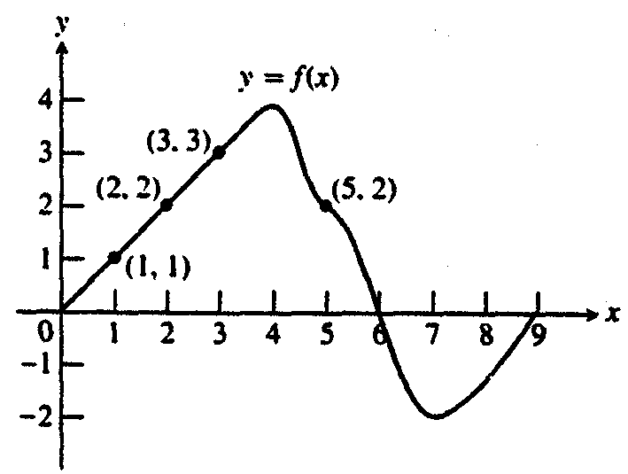

- Let F be defined by the graph shown where f is continuous and differentiable on (0,$∞$); f(0)=0; 0<a<b<c<d. Let $F(x)=\int_{a}^{x}{f(t)\text{dt}}$.

- F(a)=  - F(b)= | 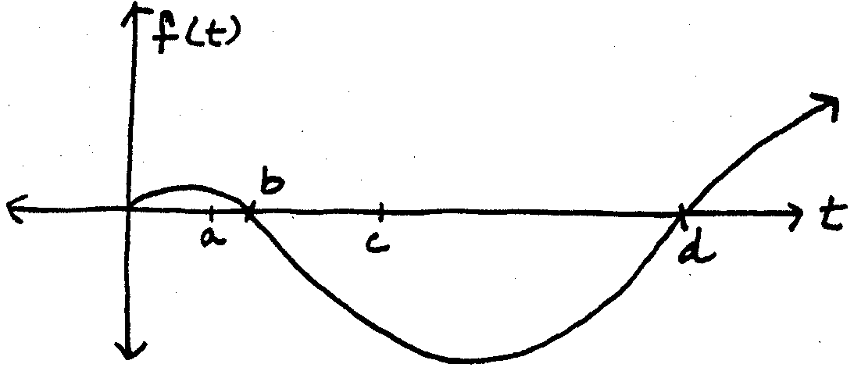
- Is F(b) positive, negative, or zero?
- Is F(c) positive, negative, or zero?
- Is F(x) increasing or decreasing at x=c?
- Is F(a) positive, negative, or zero?
- Is F(x) concave up or concave down at x=c?
- Is F(x) concave up or concave down at x=d?
- At what value of x is F(x) a maximum? A minimum?
- Is F(0) positive, negative , or zero?

Wood Page 13
14. From Salas, Hille, Etgen:

Let $F(x)=2x+\int_{0}^{x}{\frac{\text{sin}(2t)}{1+t^{2}}\text{dt}}$ . Determine: (a) F(0), (b) $F^{'}(0)$, (c)$F^{''}(0)$.

15. From Salas, Hille, Etgen:
(a) Sketch the graph of the function

$$f(x)=\begin{aligned}\left\{2−x, 0≤x≤1 | \right.\end{aligned}$$

(b) Find the function $F(x)=\int_{0}^{x}{f(t)\text{dt}}, 0≤x≤3$, and sketch its graph.

(c) What can you say about f and F at x=1?

16. From Salas, Hille, Etgen:
Let F be defined by
$F(x)=\int_{0}^{x}{\frac{1}{1+t^{2}}\text{dt}}$, where x is any real number.

(a)Find the critical numbers of F and determine the intervals on which F is increasing and intervals on which F is decreasing.
(b) Determine the concavity of the graph of F and find the points of inflection (if any).
(c) Sketch the graph of F.

Wood Page 14
On the AP Free Response questions in recent years, I have found uses of the Fundamental Theorem for these years:
87BC6, 88BC6, 91BC4, 94AB6, 97AB3, 99AB/BC5, 99BC6, 00AB4, 01BC5, 02AB/BC2, 02AB/BC4, 02AB6, 03AB3, 03AB/BC4,03BC2.

17. 1997 BC Multiple Choice:
Let $f(x)=\int_{0}^{x^{2}}{\text{sin}t \text{dt}}$. At how many points in the closed interval [0, $\sqrt{π}$] does the instantaneous rate of change of f equal the average rate of change of f on that interval?
    - Zero
    - One
    - Two
    - Three
    - Four

18. 1995 BC 6 Free Response:

Let f be a function whose domain is the closed interval [0,5]. The graph of f is shown below.

Let $h(x)=\int{f(t)\text{dt}}$  - Find the domain of h.  - Find h′(2).  - At what x is h(x) a minimum? Show the analysis that leads to your conclusion. | 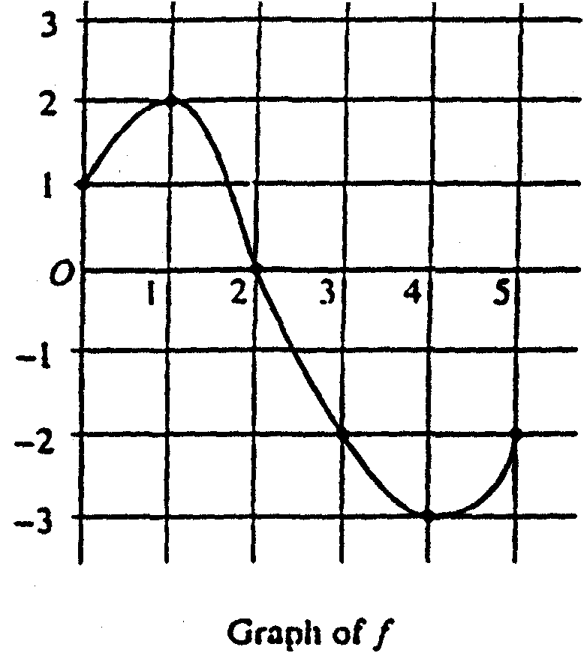

Wood Page 15
19. 1997 BC Multiple Choice:

If f is the antiderivative of $\frac{x^{2}}{1+x^{5}}$such that f(1) = 0, the f(4) =

(A) –0.012 (B) 0 (C) 0.016 (D) 0.376 (E) 0.629

20. 1997 AB/BC 5 Free Response:

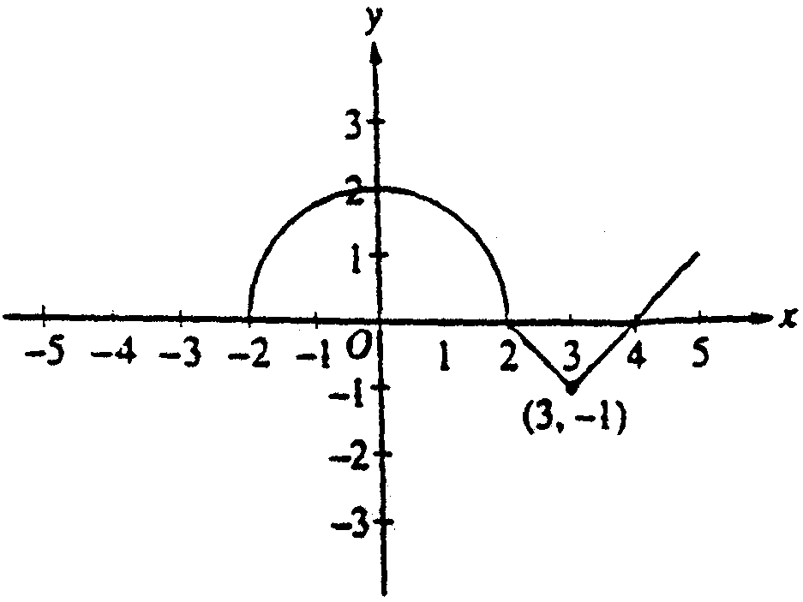

The graph of a function f consists of a semicircle and two line segments as shown above. Let g be the function given by g(x) = $\int{f(t)\text{dt}}$ .

(a) Find g(3).

(b) Find all values of x on the open interval (-2, 5) at which g has a relative maximum. Justify your answer.

(c) Write an equation for the line tangent to the graph of g at x = 3.

(d) Find the x-coordinate of each point of inflection of the graph of g on the open interval (-2,5). Justify your answer.

Wood Page 16

21. 1991 BC4 Free Response

Let $F(x)=\int_{1}^{2x}{ \sqrt{t^{2}+t} \text{dt}}$.

- Find $F^{'}(x)\text{.}$

- Find the domain of F.

- Find $\underset{x→\frac{1}{2}}{\text{lim}} F(x)\text{.}$

- Find the length of the curve y = F(x) on $1≤x≤2$.

22. 2002 BC Free Response Form B

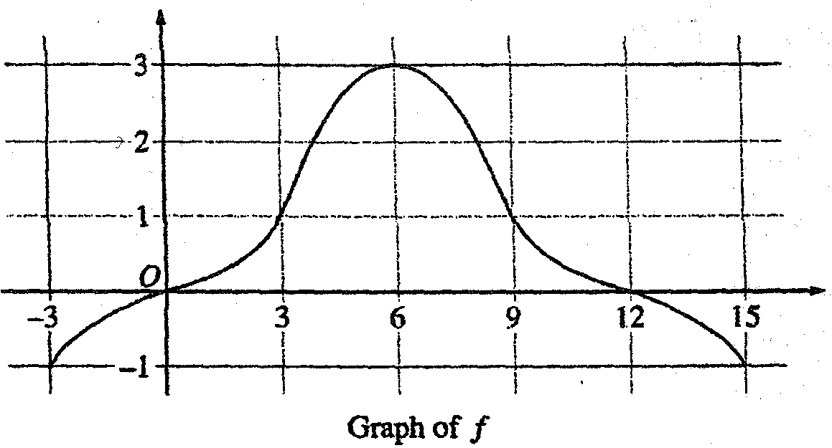

The graph of a differentiable function f on the closed interval [-3,15] is shown in the figure above. The graph of f has a horizontal tangent line at x = 6. Let g(x) = $5+\int{f(t)\text{dt}}$ for $−3≤x≤\text{15}$.
(a) Find $g(6),g^{'}(6)$, and $g^{''}(6)\text{.}$
(b) On what intervals is g decreasing? Justify your answer.
(c) On what intervals in the graph of g concave down? Justify your answer.
(d) Find a trapezoid approximation of $\int{f(t)\text{dt}}$using six subintervals of length $Δt=3\text{.}$

Wood Page 17

Multiple Choice from Stewart Test Bank:

23. Evaluate $\frac{d}{\text{dt}}\int{\sqrt{x+1}\text{dx}\text{.}}$
A) $\sqrt{t^{2}+1}$ B) $−\sqrt{t^{2}+1}$
C) 2t D)$\sqrt{t+1}$
E) 2t $\left(\sqrt{t^{2}+1}\right)$ F) 2t $\left(−\sqrt{t^{2}+1}\right)$
G) 2t $\left(\sqrt{t+1}\right)$ H) 2t $\left(−\sqrt{t+1}\right)$

24. Let f(x) = $\int{\frac{t^{2}−4}{1+{\text{cos}}^{2}t}\text{dt}}$. At what value of x does the local maximum of f(x) occur?
A) –4 B) –3 C) –2 D) –1
E) 0 F) 1 G) 2 H) 3

25. Let $y=\int{\frac{\text{dt}}{t^{2}+t+1}\text{.}}$ Find $\frac{d^{2}y}{{\text{dx}}^{2}}$.
A) $\frac{\left(\text{18}x+3\right)}{{\left(9x^{2}+3x+1\right)}^{2}}$ B) $\frac{3\left(\text{18}x+3\right)}{{\left(9x^{2}+3x+1\right)}^{2}}$
C) $\frac{−3\left(\text{18}x+3\right)}{{\left(9x^{2}+3x+1\right)}^{2}}$ D) $\frac{3\left(\text{18}x+3\right)}{{\left(9x^{2}+3x+1\right)}^{3}}$
E) $\frac{\left(\text{18}x+3\right)}{{\left(9x^{2}+3x+1\right)}^{2}}$ F) $\frac{\left(\text{18}x+3\right)}{{\left(9x^{2}+3x+1\right)}^{3}}$
G) $\frac{{\left(\text{18}x+3\right)}^{2}}{{\left(9x^{2}+3x+1\right)}^{3}}$ H) $\frac{−3{\left(\text{18}x+3\right)}^{2}}{{\left(9x^{2}+3x+1\right)}^{2}}$

26. If $F(x)=\int{\sqrt{t^{4}+\text{20}}\text{dt}}$, find the value of $F^{'}(4)\text{.}$
A) $\frac{1}{2}$ B) 1 C) $\frac{3}{2}$ D) 2
E) $\frac{5}{2}$ F) 3 G) $\frac{7}{2}$ H) 4

Wood Page 18
Example 27: Evaluate $\underset{x→3}{\text{lim}}\left(\frac{x}{x−3}\int_{3}^{x}{\frac{\text{sin}t}{t}\text{dt}}\right)\text{.}$

Example 28: If $\int_{1}^{2}{f(x−c)\text{dx}=5}$where c is a constant, then $\int_{1−c}^{2−c}{f(x)\text{dx}=}$
(a) 5+c (b) 5 (c) 5-c (d) c-5 (e) –5

Example 29: (1998 BC multiple choice)
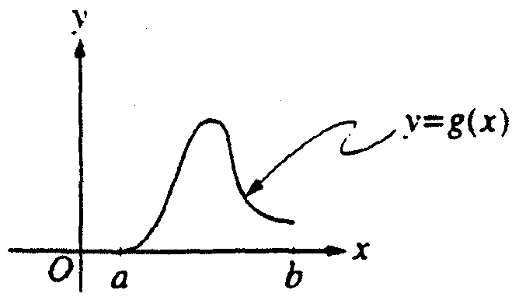
Let $g(x)=\int{f(t)\text{dt}}$, where $a≤x≤b$. The figure above shows the graph of g on [a, b]. Which of the following could be the graph of f on [a, b]?

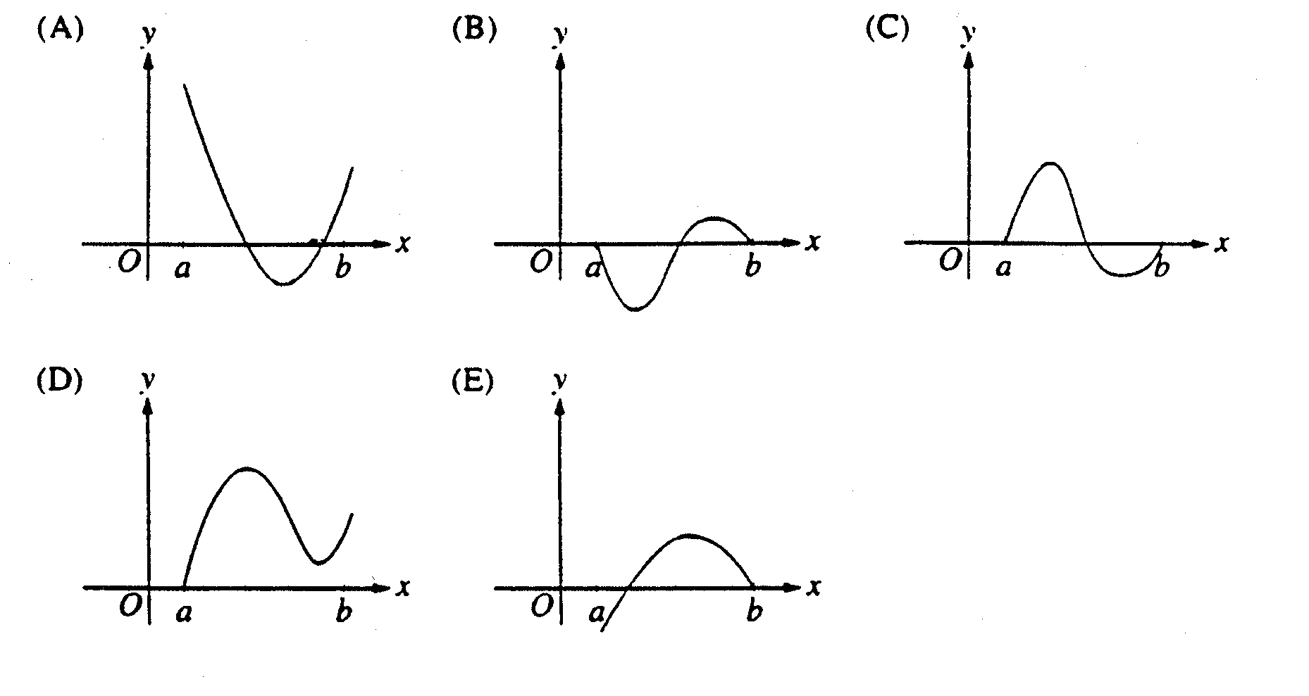

Example 30: (1998 AB multiple choice)
What are all values of k for which $\int_{−3}^{k}{x^{2}\text{dx}=0}$?
(a) –3 (b) 0 (c) 3 (d) –3 and 3 (e) –3,0, and 3

Wood Page 19

AP Calculus AB-4 / BC-4 Final Draft for Scoring 2002

The graph of the function f shown above consists of two line segments. Let g be the function given by  (a) Find $g(−1), g'(−1),$and $g\text{''}(−1)\text{.}$  (b) For what values of x in the open interval (-2, 2) is g increasing? Explain your reasoning.  (c) For what values of x in the open interval (-2,2) is the graph of g concave down? Explain your reasoning.  (d) Sketch the graph of g on the closed interval [-2, 2]. | 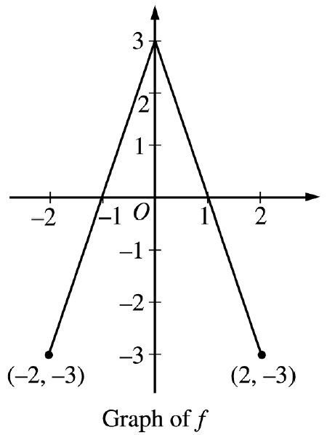

(a) $g(−1)=\int{f(t)\text{dt}=−\int{f(t)\text{dt}=−\frac{3}{2}}}$
$\begin{aligned}g^{'}(−1)=f(−1)=0 \\ g^{''}(−1)=f^{'}(−1)=3\end{aligned}$

(b) g is increasing on $−1<x<1$because $g^{'}(x)=f(x)>0$ on this interval.

(c) The graph of g is concave down on $0<x<2$ because $g^{''}(x)=f^{'}(x)<0$on this interval.
or
because $g^{'}(x)=f(x)$is decreasing on this interval.

(d) | 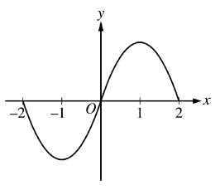

$$3\left\{\begin{matrix}1:g(−1) \\ 1:g^{'}(−1) \\ 1:g^{''}(−1)\end{matrix}\right.$$
MEAN:
AB: 3.51(4.53)
BC: 5.32(5.75)

$$2\left\{\begin{matrix}1:\text{ interval} \\ \text{1: reason }\end{matrix}\right.$$

$$2\left\{\begin{matrix}1:\text{ interval} \\ \text{1: reason }\end{matrix}\right.$$

$$2\begin{aligned}\left\{\begin{matrix}1:g(−2)=g(0)=g(2)=0 \\ 1:\text{ appropriate increasing/decreasing}\end{matrix} | \right.\left\{\text{ and concavity behavior} | \right.\end{aligned}$$

Copyright © 2002 by College Entrance Examination Board. All rights reserved.
AP is a registered trademark of the College Entrance Examination Board.

Wood Page 20
AP Calculus AB-4/BC – 4 FINAL DRAFT FOR SCORING 2003

Let f be a function defined on the closed interval $−3≤x≤4$ with  f (0) = 3. The graph of $f^{'}$, the derivative of f, consists of one line segment and a semicircle, as shown.  (a) On what intervals, if any, is f increasing? Justify your answer.  (b) Find the x- coordinate of each point of inflection of the graph of f on the open interval $−3<x<4$. Justify your answer.  (c) Find an equation for the line tangent to the graph of f at the point (0,3).  (d) Find f (-3) and f (4). Show the work that leads to your answers. | 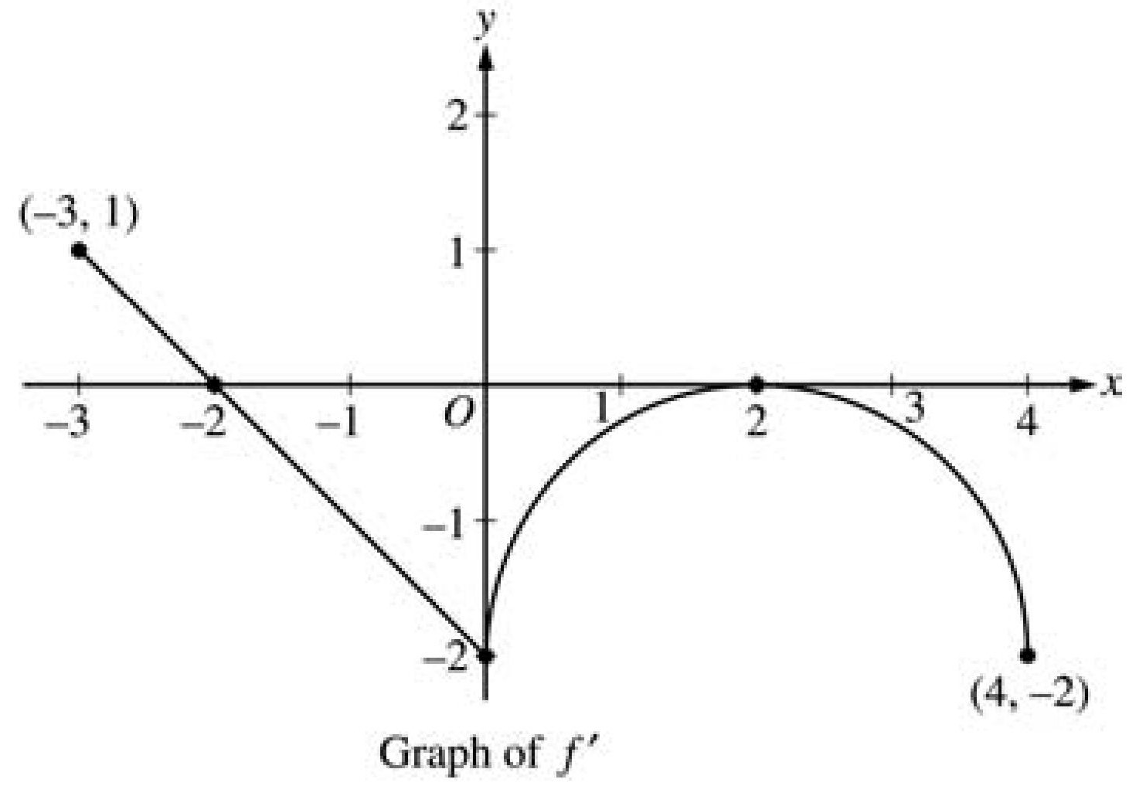

(a) The function f is increasing on [-3,-2] since $f^{'}$>0 for $−3≤x<−2\text{.}$  (b) x = 0 and x = 2  $f^{'}$ changes from decreasing to increasing at  x = 0 and from increasing to decreasing at  x = 2  (c) $f^{'}$ = -2  Tangent line is $y=−2x+3$  (d) f (0) – f (-3) = $\int{f^{'}(t)\text{dt}}$  =$\frac{1}{2}(1)(1)−\frac{1}{2}(2)(2)=− \frac{3}{2}$  f (-3) = f (0) + $\frac{3}{2} = \frac{9}{2}$  f (4) – f (0) = $\int{f^{'}(t)\text{dt}}$  = $−\left(8−\frac{1}{2}(2)^{2}π\right)=−8+2π$  f (4) = f (0) – 8 + $2π$= -5 + $2π$ | $$2:\left\{\begin{matrix}1:\text{ interval} \\ \text{1: reason }\end{matrix}\right.$$  $2:\left\{\begin{matrix}1:x=0\text{ and }x=2\text{ only} \\ 1:\text{ justification}\end{matrix}\right.$  $$1:\text{ equation}$$  $$4:\left\{\begin{matrix}1:±\left(\frac{1}{2}−2\right) \\ \begin{aligned} (\text{difference of areas of triangles}) \\ \end{aligned} \\ \begin{aligned}\text{1: answer for }f(−3)\text{ using FTC} \\ \end{aligned} \\ 1:±\left(8−\frac{1}{2}(2)^{2}π\right) \\ \begin{aligned} (\text{area of rectangle - area of semicircle}) \\ \end{aligned} \\ \text{1: answer for }f(4)\text{ using FTC}\end{matrix}\right.$$

Copyright © 2003 by College Entrance Examination Board. All rights reserved.
AP is a registered trademark of the College Entrance Examination Board.

MEAN:
AB: 2.68 (3.37)
BC: 4.14 (4.42)

Wood Page 21
(1999 AB-5/BC-5 Free Response) Mean 1.53 AB, 3.26 BC

The graph of the function f , consisting of three line segments, is given. Let $g(x)=\int{f(t)\text{dt}}$.  (a) Compute g(4) and g(-2).  (b) Find the instantaneous rate of change of g, with respect to x, at x = 1.  (c) Find the absolute minimum value of g on the closed interval  [-2,4]. Justify your answer.  (d) The second derivative of g is not defined at x = 1 and x = 2. How many of these values are x-coordinates of points of inflection of the graph of g? Justify your answer. | 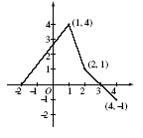

(a) $g(4)=\int{f(t)\text{dt}}=\frac{3}{2}+1+\frac{1}{2}−\frac{1}{2}=\frac{5}{2}$  $g(−2)=\int{f(t)\text{dt}}=−\frac{1}{2}(\text{12})=−6$  (b) $g^{'}(1)=f(1)=4$  (c) g is increasing on [-2,3] and decreasing on [3,4].  Therefore, g has absolute minimum at an  endpoint of [-2,4].  Since g(-2) = -6 and g(4) = $\frac{5}{2}$,  the absolute minimum value is -6.  (d) One; x = 1  On (-2,1), $g^{''}(x)=f^{'}(x)>0$  On (1,2), $g^{''}(x)=f^{'}(x)<0$  On (2,4), $g^{''}(x)=f^{'}(x)<0$  Therefore (1, g(1)) is a point of inflection and  (2, g(2)) is not. | $$2 \left\{\begin{matrix}1:g(4) \\ 1:g(−2)\end{matrix}\right.$$  1: answer  $$3 \left\{\begin{matrix}1:\text{ interior analysis} \\ 1:\text{endpoint analysis} \\ 1:\text{ answer}\end{matrix}\right.$$  $$3 \left\{\begin{matrix}1:\text{ choice of }x=\text{ 1 only} \\ 1:\text{ show }(\text{1, }g(1))\text{ is a point of inflection} \\ 1:\text{ show }(\text{2, }g(2))\text{ is not a point of inflection}\end{matrix}\right.$$

Wood Page 22
ANSWERS TO FUNDAMENTAL THEOREMS PAPER:

Pages 7 – 8:

Examples: (A) D, (B) 45.752${}^{∘}C$ , (C) no,no,no, (D) no,yes,no,yes

Pages 9-19

Examples:
(1) $\text{sin}(x^{2})−1$

(2) (a) A(5), (b) A(7), (c) A(-1), (d) (-2,6), (e) maximum, (f) Area from t=-2 to t=0 is negative.

(3) 1

(4) $x^{3}+4x−\text{16}, 3x^{2}+4,\text{No},f(x)$

(5) $−\text{cos}(2x)+\frac{1}{2}, 2\text{sin}(2x), \text{No}, f(g(x))⋅\frac{d(g(x))}{\text{dx}}$

(6) $−3x\text{sin}x, \frac{3}{\text{81}x^{4}+1}, \frac{−2}{2+e^{2x}}+\frac{2x}{2+e^{x^{2}}}$

(7) B

(8) $\frac{\text{512}x}{5}(1+\text{16}x^{2})^{\frac{−1}{5}}$

(9) $4k\sqrt{2}$

(10) -1

(11) (y-0)=2(x-1)

(12) 2 m/s, negative, 4.5m, t=6s

(13) 0,0,+,-,dec, +, down, up, max at b, min at d, -

(14) 0, 2, 2

Wood Page 23

15) $F(x)=\begin{aligned}\left\{2x−\frac{x^{2}}{2}, 0≤x≤1 | \right.\end{aligned}$
f is discontinuous at x=1 but F is continuous at x=1 but not differentiable at x=1.

(16) (a) no critical values; always increasing
(b) IP (0,0); concave up for x<0 and down for x>0
(c) Should look like the graph of $y={\text{Tan}}^{−1}(x)$.

(17) C

(18) (a) [-6,4] (b) -3/2 (c) x=4 is absolute minimum. ( x=-6 is endpoint minimum.)

(19) D

(20) (a) $π−\frac{1}{2}$, (b) max at x=2 , (c) $y−π+\frac{1}{2}=−1(x−3)$ , (d) x=0, x=3

(21) (a) $2\sqrt{4x^{2}+2x}$ , (b) x$0$ ( f(t) must be continuous on its domain so x $−\frac{1}{2}$ must be eliminated from allowed domain.), (c) 0, (d) 7

(22) (a) 5,3,0, (b) [-3,0) or (12,15], (c) (6,15], (d) 9

(23) F

(24) C

(25) C

(26) C

(27) sin(3)

(28) B

(29) C

(30) A

Wood Page 24

RESOURCES

Anton, Howard, Irl Bivens, and Stephen Davis. Calculus. Seventh Ed. New York: John Wiley and Sons,Inc.,2002.

Best, George, Stephen Carter, and Douglas Crabtree. Concepts and Calculators in Calculus . Andover, MA: Venture Publishing, 1998.

Dick, Thomas and Charles Patton. Calculus of a Single Variable . Boston: PWS Publishing, 1994.

Ebersole, Dennis and Doris Schattschnerder. A Companion to Calculus . Pacific Grove: Brooks-Cole Publishing, 1995.

Ellis, Robert and Denny Gulick. Calculus with Analytic Geometry . Austin: Holt, Rinehart and Winston, 1995.

Finney, Ross, Franklin Demana, Bert Waits, and Daniel Kennedy. Calculus, A Complete Course . Second Ed. New York: Addison-Wesley Publishing, 2000.

Foerster, Paul A. Calculus Concepts and Applications . Berkeley: Key Curriculum Press, 1998.

Hughes-Hallett, Deborah and Andrew Gleason. Calculus Single Variable. Second Ed. New York: John Wiley and Sons, Inc., 1998.

Johnston, Elgin and Jerold Mathews. Calculus for Engineering and the Sciences. New York: Harper Collins College Publishing, 1996.

Larson, Roland, Robert Hostetler, and Bruce Edwards. Calculus of a Single Variable. Seventh Ed. New York: Houghton Mifflin Company, 2002.

Ostebee, Arnold and Paul Zorn. Calculus from Graphical, Numerical, and Symbolic Points of View. Second Ed. Pacific Grove: Brooks/Cole Publishing, 2002.

Stewart, James. Calculus. Fifth Ed. Belmont: Brooks/Cole – Thomson Learning, 2003.

Swokowski, Earl, Michael Olinick, Dennis Pence, and Jeffery Cole. Calculus. Sixth Ed. Boston: PWS Publishing, 1994.

Wood Page 25

